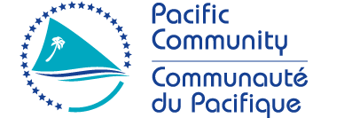

Request for Quotation (RFQ)

RFQ 21-217 - Consultancy to support the implementation of the PCREEE’s
Annual Work Plan 2021-2022 in the Solomon Islands

Please note that the deadline for submission of bids has been extended to 15th October 2021 by 4.00pm (Fiji Time).

