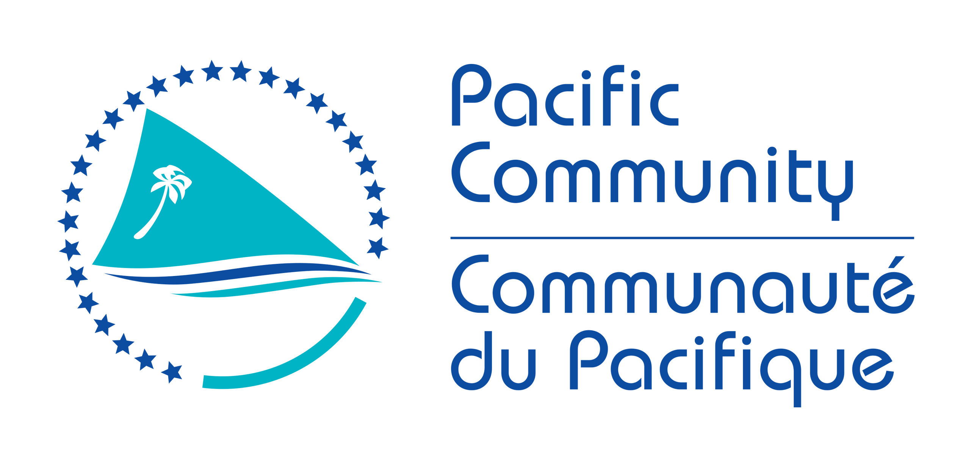

POSITION DESCRIPTION

Job Title: | Energy Investment Specialist, FSM Sustainable Energy Project (FSM.SE)
Work Unit: | Geoscience Energy and Maritime Division / Georesources Energy Programme Micronesia Regional Office (MRO)
Responsible to: | Project Manager, FSM.SE Project
Number of direct reports: | Up to 4 direct reports
Job Purpose: |  | The Energy Investment Specialist will contribute to the delivery of activities specified under outputs 1, 2 and 3 of the FSM.SE project. Overall, the Energy Investment specialist will manage State-level Investment Plan Officers and consultants to:  - Develop and implement four State level and one National level Energy Investment Plans  - Review and analyse best practices, smart incentives and other enabling environment issues related to power sector policy, laws and regulations that will encourages private sector involvement in FSMs power sector as well impact the scaling up of RE and EE investment  - Facilitate mobilisation of private and local investors and funds to contribute to the implementation of the Investments plans and increase private sector investments in RE and EE  The Energy Investment Specialist will work closely with the Project Management Team (PMT), SPC technical division staff, regional, national and local development partners and FSM national, state, and municipal counterparts. A significant amount of the work is focused on all FSM States and working closely with the four States and engaging entities including the State Energy Working Groups, the State Governors, the State Utilities and the National Government Department of Resources and Development. Strategic networking, technical capacity and relationship development are critical to this role. This position is based in Pohnpei, FSM.
Date: | November 2021

VISION

“All CROP (Council of Regional Organisations in the Pacific) agencies of which SPC is included contribute to achieving the vision embodied in the Framework for Pacific Regionalism of a region of peace, stability, economic growth, good governance and sustainable development. SPC is committed to these values and to working in partnership with national, regional and international organisations and development partners to serve its members.”
SPC’s mission is to work for the well-being of Pacific people through the effective and innovative application of science and knowledge, guided by a deep understanding of Pacific Island contexts and cultures.

BACKGROUND

GEOSCIENCE, ENERGY AND MARITME DIVISION
The Geoscience, Energy and Maritime (GEM) Division encompasses the following areas of Scientific Excellence: Georesources and Energy, Disaster and Community Resilience, and Oceans and Maritime, and is based in Suva, Fiji. The Georesources and Energy Programme will collaborate with and provide support to the Micronesian Regional Office in the implementation of project activities. The details of this collaboration will be captured in an internal GEM-MRO project management agreement.

MICRONESIA REGIONAL OFFICE
The Micronesia Regional Office provides an important presence for SPC in the North Pacific to build SPC’s understanding of the Micronesian members’ priorities, values, cultures and context and to ensure meaningful engagement and impact in the delivery of PSC projects and programmes. The office currently has responsibility for engagement with the Commonwealth of the Northern Mariana Islands, the Federated States of Micronesia, Guam, Marshall Islands and Palau. The team situated in the FSM includes the Regional Director, an administrative team, and technical staff representing several divisions of the organization. The MRO is located in Pohnpei, FSM.

Organisation Context

The overall objective of the EU EDF 11 FSM Sustainable Energy and Accompanying Measures (SEAM) financing agreement is to improve and enable the Federated States of Micronesia (FSM) population to utilize affordable, reliable, and environmentally sound energy services and benefit from transparent and efficient management of public funds. SPC, through a direct Contribution Agreement with the EU under the broader EU-FSM SEAM Financing Agreement is implementing the FSM.SE Project.

The specific objective of FSM.SE is to increase access to renewable electricity and support private sector investment in energy efficiency and renewable energy.

The four key outputs for the FSM.SE project are as follows.

- Policy, institutional and legislative structures are reviewed;
- Capacity building in energy planning and management, and monitoring and evaluation;
- Independent Power Producers (IPPs) and jointly funded grid-connected renewable energy and energy efficiency projects; and
- Renewable energy systems and technologies are promoted especially in remote communities and among youth and women.

The project will be delivered by a team of specialists from SPC, in collaboration with FSM National and State government partners, regional and local partners.
EU FSM.SE Project Team Structure
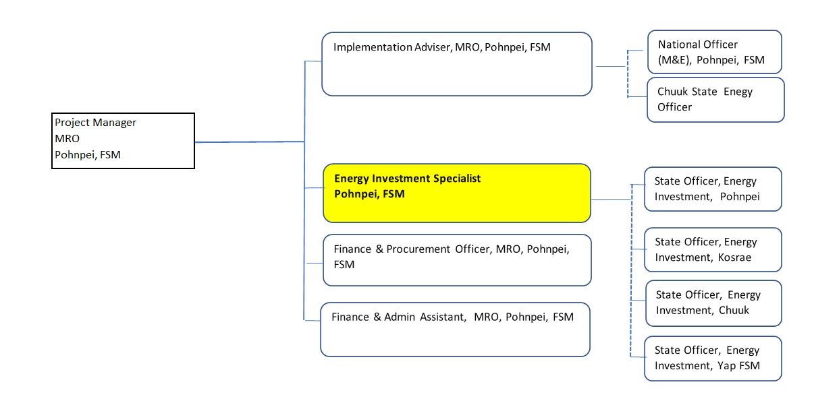
Key Result Areas

The position of Energy Investment Specialist for the FSM.SE Project encompasses the following major functions or Key Result Areas (KRAs):
- Lead the development of four State level Energy Investment Plans and one National level Energy Investment Plan for the FSM Government
- Lead efforts and strengthen partnerships in developing the necessary enabling environment and mechanisms that encourage private sector involvement in FSMs Electricity sector
- Promote and support the investment plans to leverage at least four bankable projects in RE and EE Investments
The requirements in the above Key Result Areas are broadly identified below.

Jobholder is accountable for | Jobholder is successful when
KRA 1: Lead the development of four States Energy Investment Plans and one National Energy Investment Plan for the FSM Government 25 %
Concrete projects that will be carried out in the next 5 years, detailing site locations and pre-feasibility analysis identified
- Conduct a stocktake of potential RE and EE Investment projects for the FSM States including gathering lessons learnt and sharing of past experiences that would inform the development and implementation of four States and one National Energy Investment Plans  - Facilitate consultations with National and State Governments to use national strategies and plans to identify prioritised and bankable investment activities to be delivered  - Coordinate the procurement and management of relevant consultancies and partnership agreements towards supporting feasibility studies, consultations and development of the four State Utility investment plans and one National Energy Investment plan  - Recruit and supervise up to four State Investments Officers  - Facilitate capacity buildings and trainings and sustainability options in the preparations and implementations of the investment plans after the project ends  - Facilitate the collection and sharing of information and facts on the proposed public and private investments in RE and EE including local and overseas investors | - Stocktake and baseline data on RE & EE investments available, lessons learnt are captured and used to inform the development of the National and State Investment Plans  - Prefeasibility studies of identified actions for the investment plans supported  - Partnership Agreements developed, agreed and signed  - Terms of References, Request for Proposals developed, and Services Contract signed for relevant consultancies and effectively managed to completion  - State and national level workshops supported  - 4 State level investment plans developed  - 1 national level investment plan developed  - 4 State level investment officers recruited  - Supervise the recruitment of 4 State Investment Officers each for the 4 States – Pohnpei, Kosrae, Chuuk and Yap, provide support and capacity development to efficiency and effectively complete the development and adoption of the State Investment Plans  - National and State level capacities in the implementation of the energy investments are enabled, enhanced and strengthened through prioritised trainings, consultative processed with at least two capacity development workshops on IPP and PPA conducted  - At least four (4) fact sheets on energy investments are developed, printed and disseminated, 2 policy papers and/or power points developed and presented on linkages of 5 Investment Plans to FSM Strategic development, NDC targets and SDG goals are readily available
KRA 2: Lead efforts and strengthen partnerships in developing the necessary enabling environment and mechanisms that encourage private sector involvement in FSMs Electricity sector 35 %
Institutional, policies and legislative reforms at the National and State level revised with supportive Prefeasibility studies, endorsed regulatory frameworks, programmes and supporting processes in place to encourage private sector investors.
Coordinate the procurement and management of relevant consultancies and partnership agreements towards  - Where appropriate undertake studies or conduct research on economic, gender, social and technical impacts on utilities and consumers along tariff design; quantifying economic impacts; codes, standards and interconnection processes; utility cost recovery, modelling and mitigating impacts on the electric distribution system followed by workshops that could inform smart incentives as well as energy pricing policies;  - Research and propose solutions to better align utility interests with increased grid-connected RE through supporting regulatory framework; Share lessons learned in such a manner that all state utilities are supported accordingly  - Establish scalable RE FIT programmes, competitive procurement or other policy incentive options to promote investment in grid-connected RE  - Establish flexible regulatory framework or guidelines for private sector participation in the power sector, including the role of the private vs. public sectors, and increasing access of private power producers to the grid looking at - commercial structure, assets to be supplied, associated risks (pricing, liquidity, volume, profile, credit and balancing), contract duration, price fixing, settlement, changes in laws and regulations, performance guarantees and contract termination among other factors | - Number of studies identified and or undertaken to better inform state and national governments of smart fiscal and financial incentive opportunities to promote RE and EE investments  - Regulatory frameworks established in support of private sector participation such as development of guidelines for IPPs, PPAs, net-metering and private-public partnerships  - Capacity development and workshops on PPAs development and guidelines conducted for all State utilitiesEnergy pricing policy and incentives developed and endorsed to improve affordability of electricity and promote investments in tourism, fisheries and micro enterprises  - Flexible frameworks and incentives are assessed to promote and support micro enterprises and women and youth employment  - Building networks and collaborating across the energy sector to build skills, encourage dialogue and help meet emerging challenges including setting up RE and EE standards and other new feasible technologies
KRA 3: Promote and support the investment plans to leverage at least four bankable projects in RE and EE Investments 40 %
Detailed studies, IPPs and jointly funded grid-connected renewable energy and energy efficiency projects secured
- Promote the investment plans to potential Investors and donors beginning with hosting a national energy forum to launch the Investment plans.  - Coordinate and Strengthen partnerships with all major development partners including private investors in the FSM at National and States levels.  - Identify 4 bankable RE and EE activity from the investment plan are gender inclusive and lead the preparatory work towards conducting detailed technical and financial feasibility studies to promote the projects for funding either through grants support and or private investment targeting 2 IPP projects and 2 co-financed renewable energy (RE) and energy efficiency (EE) projectsCompile a lessons learnt report on the experience of setting up the target 2 IPPS in terms of asset procurement, construction and connection of the assets to the utility grid within compliance to the agreed deliverables. | - National Energy Forum hosted with the Energy investment plans launched and promoted.  - Detailed work plans and financial aspects on the proposed five investment plans are presented to the PMT, funding partners and financial institutions  - Partnerships developed with relevant States and National Stakeholders to implement key aspects of the proposed investment plans in a mutually beneficial manner and priority actions are identified in a participatory and consultative manner with considering lessons learnt and experiences from past projects  - At least 4 feasibility studies conducted leading to securing and supporting  - At least 2 newly funded RE and EE projects;  - At least two independent power producers are identified and co-operate actively with FSM central and State government and utilities and effectively signed contracts; and  - At least 3 MW of renewable energy is installed through the Bankable projects endorsed through the detailed feasibility studies.  TORs developed to conducting detailed technical and financial feasibility studies also address gender equality issues  - Monitoring and oversight of the 2 IPPS undertaken with lessons report compiled

Note: The above performance standards are provided as a guide only. The precise performance measures for this position will need further discussion between the jobholder and supervisor as part of the performance development process.

Work Complexity

Most challenging duties typically undertaken:
- Working across multiple agencies and geographically remote States, municipalities and islands in ensuring delivery of result areas of the EU-FSM SEAM project
- Working across diverse technical and operational and financial networks in the energy sector
- Delivering project activities in different working environments, cultures and communities,
- Balancing work required from country counterparts with the needs of projects
- Managing and delivering expectations of national, state and municipal counterparts, partners and implementing agencies requirements
- Coordinating and facilitating information exchange, networking and partnership building management of consultants, investors and both large and small work contracts
- Ensuring the sustainability of actions undertaken in the country, states and municipalities with careful consideration of the unique cultural contexts for the individual states and outlying islands

Functional Relationships & Relationship Skills

Key internal and/or external contacts | Nature of the contact most typical
External
- EU Brussels and EU Delegation in Suva, Fiji  - National Minister/Secretary of Resources and Development, Assistant Secretary for Energy  - National, state and municipal government agencies, including state utilities  - Representatives of donor partners and funding agencies  - Representatives of financial institutions locally and overseas  - Recipient communities in the FSM states  - Directors of energy programmes in other regional and international agencies  - Private sector and industry association contacts  - Media (national and regional)  - Consultants and firms  - Energy efficiency and renewable energy networks  - Energy Regulators networks at international and regional | - Consultation, reporting and negotiation  - Direct national, state and municipal liaison  - Service provision and support  - Public relations  - Strategic collaboration (research and extension activities)  - Technical Advisory and Services
Internal
- SPC Senior Management  - MRO Director, GEM Director, GEP Deputy Director and Senior Management Team  - SPC operations and management teams  - Project staff  - MRO team staff  - Professional staff in GEM, SDP, MRO, SPL and other divisions | - Reporting, liaising, facilitating, and coordination of project support and activities  - Advice on any sensitive or problematic issues  - Recruitment and staff issues; budgeting, procurement and financial reporting

Level of Delegation

The position holder:
- Routine Expenditure Budget: 0 EUR
- Budget Sign off Authority without requiring approval from direct supervisor: EUR 50

Person Specification

Qualifications
Essential: | Desirable:
- Postgraduate degree (in Economics, Energy Planning, investment, Law, financial management or other fields relevant to this position. | - Ability to work collaboratively with many agencies and partners and to foster spirit of dialogue, sharing and compromising

Knowledge / Experience
Essential: | Desirable:
- At least 9-10 years in a similar project in particular in energy policy and regulation.  - Experience developing energy investment plans and resource mobilisation work  - Thorough understanding of energy investments opportunities and project cycles, log-frames, monitoring and evaluation, and risk management  - Demonstrated experience managing a high volume and high dollar value procurement  - Managing logistics in challenging and remote locations  - Demonstrated abilities in remote staff management and their performance evaluation  - Excellent interpersonal skills in a multicultural environment such as the Pacific Islands region  - Excellent English communication skills (oral and written)  - Excellent computer skills across necessary applications | - Effective communicator and skilled in liaison and negotiation with energy stakeholders in FSM States  - Experience working in the Federated States of Micronesia or the North Pacific islands  - Experience in managing development assistance issues, in a small island context, would be an advantage  - Experience in managing EU-funded projects  - Fluency in English

Key Skills /Attributes / Job Specific Competencies
The following levels would typically be expected for the 100% fully effective level:

Expert level | - Sound analytical, technical, organizational, and project management skills  - Excellent liaison skills especially with Pacific Islanders  - Knowledge of corporate affairs and budgetary processes  - Advocacy with demonstrated initiative and ability to think laterally to identify innovative solutions
Advanced level | - Ability to lead a team, comprising professionals and administrative staff, as well as ability to work independently or as part of a team  - Capacity building and mentoring  - Skills in prioritisation, decision making, problem solving and management of risks  - Understanding of energy efficiency and renewable energy in the Pacific Islands region  - Excellent command of both written and spoken English required  - Communication and responsiveness to needs of stakeholders
Working Knowledge | - Computer literacy, particularly with Microsoft Office and related project management software  - Energy and climate change related international, regional and national conventions /legislation /regulations /policies
Awareness | - Familiarity with donor reporting requirements  - Financial management and procurement procedures

Key Behaviours
All employees are measured against the following Key Behaviours as part of their Performance Development:

- Change and Innovation
- Interpersonal Skills
- Teamwork
- Promotion of Equity and Equality
- Judgement
- Building Individual Capacity

Personal Attributes
- Self-motivated
- Demonstrates cultural and gender sensitivity
- Ability to think and act on initiative
- Strong client orientation and continuous improvement mindset
- Highly motivated and strong affinity to teamwork
- Analytical and smart thinking – solutions oriented
- High work standards, good work ethic and positive attitude to work
- Proactive with creative ability to meet deadlines, achieve objectives and master new material quickly
- Performs well under pressure and strongly committed to work
- Positive attitude, excellent interpersonal skills, well organized, dependable and honest
Change to Job Description:

From time to time it may be necessary to consider changes in the job description in response to the changing nature of our work environment – including technological requirements or statutory changes. Such change may be initiated as necessary by SPC. This Job Description may be reviewed as part of the preparation for performance planning for the annual performance cycle.

