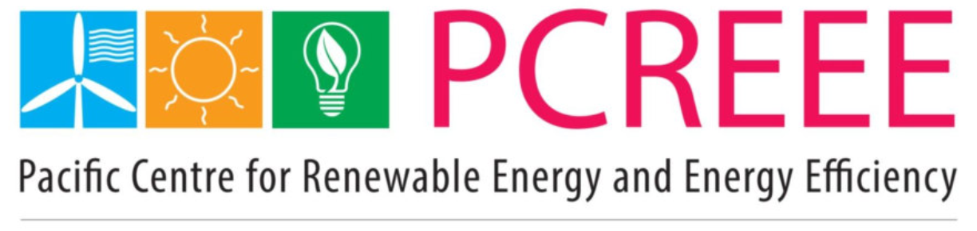
Business Plan
 | 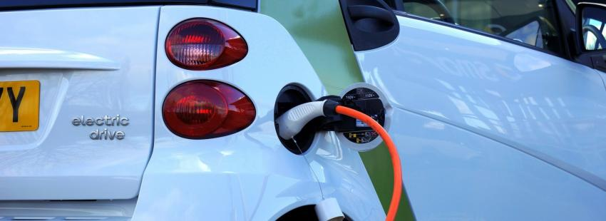
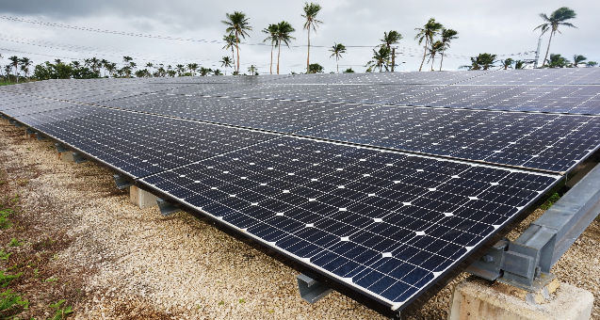 | 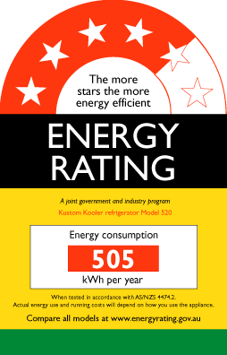
Pacific Centre for Renewable Energy and Energy Efficiency

2020–2030

Draft October 31st , 2020

Table of Contents

List of Tables 4
Table of Figures 5
Acronyms 6
1. Executive Summary 8
2. Introduction 9
2.1 Vision, Mission, and Objectives for PCREEE 9
2.2 Mandate 9
2.3 Value Proposition 10
2.4 PCREEE´s Operational Achievements (2018 – 2019) 10
3. Strategic Positioning and Technical Mandate 11
3.1 Strategic Position 11
3.2. Technical Mandate 12
4. Strategic Programmes 12
4.1 Selected Programmes 13
4.2 Cross Cutting Areas 14
4.3. GEM Business Plan 15
4.4 Description of Selected Programmes 16
4.4.1 Local RE&EE Business Start-Up and Entrepreneurship Support 16
4.4.2 RE and EE for Sustainable Mobility 17
4.4.3 RE Mini-Grids 19
4.4.4 Energy Efficiency Investment 20
5. Organizational Capability and Implementation 22
5.1 Staffing Strategy 22
5.2 Organizational Chart 24
5.3 Internal Procedures 26
6. Sustainable Business Model 27
6.1 Financial and Economic Viability 2020 & 2030 27
6.1.1 Core Costs (overhead) 27
6.1.2 Operational Costs 28
6.2 Fund Mobilisation Strategy 29
6.3 Gender Mainstreaming strategy 33
6.4 Environmental and Social Governance 34
6.5 Market Potential of Proposed Activities and Income Generation Capacity. 34
7. Strengthening Cooperation 35
8. Monitoring and Evaluation 36
8.1 Quality and Appraisal Framework for the Technical Operations 36
8.2 Logical Framework Matrix/Results Framework 37

List of Tables
Table 1: Four (4) Prioritized Strategic Programmes and Cross-Cutting Areas. 14
Table 2. GEP results framework 15
Table 3: Relationship between the four (4) proposed PCREEE´s areas and the GEP 16
Table 4: Revenue Generation 32
Table 5: Thematic Hubs and main cooperation area 35
Table 6: PCREEE Results Framework 38

Table of Figures
Figure 1: FTEs per Year and Strategic Programme 23
Figure 2: FTEs per Year, Technical vs. Admin and Senior vs. Junior Staff 24
Figure 3: PCREEE Organizational Chart in 2030 (Grey: Managers; Green: Senior Staff, Blue: Junior Staff) 25
Figure 4: PCREEE Operational Budget 27
Figure 5: PCREEE Programmatic Budget 29
Figure 6. PCREEE Programmatic and Operational Budget 30
Figure 7: Share of Funding Sources 31
Figure 8: Funding by Source per Year 31
Figure 9: PEGSAP’s Proposed Areas of Intervention 33

Acronyms
ADA Austrian Development Agency
ADB Asian Development Bank
ASHRAE American Society of Heating, Refrigerating and Air-Conditioning Engineers
BP Business Plan 2020- 2030
CROP Council of Regional Organizations in the Pacific
CSR Corporate Social Responsibility
DSM Demand Side Management
ECREEE ECOWAS Centre for Renewable Energy and Energy Efficiency
EE Energy Efficiency
EGSS Environmental, Gender and Social Safeguards
EV Electric Vehicles
FAESP Framework for Action on Energy Security in the Pacific
FTEs Full Term Employees
GEM Geoscience Energy and Maritime Division
GEP Geo-resources and Energy Programme
GHG Greenhouse Gas
GN-SEC Global Network of Regional Sustainable Energy Centres
ISO International Organisation for Standardisation
IUCN Union for Conservation of the Nature
M&E Monitoring and Evaluation
MOU Memorandum of Understanding
NDC Nationally Determined Contributions
NFI National Focal Institution
NGOs Non-Governmental Organisations
O&M Operation and Maintenance
PALS Pacific Appliance Labelling and Standards Programme
PCREEE Pacific Centre for Renewable Energy and Energy Efficiency
PEGSAP Pacific Energy and Gender Strategic Action Plan
PESTLE Political, Economic, Social, Technological, Environmental and Legal Analysis
PNG Papua New Guinea
PPA Pacific Power Association
PSEEF PCREEE Sustainable Energy Entrepreneurship Facility
PICTs Pacific Island Countries and Territories
P&R Policy and Regulatory
RE Renewable Energy
REMPP Renewable Energy Mini-grid Programme for the Pacific Island Countries and Territories
SDGs Sustainable Energy Goals of the United Nations
SECT Sustainable Energy and Climate Technologies
SEIAPI Sustainable Energy Industry Association of the Pacific Islands
SIDS Small Island Developing States
SMEs Small and Medium Enterprises
SPC Pacific Community
SPREP Secretariat of the Pacific Regional Environment Program
SWOT Strengths, Weaknesses, Opportunities, and Threats Analysis
TA Technical Assistance
TAC Technical Advisory Committee
UNESCAP United Nations Economic and Social Commission for Asia and the Pacific
UNIDO United Nations Industrial Development Organization

Executive Summary
The Pacific Centre for Renewable Energy and Energy Efficiency (PCREEE) has been established to play a key role in promoting and supporting private sector investments in renewable energies (RE) and energy efficiency (EE) in the Pacific region. PCREEE is hosted by the Pacific Community (SPC) under the Geoscience Energy and Maritime (GEM) Division. The Centre receives key technical support from the United Nations Industrial Development Organisation (UNIDO) and financial assistance from the Austrian Development Agency (ADA) and the Norwegian government. PCREEE is a member of the Global Network of Regional Sustainable Energy Centres (GN-SEC) and focuses on the up-scaling and replication of national efforts, support to the private sector and industry and targeted RE&EE Programmes .
The current document presents PCREEE´s Business Plan for the coming 10 years (2020-2030). Moreover, and following an extensive and consultative process, the document presents the main four (4) Programmes that will be the focus of PCREEE´s actions in the region, including:
- RE&EE Business Start-Up and Entrepreneurship Support, including differentiated support to entrepreneurial RE&EE businesses across the enterprise development life cycle (start-up, early-stage, growth, and maturity).
- A regional E-vehicles (EV) Readiness Program aiming to prepare the Pacific Island Countries and Territories (PICTs) for the eventual uptake of EV technology by developing a stable base of capability and capacity in the region.
- A RE Mini-grid Programme for the PICTs (REMPP) designed for PCREEE to overcome identified gaps in the market to promote mini-grid renewable energy development. The program includes measures to address market intelligence, capacity building, and Public and Private Partnerships and guidelines and an Operation and Maintenance (O&M) Platform
- Energy efficiency investments aimed at enhancing the competitiveness of manufacturing industries in the Pacific Region by improving and harmonizing national policies and regulatory frameworks and institutional capacity building for domestic, industrial, and commercial EE and the implementation of energy management systems.
A detailed analysis of the required operational and programmatic resources required to achieve PCREEE´s mandate is presented. An ambitious resource mobilisation strategy for the four strategic Programmes has been designed and presented. Continued engagement with key partners (ADA, UNIDO and Norway) as well as new alliances and partnerships will be critical to advance PCREEE’s positioning and regional added-value.
A results and monitoring framework is presented, which allows monitoring and evaluation. The framework provides an overview of the major Programmes , outputs and performance indicators. p These are considered a solid framework upon which the PCREEE team can formulate its annual work programme and budget together with the detailed activities.

Introduction

2.1 Vision, Mission, and Objectives for PCREEE
Vision: “Promoting sustainable energy markets to transform the lives of Pacific Islands people”.
Mission: To create, educate, and facilitate the increased awareness and development of the RE&EE Agenda in the Pacific region, with special emphasis on the private sector and local industries.
Objectives:
- To improve access to modern, affordable and reliable energy services, energy security and mitigation of negative externalities of the energy system (e.g. local pollution and GHG emissions)
- To promote renewable energy and energy efficiency investments, markets, and industries in the PICTs.
PCREEE is part of the Global Network of Regional Sustainable Energy Centres (GN-SEC), a global initiative led by UNIDO encompassing 10 regional centres to date.

2.2 Mandate
The 2nd Pacific Energy and Transport Ministers Meeting in 2014 mandated the establishment of the Pacific Centre for Renewable Energy and Energy Efficiency (PCREEE) to support private sector investments in renewable energy and energy efficiency.
The PCREEE is hosted by the Pacific Community (SPC) under the Geoscience Energy and Maritime (GEM) Division. The GEM supports PICTs by developing critical data, applied science, and technical solutions to overcome some of the greatest challenges faced by members. GEM is made up of 4 Programmes – Disaster and Community Resilience, Ocean and Maritime, Earth and Marine Observation as well as the Georesources and Energy Programme (GEP). Providing energy security and supporting more informed decision making on the use of the region's geophysical resources is at the core of GEP’s work. PCREEE operates under the GEP and addresses existing barriers and strengthen drivers for sustainable renewable energy and energy efficiency (RE&EE) markets, industries and innovation through regional methodologies and tools and complements GEP´s other programmes: i) Policy and Governance; ii) Technical Assistance and; iii) Capacity, Data, and Strategy.
PCREEE positions itself as a “one-stop-shop” delivering sustainable and reliable energy solutions appropriate to the 22 PICT members of the SPC. PCREEE´s focus includes the up-scaling and replication of national efforts, has a strong private sector and industry focus and supports targeted RE&EE Programmes to enhance the productivity of key industries with high job leverage (e.g. agriculture, tourism, fishery, manufacturing, creative industry) and the creation of a local sustainable energy servicing and manufacturing industry.

2.3 Value Proposition
PCREEE´s principles include maximizing impact, avoiding duplication, and strengthening and up-scaling of already existing local private sector capacities.
PCREEE positions itself as regional RE&EE promotion and facilitating agency rather than just an implementer, hence catalysing the establishment, and fostering the future expansion, of the RE&EE market in the region. PCREEE aims to maximize local added value through coordination with national/regional institutions and/or existing private sector and industrial bodies (e.g. north-south and south-south technology and know-how transfer to the Pacific region). PCREEE’s membership under the GN-SEC allows the Centre access to further Small Islands Developing States (SIDS)-SIDS cooperation with other Centres in the GN-SEC.

2.4 PCREEE´s Operational Phase 1 Achievements (2017 – 2019)
Over the past 3 years, PCREEE´s operational work has rapidly evolved according to the PCREEE Project Document of 2016 and subsequently updated in 2018. Numerous achievements are listed in its annual progress reports and presented to its Steering Committee Meetings, according to its four key Outcomes as follows:
Outcome 1: Enhanced regional institutional capacities
- Increased SPC staff working fulltime on the PCREEE from one to four.
- Significantly increased the Centre´s recognition and awareness-raising in the region.
- Secured an office space that would cater for the future growth of up to 20 staff.
- Eight Memorandums of Understanding (MoUs) have been signed with other national/ regional institutions, providing a solid platform for an increased level of partnerships and collaboration across the region.
- Confirmed seed funding support for its Second Operational Phase (2021 – 2025).
- Integrated PCREEE’s operations with the established financial and management policies and procedures of the SPC.
Outcome 2: Strengthen capacities of local key institutions and stakeholder groups
- Provided training to more than three hundred trainees throughout the region.
- Supported building the capacity of Energy Regulators to manage Power Purchase Agreements and the reset of power tariffs given their impacts on the private sector investments.
- Strengthened local RE&EE capacities of business and industry sector by the establishment of national sustainable energy industry associations to introduce professionalism and discipline in the industry.
Outcome 3: Awareness and knowledge base of local key institutions and stakeholder groups
- Conducted National Energy Dialogues and capacity building and support workshops to openly discuss the achievements of countries in their RE&EE developments, the challenges, and how they can collectively be addressed as well as raising the business, investment, and employment opportunities from pursuing the national energy targets in the region.
- Supported the further detailing and costing of the PITCs’ Nationally Determined Contributions (NDCs), Energy Roadmaps, Energy Master Plans as well as Investment Plans.
Outcome 4: Increased RE&EE business opportunities for local companies and industry
- Launched the PCREEE Sustainable Energy Entrepreneurship Facility (PSEEF), a dedicated regional financing vehicle with a special focus on support to increase RE&EE business opportunities for local Small and Medium Enterprises (SME) companies, Non-Governmental Organisations (NGOs) and industry.
- Supported postgraduate researchers on sustainable energy through its research support fund and competition on sustainable energy innovation.
- Strengthened the capacity of developing and financial institutions in the Pacific.
- With the support of the United Nations Industrial Development Organization (UNIDO), PCREEE is currently developing an innovative regional programme to facilitate the uptake of e-mobility markets within PICTs´ RE expansion plans.

Strategic Positioning and Technical Mandate

Strategic Position
A Political, Economic, Social, Technological, Environmental and Legal (PESTLE) Analysis was carried out to chart the risks, challenges, gaps, and niches for PCREEE in the sector in the Pacific Region. Additionally, Strengths, Weaknesses, Opportunities, and Threats (SWOT) Analysis was undertaken to understand PCREEE´s strengths, weaknesses, opportunities, and threats.
As a result of this analyses, some relevant strategic aspects for PCREEE in the energy sector in the Pacific Island region have been identified:
- Many active regional organisations and establishments with a consequent big demand for effective coordination and collaboration.
- Existing and new regional institutions in the area may provide similar or overlapping services and capabilities to those of the Centre. Hence, finding the right added value for PCREEE´s programmes will be key.
- The Centre needs to increase the financial and technical support from core partners and incorporate new (core) donors to generate impact.
- Co-hosted by the (SPC) and sitting in GEP, PCREEE enjoys strong institutional support and direct access to a pool of seconded available expert staff and a wider team within the SPC.
- The Centre is well connected at international levels and with other regional Centres, including existing core partners (Austrian Development Agency (ADA), UNIDO, and the Norwegian Cooperation), the GN-SEC centres and with potential to initiate connections to new development partners.
- PCREEE enjoys a high level of openness from the PICs to support and contribute to the Centre and a growing appreciation of the regional approach.
- While most of the PICTs enjoy universal access to electricity, only about 35% of the population in the Pacific Community enjoy access to electricity (2.7 million are still without it, with the bulk of it in Papua New Guinea - PNG).
- Biomass use is a concern, with a high amount of traditional biomass consumption for cooking and very low development of waste-to-energy technologies or services.
- Most of the PICTs are currently reviewing their NDCs as well as their energy roadmaps to ensure there is consistency and that the ambitious targets are still realistic.

Technical Mandate
PESTLE and SWOT analysis also provide relevant aspects for PCREEE´s technical mandate:
- The Centre needs to focus on a well-defined portfolio aligned with the Centre´s added value and technical mandate.
- PCREEE´s regional approach is relevant, although some Member States may prefer dealing with RE&EE policies, regulation, and capacity building on a national level rather than on a regional one.
- Generally, infant RE&EE national policy and enabling financing environments as well as low density and small energy markets are hindering the role and presence of international private sector investors and developers.
- The Centre´s regional approach and its mandate to support the private sector is well aligned with the current RE&EE regional market context.
- PCREEE will have to successfully engage with the PICTs and understand the differences between them. PICTs with more advanced policy and regulatory frameworks, supported by dedicated local budget allocation and staff numbers, tend to have bigger penetration of RE and more active involvement of the private sector.
- A few innovative areas of great interest for the region are starting to emerge, some of which could be led by the Centre, including grid-integrated RE systems with battery storage, smart mobility and local carbon transportation, the development of sustainable small off-grid solutions and the increasing attention on non-electricity uses of renewable energy, as in cooking, heating, and cooling.

4. Strategic Programmes
Following a comprehensive process under which PCREEE´s outcomes and outputs (as per PCREEE´s Project Document) and Initiatives (as per the Framework For Action on Energy Security in the Pacific (FAESP)) were analysed against the Centre´s mandate and previously undertaken internal and external environment analyses (National Focal Institutions (NFIs) survey, PESTLE & SWOT analyses), the following 4 strategic programmes with the highest impacts have been identified. Selected programmes represent an update from the outcomes identified under PCREEE´s Project Document for the previous Operational Phase (2016 - 2020).

4.1 Selected Programmes
Based on the analysis undertaken and described in Section 3, four (4) proposed PCREEE´s programmes have been selected:
Programme 1. RE&EE Business Start-Up and Entrepreneurship Support
In a context of need by the private sector to get additional support, Strategic Program 1 was felt by NFIs as extremely relevant to help to move the current RE&EE regional and national enabling environments and RE&EE markets. This will no doubt build up initial market momentum, followed by a gradual ramping up of efforts in areas such as facilitating early-stage and seed RE&EE financing, investment, and project preparation for (domestic) RE&EE start-ups and entrepreneurs.
Programme 2. RE and EE for Sustainable Mobility
Sustainable mobility offers an alternative to reduce fossil fuel dependency, increase energy security, mitigate climate change effects, and underpin the Pacific Islands’ domestic economies without further harming the environment. The readiness programme aims to cover land transport only while tackling the issue of electric vehicles and other innovative solutions.
Programme 3. RE mini-grids
Many PICTs have been successful in securing grant and concessionary funding for big size grid-connected RE projects. During recent years, many remote and rural areas beyond existing national grids (e.g. outer islands), have had stand-alone PV systems installed. Some of these are now being upgraded to RE mini-grids through donor funding. A PICTs RE mini-grid market and industry report was elaborated through Korean financing and highlighted the needs for support through a renewable energy mini-grid program.
Programme 4. Energy Efficiency Investment
Although regarded as a crucial area, EE remains barely developed in the region and is only briefly mentioned in development plans or in the NDCs themselves. EE has been identified as a niche area of opportunity for PCREEE to further enhance regional and national policies, support in the area of capacity building and increase the needed awareness to boost this sector across the lighting, appliances (solar heating) and building sectors (including industrial and touristic premises). The Pacific Appliance Labelling and Standards Programme (PALS), ran from 2012-2019 but has come to an end and is one of the few regional programmes on EE. This programme will mostly aim to mobilise additional investment for public institutions and private sector organisations in the market of domestic, industrial, and commercial EE.

4.2 Cross Cutting Areas
The proposed 4 programmes suggested in the Business Plan are well aligned with the needs from PICTs and complementary to what other programmes of the GEP and the Council of Regional Organisations of the Pacific (CROP) agencies are doing.
Moreover, the Pacific region finds itself transitioning from an infant RE&EE policy and financing enabling environment, infant policy and regulatory frameworks, and existing but yet weak capacities towards a growing interest and level of investment into RE&EE Programmes and activities. For this, the four (4) prioritized Strategic Programmes will address the following proposed cross-cutting areas (1. policy support; 2. capacity building; 3. knowledge sharing; 4. project development and financing and 5. innovation and entrepreneurship), in a complementary manner to the work of the other programmes at GEP thereby enabling PICTs to advance to market maturity, provide support to target local companies and scale up RE&EE solutions in the region. Environmental, Gender mainstreaming and Social Safeguard (EGSS) is an integral part of the sustainable business model of PCREEE and will contribute to the gender-based activities of the GEP and SPC as an organisation .
Additionally, relevant stakeholders, including core partners, have highlighted their interest in achieving concrete initial results that foster the necessary regional scaling up of RE development while increasing efforts to progress in the EE sector, through creating the right enabling environment and capacities at public national level and facilitating the mobilization of important financial resources at the regional level. For this, PCREEE will play an important role initially in building capacity and awareness across the private sector and industrial bodies, mobilizing resources regionally, facilitating knowledge sharing opportunities, providing TA for project preparation while increasingly connecting projects with financing facilities at a later stage, hence facilitating the channels for disbursement of financial resources of major stakeholders into the infant local private sector. Table 1: Four (4) Prioritized Strategic Programmes and Cross-Cutting Areas. shows the four (4) prioritized Strategic Programmes and their interaction with the cross-cutting areas.

Table 1: Four (4) Prioritized Strategic Programmes and Cross-Cutting Areas.
Prioritized Programmes | Cross-cutting areas
 | Policy Support | Knowledge Management | Capacity Building | Project development & financing | Innovation and entrepreneurship
- Local RE&EE Business Start-Up and Entrepreneurship Support | yes |  | yes | yes | yes
- RE and EE for Sustainable Mobility | Yes | yes | yes | Yes | yes
- RE mini-grids | Yes |  | Yes | Yes | Yes
- Energy Efficiency Investment | Yes | Yes | Yes | Yes | Yes
PCREEE will call on the other and complimentary GEP Sectors (“Policy and Governance”, “Technical Assessment” and “Capacity, Data, and Strategy”) in addressing the cross-cutting areas. For instance, EGSS will be addressed through the Policy and Governance programme while knowledge management can be carried out through the Capacity, Data, and Strategy Programme.
Being able to assess strengths across PICTs and mobilizing their capacities and skills with the vision of not leaving anybody behind and instead fully exploiting the added value of a regional intervention is a clear added value for the Centre.

GEM Business Plan
In May 2020, SPC’s Geoscience, Energy and Maritime (GEM) Division had elaborated a Business Plan for its 4 Programmes – Disaster and Community Resilience, Ocean and Maritime, Earth and Marine Observation as well as the Georesources and Energy Programme (GEP). Enhanced private sector participation in Renewable Energy and Energy Efficiency is one of the Divisioanl Business Plan objectives.

PCREEE operates under the GEP and addresses sustainable RE&EE issues. GEP has four divisional business plan objectives as shown in the table below:
Table 2. GEP results framework
Divisional business plan objective | Divisional Key Results
1. Good Governance for PICT Georesources and Energy | Result 1.1: PICTs adopt and use relevant international and regional frameworks for georesources and energy
 | Result 1.2: PICTs develop, adopt and implement national policies and laws for responsible georesources management and sustainable energy
2: Quality Technical Assessments in Georesources and Energy | Result 2.1: Infrastructure planning and development in PICTs is supported by advance technical surveys
 | Result 2.2: PICTs supported with technical assistance for improved minerals management and energy efficiency and strengthened sustainable and renewable energy industry
3. Capacity Development in Geo-resources Management and Energy Security | Result 3.1: skills, knowledge and practice is improved for PIcT personnel responsible for geo-resources and energy
 | Result 3.2: Women and youth have increased awareness and participation in the geo-resources and energy sectors
 | Result 3.3: PICTs capacity, systems and tools for data collection and analysis, dissemination in geo-resources and energy is improved and supported by functional secure regional and national data repositories
4. Enhanced private sector participation in Renewable Energy and Energy Efficiency | Result 4.1 enhanced productivity and competitiveness for island industries with high value and job creation potential through sustainable energy solutions and technologies supports
 | Result 4.2 Increased combined energy approaches of sustainable energy interventions and other aspects of circular economy
 | Result 4.3 enhanced sustainable energy entrepreneurship, industrial development and innovation
A comparison with the GEM business plan shows how each of the proposed PCREEE areas relate to the GEP divisional objectives and results:
Table 3: Relationship between the four (4) proposed PCREEE´s areas and the GEP
Proposed four (4) PCREE programmes | Consistency with GEP Divisional Objective/Results
1. RE&EE Business Start-Up and Entrepreneurship Support | GEP 4: 4.1; 4.2; 4.3
2. RE&EE for Sustainable Mobility | GEP 1: 1.1; 1.2  GEP 4: 4.1; 4.3
3. RE mini-grids | GEP 3: 3.1; 3.3  GEP 4: 4.1; 4.3
4. Energy Efficiency Investment | GEP 1: 1.1  GEP 4: 4.1; 4.3  GEP 3: 3.1

4.4 Description of Selected Programmes

4.4.1 Local RE&EE Business Start-Up and Entrepreneurship Support
Objective: Differentiated support to entrepreneurial RE&EE businesses across the enterprise development life cycle (start-up, early-stage, growth, and maturity).
Output 1: Project preparation Technical Assistance (TA) to support companies to progress until achieving financial close.
Indicator O1 (a) No. of TAs targeting specific needs of Type A, B & C businesses.
Indicator O1 (b) number of customized business acceleration support in the form of TA to early-stage businesses that have advanced beyond the start-up stage but are still developing and iterating their business model, adapting technology, and finalizing product marketing strategies.
Indicator O1 (c) number of successful local businesses that are operating in non-RE&EE industries that have entered the RE&EE industry.
All the TA and advisory work will be implemented by PCREEE in partnership with selected organizations, which will be selected based on TA themes and the organizations capacity to provide that support.
Output 2: Financial support in the PICTs to increase RE&EE business opportunities for local companies and industry.
Indicator O2: Value of co-financing grants provided to local SMEs and NGOs.
This funding would be up to a maximum of 20% of the total activity costs to assist these entrepreneurs to develop their ideas into viable businesses or developing and test marketing their products. Each business receiving a grant would be required to provide co-financing at the ratio of $1 Facility: $4 Co-financing to demonstrate the commitment to the proposal. Grants will be provided on a milestone basis to eligible, competitively selected businesses and will be used on specific eligible activities defined during project implementation. The entrepreneurs must follow commercial practices outlined by the PCREEE Sustainable Energy Entrepreneurship Facility, PSEEF.
Output 3: access to finance via different instruments, including connecting with existing financing facilities (i.e. local development banks, targeted local stimulus packages, local energy / environment funds or the Asian Development Bank (ADB)).
Indicator O3 (a): Number of investment forums conducted and Commercial financial institutions engaged in the financing of RE&EE companies.
Indicator O3 (b): Number of Loans accessed through debt facilities.
Output 4: Support to improvement of the policy and regulatory frameworks and business enabling environment both at the regional and national levels.
Indicator O4 (a): Number of TAs and Services provided to RE&EE national industrial bodies or other similar industrial associations that can help to channel additional efforts at the national level.
Indicator O4 (b) Number of Promotions of income-generating activities and productive uses of energy.
The technical support will seek to enhance the capacity, skills, and expertise of eligible businesses. This subcomponent will also remove information and knowledge barriers to attract new players to the RE&EE systems market. The technical support facility will be coordinated with the Pacific Power Association (PPA) and the Sustainable Energy Industry Association of the Pacific Islands (SEIAPI)’s work on industry guidelines, capacity building, and accreditation /certification on RE topics and will be framed within the PCREEE´s PSEEF.

4.4.2 RE and EE for Sustainable Mobility
Objective: A comprehensive e-mobility readiness programme that best prepare PICTs for their respective sustainable mobility futures.
Output 1: Central Sustainable e-mobility Policy and Regulatory Frameworks
Indicator O1 (a): Number of PIC High-level energy and GHG targets and mandates that include RE and EE in the promotion of low carbon mobility
Indicator O1 (b): Number of PIC drafts and adopted regulatory frameworks and policies that consider exploring the feasibility of EVs for low carbon mobility
Indicator O1 (c): A Project Document with a monitoring and evaluation system for promoting the understanding and familiarity wth EVs
Output 2: Adopted Standards and Guidelines
Indicator O2 (a): Number of model Standards and Guidelines developed for aspects of EVs (i.e. retirement of EVs, low-voltage vehicles, mobility batteries, standards for “EV-ready” new constructions, among others)
Indicator O2 (b): Number of model Standards and Guidelines set for other aspects of EVs (i.e. charging connectors, use of V2H and on-site management charging, e-mobility security and available options among others)
Indicator O2 (c): number of technical courses developed and introduced on EVs
Output 3: Awareness Raising and Promotion
Indicator O3 (a): Number of Social marketing research undertaken
Indicator O3 (b): Number of EV awareness, information, and promotional campaigns developed and delivered
Indicator O3 (c): Number of Guidelines on EV purchase, charging, servicing, and support developed, published and promoted
Output 4: Demonstration and Upscale
Indicator O4 (a): Quality products and services system supported and demonstrated to improve the understanding and experiences with EVs
Indicator O4 (b): Number of demonstrations of the EV technologies and business services (i.e. small marine vessels, electric bus, e-mobility charging facilities and battery swapping, among others)
Indicator O4 (c): Number of Public charging infrastructure installed and / or co-investment promoted
Sustainable mobility, including E-mobility and EV, can represent a paradigm shift if the technical characteristics and regulatory frameworks of the transport and power sectors are smartly integrated. This requires strong cooperation between and capacities of the key stakeholders in the power and transport sectors. Combined with the latest digital innovations (e.g. internet devices) and the shift of vehicle ownership to shared modalities, e-mobility concepts open opportunities for new business models.
Although some Governments in Small Island Developing States (SIDS) have started to assess the feasibility and viability of renewable energy-based e-mobility futures, where limited driving distances, high fossil fuel (import) costs, significant renewable energy potential, and the need for grid storage solutions make PICTs and SIDS in general, an interesting place to invest in e-mobility concepts, e-mobility markets have not reached the required economies of scale and did not transform into a vibrant private-sector driven business sector. Currently, most energy, climate, and industrial development policies (incl. the NDCs) of PICTs do not include concrete targets and support modalities for renewable energy-based e-mobility concepts. ​

4.4.3 RE Mini-Grids
Objective: Increased clean energy access and improved livelihoods for communities through technically sound mini-grid systems
Output 1: Market intelligence; enhanced awareness of mini-grid market and strengthen market knowledge through market intelligence development.
Indicator O1 (a): A Web-based market knowledge platform is established
Indicator O1 (b): Up-to-date market information are published and shared in the platform
Indicator O1 (c): A regional Database of Mini-grid projects in PICTs is established
Output 2: Capacity Building and Public and Private Partnerships; empowered local institutions and private sector and increased project developments through capacity building and reinforced networks and partnerships between stakeholders.
Indicator O2 (a): A Pro-Poor Public-Private Partnership (5Ps) business development model is developed for mini-grids
Indicator O2 (b): A Capacity building program on mini-grids is delivered
Indicator O2 (c): Number of Promotions on mini-grid and public-private partnerships conducted
Indicator O2 (d): Number of of national sustainable energy industry associations established to support mini-grids
Output 3: Increased entrepreneurship through productive uses of energy
Indicator O3 (a): Number of micro and SMEs established due to the improved reliable supply of energy
Indicator O3 (b): Increased jobs and income generation activities due to the improved reliable supply of energy
The above three outputs are components of the Renewable Energy Mini-grid Programme for the Pacific Island Countries and Territories (REMPP), which was designed for PCREEE to overcome the gaps in the market to promote mini-grid renewable energy development.
The project in consultations with various stakeholders in the PICTs identified the main mini-grid market challenges and then designed measures to overcome the barriers. The programme is focused on both “soft” and “hard” methodologies to support and enhance the renewable energy development in the Pacific Community recognizing its unique geographical conditions and other factors including policy, economy, technology, and local context in the region. The program includes the following measures
To overcome limited market knowledge and data for private sector involvement, it was decided to develop a web-based database repository. It will allow access to regional market information which traces, records, and accumulates performance and troubles of mini-grid projects in the PICTs. The database will be a repository to facilitate the sharing of operational data for mini-grid projects between countries and the SPC and builds a comprehensive statistical database of records of key troubles including the operational performance of individual mini- grid projects. Such a database will provide a critical knowledge base for market information and optimal design with best practices guidance for future mini-grid projects in the PICTs.
To overcome limited financial allocation in the energy sector, it was decided that investments needed to be promoted. Due to the high risk and complexity of investing in the PICTs the barriers to entry must be lowered and costs reduced so that international partnerships can be formed which take advantage of the opportunities for RE development in the PICTs.
To overcome the high risk in private sector involvement and limited economic scale, two components were decided upon. (i) To categorize islands into sub-groups based on similarities in geographical, economic, and demographic conditions, and adopt different mini-grid technical and business models for each subgroup. (ii) To apply UNESCAP’s “5Ps model” to the business practice of mini-grid projects. The main objective of the ‘5Ps model’ is to help reduce the business and financial risks to private companies in the PICTs so that private companies may focus on their core activities—sustainable operation of mini-grid systems and the provision of reliable electricity supply.
To overcome limited capacity in technical skills and project development, another two components were decided upon: (i) To establish a capacity building program to upgrade knowledge of the advancement in technologies and impacts of changes in policies and legislation. Also, organize regular networking events to share experiences and develop strong partnerships to facilitate the development of mini-grid projects; (ii) Design and operate an ‘Integrated Mini-grid O&M (Operation and Maintenance) platform to reduce the cost of operations and maintenance of individual mini-grid projects while providing timely and professional technical services to mini-grid projects in isolated locations.

4.4.4 Energy Efficiency Investment
Objective: To enhance the competitiveness of manufacturing and service industries in the Pacific Region while reducing Greenhouse Gas (GHG) emissions by mobilising additional investment for public institutions and private sector organisations in the market of domestic, industrial, and commercial EE.
Output 1. International standards (American Society of Heating, Refrigerating and Air-Conditioning Engineers (ASHRAE), International Organisation for Standardisation (ISO), ANZ, etc.) developed or adopted for lighting, equipment, and thermal efficiency including the potential inclusion of such energy standards in building codes.
Efficiency standards and labels applied to several categories of appliances: fridges and RE-run cooling appliances, freezers, washing machines, tumblers, dryers; dishwashers; ovens; hot water production and supply equipment; lighting sources; air conditioning devices.
Indicator O.1.:. Number of Validation workshops and TA support for PICTs on appliance standards and labelling.
Output 2. Assistance provided to PICTs for adopting energy conservation practices for the design, construction, and utilization of energy-efficient facilities.
PCREEE will assist PICTs in realizing a significant reduction in energy use and costs while maintaining efficient operation and services in those premises. This will include the energy performance of buildings, defining minimum energy performance standards for new and existing buildings to be imposed by PICTs.
Indicator O.2.: Conservation practices guidelines, mandatory consumption reporting, energy saving plans, maintenance plans, TA, and forums to support PICTs and encourage the private sector to step in.
Output 3. Access to financing via different instruments facilitated.
The centre will work with domestic and international financiers and PICTs-relevant agencies to design a pathway to mobilise financing instruments suitable for the private sector and public agencies.
Indicator O.3.: EE financing instruments research study, consultation workshop with relevant institutions, TA support to public and private organisations and seed-funding grant provision.
Because of the dependence of the PICTs on imported oil and the increasing cost-impact of this dependence, there is a serious need to reduce waste in the consumption of energy and PCREEE will continue to support this move. Additionally, the development of solid legislative and regulatory frameworks and strong institutional structures to ensure sustainability, measures to stimulate market mechanisms, and to promote behavioural changes have so far not been given as much attention and priority in the Pacific.
PCREEE will promote and support investment mobilisation for energy efficiency investments in several areas:
- Industry and buildings as that are where the greatest energy efficiency potential in the PICTs lies. PCREEE will, therefore involve the private sector at the start of any initiative, whether as an end-user, a potential implementer, or a possible financier.
- Energy efficiency in the public sector. The PICTs have pressing needs to rehabilitate old and build new infrastructure, because public buildings, schools, hospitals, streetlights, water pumps, and other infrastructure are often outdated and poorly maintained.
- The residential sector is among the largest (typically comprising 60–70 percent of building energy use) and most challenging for realizing energy efficiency. Having regulations in place and increasing enforcement, particularly of national appliance standards, is an important first step. PCREEE will also pursue Programmes with incentive schemes, utility Demand Side Management (DSM) Programmes , credit schemes through banks, bulk purchases, and discounts by manufacturers as well as communication campaigns and behaviour change mechanisms, access to information, financing, and other measures.
Clean cooking has been identified as a very important topic, because it touches on RE, EE (including standards), health, environment, and gender. PCREEE will assist the PICTs in accelerating access to clean cooking through modernized cooking technologies and facilitating shifts to sustainable fuels.

5. Organizational Capability and Implementation

5.1 Staffing Strategy
The current staffing strategy considers a range of assumptions including the integration of the PCREEE expertise with other GEP/SPC disciplines in Technical Workshop, Procurement, Finance, HR & M&E. As a unit within GEP, PCREEE will hence have specific staffing needs and structure composed of:
- One Manager.
- One Programme Delivery Adviser (PDA), 5 Programme Delivery Officers (PDOs), and 2 Monitoring and Evaluation (M&E) Officers.
- Administration and Financial officers.
- As fund-raising efforts will be critical for PCREEE, the PDA will have joint collaboration with the GEP resources mobilization platform.
Figure 1: FTEs per Year and Strategic Programme shows the planned uptake of the staff and its assignment to the different four (4) strategic programmes. Assumptions in the following figure are divided by 2 periods (1. 2020-2025 and 2. 2026-2030) and include a target number of 19 Full Term Employees (FTEs) reached by 2030.
- 2020-2025. This period covers a steep increase in staff until 2026. This is mainly due to an active fund-raising campaign, and the building up phase of programmes that are expected to last for at least 5 years.
- 2026-2030. This second period is characterized by a more moderate staff growth until 2030. The figure from 2026-2030 focuses on the delivery of the 4 programmes (assuming they are all fully funded). Upcoming and unforeseen programmes from 2026 and onwards could further increase the last 5 years’ operation and total budget.

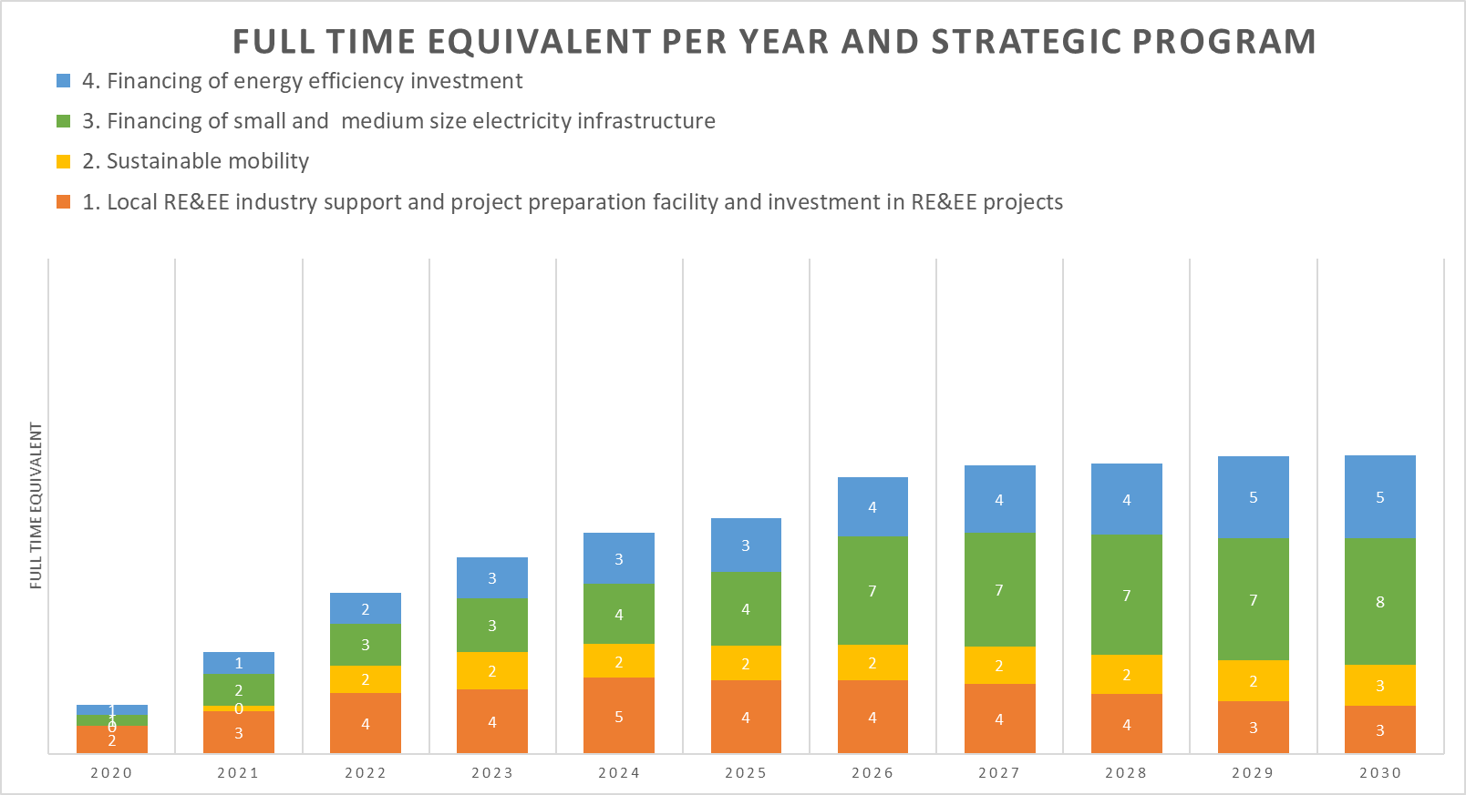
Figure 1: FTEs per Year and Strategic Programme
The number of FTEs per each of the four (4) strategic programmes is proportional to the programmatic budget designed for each respective programme (see Programmes 6). This means that time availability and expertise of assigned personnel shall be in line with the tasks´ requirements defined under each respective strategic programme to achieve the expected outputs for the Programmes .
Building a team composed of senior experts supported by a pool of cross-thematic administrative and technical staff is the emphasized strategy in this BP as this will provide PCREEE with enough flexibility to convey programmatic delivery, administrative follow-up, Monitoring and Evaluation (M&E) while ramping up fund-raising efforts. The expected 18 FTEs do include both technical as well as an administrative staff together occupying management, senior and junior positions. The following figure shows the distribution of the different staff levels per year.
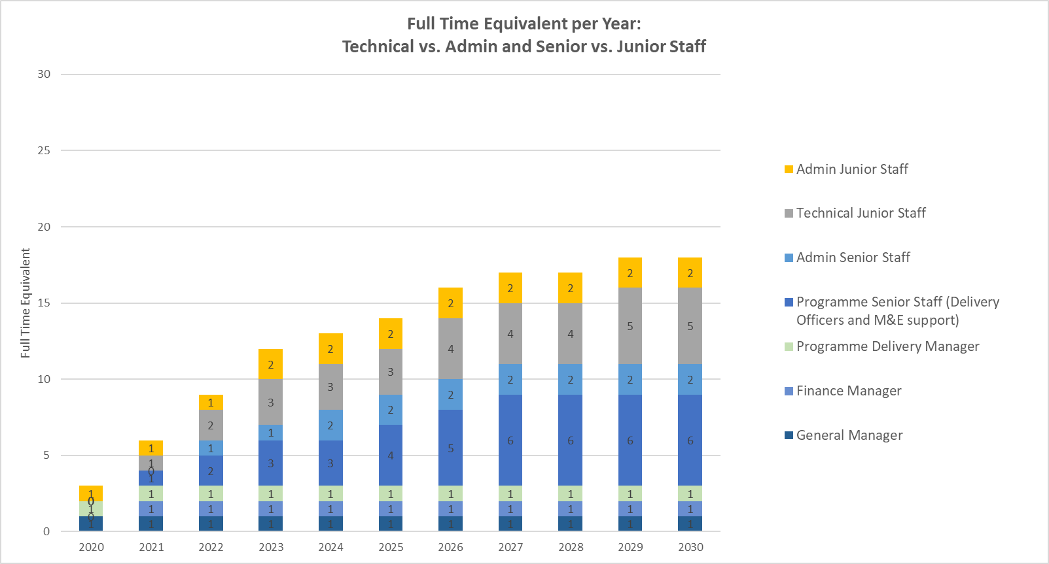
Figure 2: FTEs per Year, Technical vs. Admin and Senior vs. Junior Staff

5.2 Organizational Chart
Two differentiated units are proposed under this BP. On the one hand, a programmatic (or technical) unit, and on the other, an administrative one.
- Programmatic unit: Given there are 4 strategic programmatic areas defined in this business plan (see Programmes 4), 4 PDOs under the supervision of the PDA are meant to be assigned to the management of the 4 selected strategic programmes. The overall coordination of the 4 programmes and the staff assigned falls under the responsibility of PCREEE´s PDA . Programmes 3 and 4 will manage a bigger volume of funds and activities than Programmes 1 and 2, including project funding support and M&E, hence requiring additional support in the form of 2 M&E Support Officers providing a pool of M&E and project support. Hence, a total of 6 Technical Staff will have to be hired by 2027.
- Administrative unit: Led by a Finance Manager, the unit will include 2 senior staff, (one Accounting Officer and one Human Resources and Procurement Officer), with a recruitment period foreseen the latest in 2024.
The activity of the Senior Technical and Administrative staff will be supervised and guided by the Management Team, composed of the Deputy Director (GEP), PCREEE´s Manager, the PDA , and the Finance Manager. The Management team should be in place by 2021.
Additionally, PCREEE´s team will be complemented by an internship programme, able to mobilise up to 5 technical and 2 administrative junior staff. The technical junior staff members are organised under a junior pool of technical support, able incrementally reinforce the work led by the senior technical staff on the different projects according to the necessities and workload of each strategic program.
Pool of Junior Technical Program Assistant
5 technical FTE
Figure 3: PCREEE Organizational Chart in 2030 (Grey: Management Team; Green: Senior Staff, Blue: Local / Support Staff)
As described under the gender strategy below, and based on SPC internal regulations, the Centre should aim for a gender balance staff, including a mid-term objective of 50% of women across all positions, i.e. including management, administrative and technical senior/junior staff.

The Manager is also in charge of external relations to stakeholders, acquiring new funding sources and ensuring alignment and collaboration with SPC and more specifically with the GEP, with PICTs and, to a lesser extent, other relevant regional and national partners. Business development and resource mobilisation will continue to be led by the Manager in close collaboration with the PDA. Tight coordination in this regard will be established with the Programme Delivery Officers when required.
The PDA oversees the 4 programmes and ensures that PCREEE is carrying out the planned activities and is reaching its operational targets according to the Business Plan and each annual plan. This figure will also timely shift and assign support staff according to workload or operational necessities.
The Programme Delivery Officers are line-managed and closely coordinated by the PDA. Senior M&E and junior staff will report to their respective Programme Delivery Officers, who will also lease the coordination and management matters with the PDA if deemed needed.
The Finance Manager is responsible for the administrative and financial tasks which include supporting day to day PCREEE´s operations and its technical activities.
The Deputy Director (GEP), Manager and both the PDA and Finance Manager will constitute the Management Team , with regular monthly meetings aiming to provide strategic coordination for the rest of the team.

5.3 Internal Procedures
While the overall responsibility and the strategic direction lies with the Management Team, the annual work plan of PCREEE will involve the PDOs. The work plan and budget require vetting by PCREEE´s Steering Committee before endorsement by the SPC Executive.
As outlined in PCREEE´s Project Document, and for the Centre´s first phase, internal rules and regulations will be worked out in accordance with SPC´s rules and regulations (e.g. procurement, sub-delegation, human resources , financial reporting, etc.). At the end of the second operational phase, based on PCREEE’s desired level of autonomy and independence and in agreement with the SPC, the organization will decide to what extend internal rules and regulations need to be further tailored for PCREEE.
PCREEE will ensure all the fiduciary standards are met and maintained (including financial, administrative, procurement, internal controls, and project cycle management) required to manage international donor funding.
Additionally, and for the 4 selected programmes, PCREEE will establish / connect these with relevant steering and guiding mechanism composed of relevant representatives from within SPC, member countries, the donor community and the industry.
It is important to keep the procedures simple, efficient and straight forward to avoid employees spending too much time on internal issues which do not constitute a value-add for the programmes and the organization. Target size of 18 staff members should be manageable with a maximum of 3 hierarchical levels.

6. Sustainable Business Model

Financial and Economic Viability 2020 & 2030

Core Costs (overhead)
The core costs include all costs to run the PCREEE office (including core staff salaries and office running costs). The following graph shows the expected growth in PCREEE budget over the next ten years based on the proposed strategy.
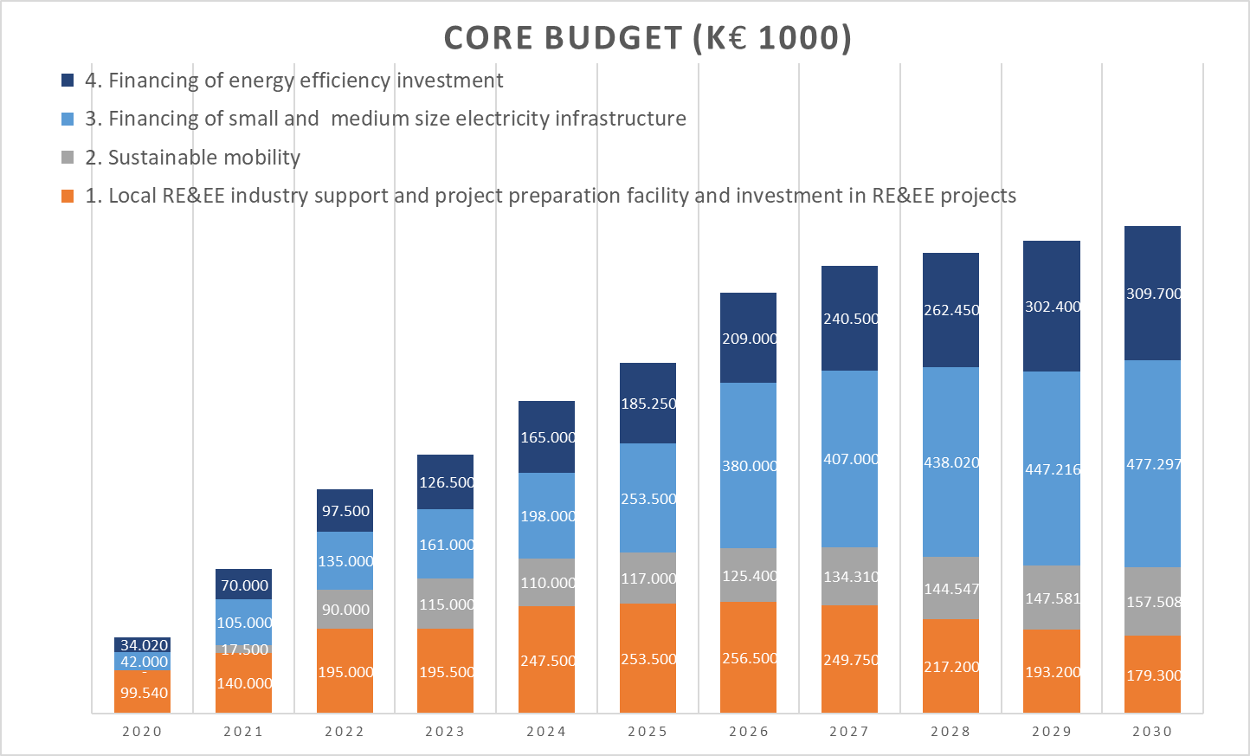
Figure 4: PCREEE Operational Budget
Figure 4: PCREEE Operational Budget shows costs proportional to the staff uptake described in the previous Programmes . It is based on salary levels according to the SPC salary band. Salaries shown in the previous figure do also include salary-related budgetary elements such as health insurance, flights, provident funds, school, and housing allowance for the selected staff. The core costs do include the manager’s, PA and senior admin and programmatic staff, as explained previously in Programmes 5. An annual salary update of 3% has been factored in. Running costs for PCREEE has also been taken into consideration.

6.1.2 Operational Costs
The uptake of the operational program budget (or programmatic budget), which aggregates the budget from the selected 4 Programmes in Programmes 4 is shown in Figure 5.

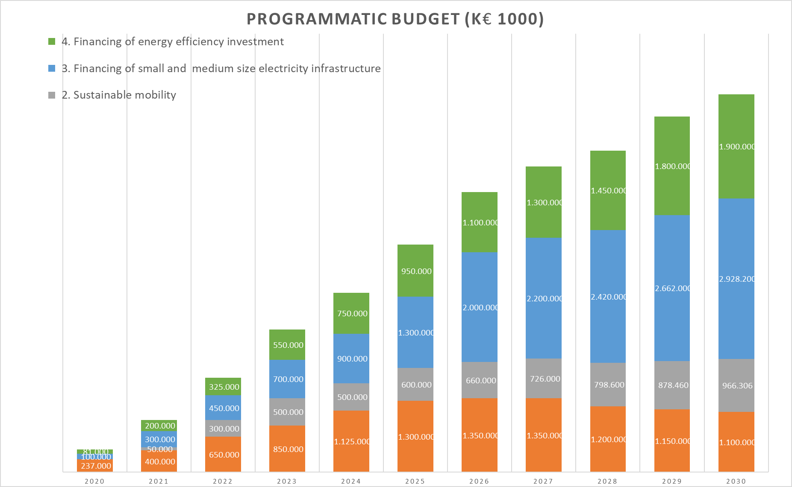
Figure 5: PCREEE Programmatic Budget
The costs have been annually estimated per strategic area. Programmes 3 “RE mini-grids” and 4 “Energy Efficiency Investment” (Programmes 4) represent the highest costs throughout the 10-year period growing significantly over the last 5 years. This is due to the expected mobilisation of private investment as a result of the seed-funding initially mobilized by PCREEE. The year 2022 represents a leapfrog in funding mobilisation and private financing capital for the programmatic area 2 “RE and EE for Sustainable Mobility”, hence responsible for the sharp increase in the technical programmatic budget.
As Programme 1 targets most PCREEE´s core mandate to support the private sector across the regional RE&EE market, it is fundamental to increase it over the PCREEE´s first period (2020-2026). Over time, as the local private sector demands growing specific sector support to further expand their operations, the specific weight of the other 3 selected Programmes grows in parallel while funding needs from Programme 1 declines from 2026 onwards.
Other costs intrinsically related to programmes expenses like travel, workshop or meetings organisations, etc., are not included in Figure 4: PCREEE Operational Budget but in Figure 5: PCREEE Programmatic Budget, as they refer to technical programme costs.

6.2 Fund Mobilisation Strategy
The Draft November 2018 PCREEE Fundraising Strategy 2018-2021 lists five (5) priorities when leveraging funds and negotiating with potential donors and partners:
- Multi-year flexible program funding to SPC Georesources and Energy program (GEP), which includes PCREEE activities in collaboration with the rest of GEP units;
- Project funding through multilateral and bilateral donors & other agencies directly to PCREEE or PCREEE providing services/technical assistance within larger projects;
- Service provider (consultancy services) when relevant to ministries with available bilateral funding;
- Fundraising support by the host country, Tonga, through increasing the visibility of PCREEE’s efforts and opportunities to upscale efforts in Tonga and the region;
- Foundations, Corporate Foundations, and Trust Funds.
Austria, Norway, UNIDO, SPC, and Tonga have funded PCREEE's 1st Operational Phase. However, PCREEE still needs funding for its on-going operations and the 2nd Operational Phase.
The total PCREEE budget for 2020-2030 consisting of operational and programmatic costs together is shown in Figure 6. PCREEE Programmatic and Operational Budget.Error! Reference source not found.

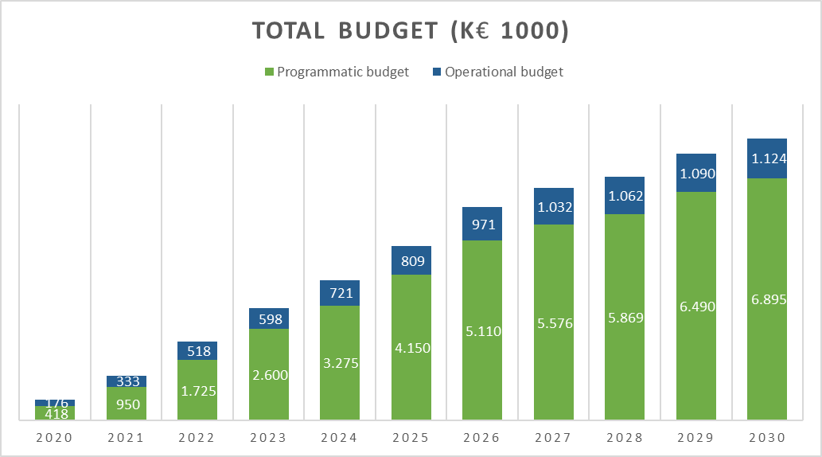
Figure 6. PCREEE Programmatic and Operational Budget
Revenues for PCREEE consist of: (a) donor grants, (b) contributions by national governments or private entities; (c) fee-for-service revenues; and (d) interest accruing from unspent cash held in accounts controlled by PCREEE.
The Fund mobilization strategy aims to cover the proposed core and operational (programmatic) budgets. At present, PCREEE’s revenues are grants by bilateral and multilateral institutions and SPC's contribution to PCREEE's manager's salary, to support PCREEE's core operating costs as well as specific program costs. Over time PCREEE’s revenues will need to be diversified with a progressively higher share of revenues falling on budgetary support from member states and fee-for-service. PCREEE needs new donors from both the bilateral/multilateral category as well as from private foundations and corporate foundations. Resources support can come as direct funding contribution or in-kind contributions (staff delegations, facilities, equipment, etc.):
Proposed assumptions regarding the fund mobilization of Programmes are:
- No core-funding from SPC, but SPC keeps financing PCREEE's Manager's salary;
- The current grants from UNIDO, ADA, and Norway will either be continued or substituted by similar amounts from other donors. All junior staff are financed from the four selected Programmes ;
- Any additional funding from international and/or domestic donors or through own revenues will come on top of the minimum funding;
- The final 5% of the budget comes from fees-for-service by the centre.
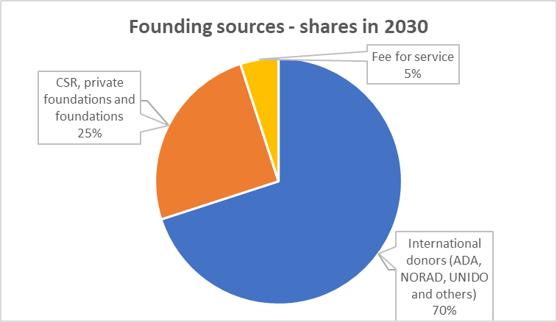
Figure 7: Share of Funding Sources
Based on these assumptions, the annual funding required by funding source is depicted in the following figure.
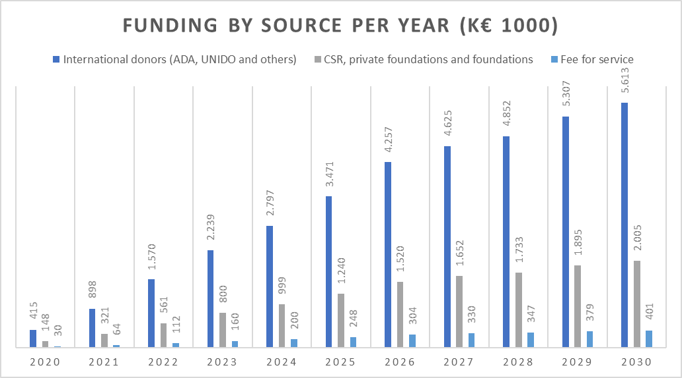
Figure 8: Funding by Source per Year
The yearly share of the contributions is likely to change over the ten years. Securing support from SPC will be crucial for the future financial sustainability of the Centre. The current strategic partnership with the SPC and GEP will facilitate the growth of the Centre, and this will contribute to enhancing the ownership of PCREEE by the SPC member states.
CSR, corporate foundations, and foundations will also play a vital role in future PCREEE's financial sustainability. However, PCREEE must match the level of business development efforts required by those entities with an intensive public relationship involvement by PCREEE's program business developers and an explicit strategic complementary intervention.
Generating revenues

The objective of this document is to identify the most effective ways to mobilize budgetary resources for PCREEE's work in support of the 2020-2030 business plan:

Table 4: Revenue Generation
Category | Proposed actions
Widen donor base | Strengthen Strategic Partnerships with stakeholders  Reach out to the private sector, donors, and financial institutions.  Establish pooled funding for cross-sectoral activities.
Building resource mobilization capacity | Develop the temporary capacity to support resource mobilization at the corporate level, financed from existing resources, or draw upon SPC’s resources.  Establish an internal task force led by the Manager to mobilize funding.  Review and streamline internal administrative procedures to support practical resource mobilization.
Cost recovery planning | Develop a resource mobilization action plan for each sub-program, identifying funding gaps and targets and timelines for mobilizing budgetary resources.  Establish cost-recovery arrangements when planning for resource mobilization.  Regional Advisors funded from Programmes for Technical Cooperation to mobilize extra-budgetary resources for regional advisory services in PICT's.
Seek voluntary contributions | Explore Voluntary contributions of PICT's Member States such as Junior Professional Officers/Associate Experts.  Seek voluntary logistical and substantive in-kind contributions from PICT's in different forms (i.e. technical expertise for studies, assessments, and publications; communication networks and on-site resources).
Ensure transparency of budget funding and projects | Use the Open PCREEE sections on the PCREEE website.  Provide regular reporting to the intergovernmental bodies and donors on the receipt and expenditures of budgetary resources to sustain trust and support.
Strengthen national ownership and increase the sustainability of projects | Provide small grants to non-profit organizations for specific tasks (administrative, logistical, and substantive). Ensure strict compliance of grants with UN financial rules and regulations.

6.3 Gender Mainstreaming strategy
Figure 9: PEGSAP’s Proposed Areas of Intervention
LONG-TERM APPROACH
Planning and Procurement
Sales and Distribution
Installation
O&M and Decommissioning
SHORT-TERM AND MID-TERM COUNTRY-SPECIFIC APPROACH
Structural Challenges
- Legal/ institutional framework
- Values and customs
- Balance with the reproductive role
- Youth and female entrepreneurship
- Access to resources
- Gender-based violence
Energy Access
- Adopt a Regional Policy on Gender-responsive Energy Access and a whole-sector approach to energy.
- Assist PICs with developing the gender-aware regulatory frameworks, standards, incentives and financial mechanisms.
- Build capacity and develop data.
Upstream – Gender Equality in the Energy Value Chain
Employment in Public Services
- Energy as an interdisciplinary topic.
- Promote an inclusive work environment within the government and electricity utilities.
- Establish mentoring programs and networks for women and girls.
- Provide awareness-raising on the opportunities in educational and training institutions.
Entrepreneurship
- Reform and establish the Pacific Barefoot College and sign MOUs with energy suppliers
- Conduct demand assessments of efficient cook stoves and involve women as stakeholders in their distribution.
- Support women and youth entrepreneurs with training, networking, market access, mobility, access to credit, and procurement.
Downstream – Economic Opportunities from Enhanced Access to Clean Energy
Agriculture
Fisheries
- Support women and youth entrepreneurs with training, networking, market access, mobility, access to credit, and procurement.

PCREEE operates under the rules and procedures of the SPC, including SPC´s gender policy. Furthermore, it is noted that the Policy and Governance programme of the GEP is coordinating the Pacific Energy and Gender Strategic Action Plan (PEGSAP) for 2020-2030. The PCREEE must contribute through these existing platforms rather than duplicating current efforts.

6.4 Environmental and Social Governance
NFIs nominated by the Ministries of Energy will have to build strong links with governmental institutions in charge of the environment and social aspects of sustainable energy, particularly with transport and power utilities. Additionally, and alongside with annual multi-stakeholder events, a more comprehensive and open stakeholder consultation process will provide the much-needed civil society´s feedback to the work of PCREEE.

6.5 Market Potential of Proposed Activities and Income Generation Capacity.
PESTLE analysis showed the right enabling environment will be crucial, including ramping up awareness-raising and capacity building, designing, and implementing a set of harmonized policy and regulatory frameworks, hence attracting investors into various RE&EE markets. Also, a deeper involvement and growth of the local private sector at any level is key to lever efforts and scale-up solutions. The 4 selected programmes in this Business Plan draw the highest market potential always employing a regional approach, aiming to bring the front-runner countries to share their experience and capacities with those others where investment interest and market readiness do not yet exist.
Thematically, there is also a differentiated market potential across the suggested 4 programmes, which are designed aiming to gradually evolve from providing capacity building to market support to local private sector players. This will help to transition the market into a situation where incentives and project development support is offered, aiming to ultimately strengthen local and, to a lesser extent international companies, capable of scaling up efforts and extend RE&EE services throughout the entire Pacific region.
Specifically, the BP has identified high market potential and income generation capacity around the areas of RE-based productive uses of energy, including fostering the current local market sustainability (e.g. agriculture or tourism) and the employment growth. For this, the programme “Financing of small and medium-size electricity infrastructure” will have to emphasize in the nexus approach energy/food/water and the off-grid local private sector support.
Other areas where market potential has been analysed as to be high for the coming 5 years include those under the programmes “Energy Efficiency Investments” and “RE and EE for Sustainable Mobility”. For them, market status is still in an infant stage. However, boosting the technology transfer as well as gaining more traction around the financial and socio-economic benefits under the three of them will surely help to accelerate the market transition, hence helping to incentivize those markets across the region.

7. Strengthening Cooperation
Collaboration within the SEforALL Asia Pacific Hub
The multi-stakeholder partnership Sustainable Energy for All (SEforALL), has three interlinked objectives to be achieved by 2030: (i) universal access to modern energy; (ii) Double the energy efficiency, and (iii) Double the renewable energy. These objectives encompass the energy sector objectives and aspirations of all the PICTs. PCREEE is working with the SEforALL initiative promoting the development of renewable energy and energy efficiency in the region. A concrete result is the Pacific Regional Data Repository for SEforALL (PRDR), which was launched in 2013 to support the Pacific governments and their development partners working in the energy sector by facilitating access to up-to-date, reliable energy data and project information.
Collaboration with National Focal Institutions (NFIs) and Thematic Hubs (THs) and SPC Regional Stakeholders:

PCREEE develops and executes its activities through a network of Thematic Hubs (THs) and NFIs among all PICTs. NFIs act as PCREEE's focal points in each PICTs country, channelling, and sometimes implementing PCREEE's interventions at the national level. PCREEE will work through thematic hubs for policy, knowledge management, investment, and capacity development:
Table 5: Thematic Hubs and main cooperation area
Thematic hub |  | Main cooperation area
SPC | Pacific Community | Policy and knowledge management
PIFS | Pacific Islands Forum Secretariat | Climate Change finance coordination
PPA | Pacific Power Association | Power Utility Engagement
SPREP | Secretariat of the Pacific Regional Environment Program | Climate Change Resilience
USP | University of the South Pacific | Capacity Development and Applied Research
ADB | Asian Development Bank | Investment & Business Promotion
SEIAPI | Sustainable Energy Industry Association of the Pacific Islands
SIDS DOCK | Small Island Development States Docking Station | SIDS-SIDS Cooperation
UNIDO | United Nations Industrial Development Organization
OPERA | Pacific Energy Regulatory Alliance | Regulatory issues

Collaboration with PCREEE Member PICTs
Collaboration between PCREEE and its member PICTs goes beyond the network of NFIs as other relevant national public institutions and agencies may play an appropriate role in the implementation of programmatic interventions and bilateral efforts. Additionally, PCREEE and the centre´s member states will have reciprocal conversations and collaboration, where PCREEE will be the facilitator of a potential regional involvement and cooperation by the PCREEE member PICTs.
The collaboration will include capacity building, arranging knowledge and technology exchange Programmes with countries and relevant agencies to provide the best and most successful regional (and national) practices. The collaboration will bring world-class international standards in terms of technology and innovations to the Partner PICTs.
Collaboration with Private Sector
PICTs have expressed a need to support local human resources, awareness, and knowledge management, as well as businesses and industries in the sustainable energy sector. PICTs have noted that the local private sector and industry do not take advantage of the growing sustainable energy market and the associated job opportunities. PCREEE will mainly focus on addressing existing barriers for the local private sector and small-scale industries.
Collaboration with Academia and Civil Society
“Train the trainer” approaches in renewable energy and energy efficiency can facilitate national follow-up activities, and regional research projects can develop the capacities of universities and vocational centres. PCREEE will collaborate with relevant actors and act as coordinators of regional “train the trainer” networks and applied research networks as well as act as the body accrediting training centres and providing certificates to trainers.
Collaboration with Development Partners
PCREEE will work closely with the SPC, Partner Member PICTs and development partners to implement activities aimed at mobilizing resources for this Business Plan. PCREEE will strive to seek support from or work with development partners to design, implement, and build capacity, especially for EE Programmes. PCREEE will try to build up strategic relationships with prospective or current partners, including joining efforts towards specific actions or interventions. PCREEE will seek collaboration and affiliation with leading international RE&EE "brand" associations, who carry out/encourages "cutting edge" research, development, and utilization of various RE resources as well as EE worldwide.
Collaboration with Other Regional Sustainable Energy Centres through the GN-SEC
PCREEE is part of the GN-SEC, aiming at creating integrated and inclusive regional markets for sustainable energy and climate technology (SECT) products and services. PCREEE will collaborate with these organizations and make use of their various comparative advantages.

8. Monitoring and Evaluation

8.1 Quality and Appraisal Framework for the Technical Operations
BP’s quality and appraisal framework consist of a qualitative and a quantitative assessment. It presents the progress of the planned activities in accordance with the stated schedule and explains any occurred unforeseen modification or delays.
Quantitative assessment: The quantitative assessment follows up on the progress in the implementation of the Business Plan, particularly programmatic and operational budget, staff development, and funding.
Qualitative assessment: To measure whether proposed activities and deliverables achieved the changes and impacts they aimed to (e.g. a strategic policy report did change the policy views of national stakeholders or did help to shape a policy later).
Also, cross-cutting goals include: (i) Contributing to achieving gender balance; (ii) Contributing to the development of the Pacific region in accordance to the SDGs and; (iii) Contributing to the deployment of RE&EE technologies and services as well as the growth of the local private sector.
Frequency
Quarterly basis and reported to the Board twice per year, with an annual status report and a shorter mid-year report.

8.2 Logical Framework Matrix/Results Framework
Table 4 shows the proposed tracking framework for PCREEE and the four strategic programmes. The table includes the most relevant performance indicators, their baselines, and the expected milestones (based on the 2020 targets defined in the Business Plan by the GEM division) and targets (2025 and 2030).

Table 6: PCREEE Results Framework

Development Impact (ultimate outcome) | Indicators | Baseline and targets | Means of verification | Risks and assumptions
Improved access to modern, affordable and reliable energy services, energy security and mitigation of negative externalities of the energy system by promoting renewable energy and energy efficiency investments, markets and industries in PICTs. | - % increase of people with access to modern, reliable and affordable energy services provided by RE technologies baseline 2017  - % increase of the RE and contribution to the electricity and transport mix of the PICTs (baseline 20173)  - Increase of investments in RE&EE projects in PICTs baseline 2017 in USD  - declining growth of fossil fuel use in power generation and land transport compared to BaU scenario. baseline 2017  - % decrease of GHG tCO₂ emissions through implemented RE&EE projects  - Number of additional jobs created directly or indirectly in the RE&EE sector in PICTs  - % increase of registered local companies in the RE&EE sector | Baseline:  - High energy costs and non-access hamper the socio-economic and industrial development in PICTs; rapid growth in fossil fuel use; low productivity and competitiveness of local key industries due to energy costs (e.g. food processing, manufacturing of niche products, fishery, tourism); low levels of RE&EE investments; lack of local energy service companies;  Target(s):  - 10% increase of people with access to modern, reliable and affordable energy services provided by RE technologies (baseline 2017)  - 10% increase of the RE contribution to the electricity and transport mix in PICTs (baseline 2017)  - USD 100 million of additional investments in RE&EE projects (at least 25% of it are addressing key productive sectors in PICTs (baseline 2017)  - 2% decline in the growth of fossil fuel use in PICTs due to the introduction of RE&EE technologies and solutions (baseline 2017)  - 2% decrease of GHG tCO₂ emissions through implemented RE&EE projects  - At least 100 additionally (directly or indirectly) created local jobs in the RE&EE sector (baseline 2017)  - 10% increase of registered local companies in the RE&EE sector (at least 25% of them are in the manufacturing sector) | - Regional statistics on investments in RE&EE projects in the region  - Regional statistics on GHG emissions  - Regional statistics and energy balances  - National and regional policy and strategy papers | - Investments in RE&EE projects continue to be and perceived as feasible and viable options  - Regional development of policies and legal frameworks for energy continues and creates a favourable environment for sustainable energies  - Stable political situation in countries

 | Outcome 1: RE and EE Business Start-Up and Entrepreneurship Support
 | Objective: To provde differentiated support to entrepreneurial RE&EE businesses across the enterprise development life cycle (start-up, early-stage, growth, and maturity).
 | Outputs |  | Indicators | Baseline and Targets | Means of verification | Risks and assumptions
 | Output 1.1 Project preparation Technical Assistance (TA) to support companies (A -start-up, B - early-stage, C- growth, and maturity). to progress until financial closure. |  | - No. of TAs targeting specific needs of Type A, B & C businesses  - No. of successful local businesses (Type -C) that are operating in non-RE&EE industries that have entered the RE&EE industry. | Baseline:  Absence of TAs targeting specific needs of Type A, B & C businesses.  Target(s):  At least 1 Type A, B & C businesses are supported by PCREEE annually.  Programmes  Baseline:  Existing businesses consider energy as high risk and unprofitable.  Target: At least 2 existing businesses per year extend their portfolio to include sustainable energy. | - TA reports  -  - Training documents  - Business Registration | - The technical support facility is framed within the PCREEE Sustainable Energy Entrepreneurship Facility ( PSEEF).  - All the TA and advisory work are implemented by PCREEE in partnership with selected organizations.  - There is private sector interest in investing in RE&EE projects in the region
 | Output 1.2 Financial support in the PICTs to increase RE&EE business opportunities for local companies and industry. |  | Value of loans and co-financing grants provided to local SMEs and NGOs | Baseline: Inability of local businesses to comply with the credit crtierias of financing institutions, PSEEF, etc.  Target(s): At least 10 million USD of new loans and co-financing grants to local SMEs and NGOs in 2004 | - Loan documents  - Annual reports of financing and grant institutions | - The PCREEE Sustainable Energy Entrepreneurship Facility, PSEEF is well resourced and widely known in the region.  - There is private sector interest in investing in RE&EE projects in the region  - Regional development of policies and legal frameworks for energy continues and creates a favourable environment for sustainable energies.  - Investments in RE&EE projects continue to be and perceived as feasible and viable options.
 | Outputs |  | Indicators | Baseline and Targets | Means of verification | Risks and assumptions
 | Output 1.3 access to finance via different instruments, including connecting with existing financing facilities (i.e. local development banks, targeted local stimulus packages, local environment / energy funds or ADB). |  | - No. of investment forums conducted and Commercial financial institutions engaged in the financing of RE&EE companies.  - | Baseline: absence of a regular forum to match investors, project developers and financiers.  Target(s): At least 1 investment forum is conducted annually. | -  - Investment Forum reports. | - The Financial Institutions are interested in extending providing term loans to private sector service providers for RE&EE services.  - There is private sector interest in investing in RE&EE projects in the region
 | Output 1.4 Support to improvement of the policy and regulatory frameworks and business-enabling environment both at the regional and national levels. |  | - No. of inputs from the national industry associations and related businesses to the review and and drafting of the sustainable energy policy and regulatory frameworks.  - No. of Promotions of income-generating activities and productive uses of energy. | Baseline:  Lack of and inactive participation of the national industry associations in shaping the sustainable energy business environment in PICs. Target(s):  At least 3 TAs conducted to support inputs from national industry associations to the policy and regulatory framework regarding the national sustainable energy business environment. | -  - Training reports  - Minutes of investment forums | - Involved organisations accept and assist the support to the improvement of the policy and regulatory frameworks and business-enabling environment both at the regional and national levels.  - There is private sector interest in investing in RE&EE projects in the region
 | Outcome 2: RE and EE for Sustainable Mobility
 | Objective: A comprehensive e-mobility readiness programme that best prepare PICTs for their respective sustainable mobility futures.
 | Output |  | Indicators | Baseline and Targets | Means of verification | Risks and assumptions
 | Output 2.1 Adopted Sustainable e-mobility Policy and Regulatory Frameworks |  | - No. of High-level energy and GHG targets and mandates that include RE and EE in the promotion of low carbon mobility  - No. of PICs with adopted regulatory frameworks and policies that consider exploring the feasibility of EVs for low carbon mobility  - A Project Document with a monitoring and evaluation system for promoting the understanding and familiarity with EVs | Baseline: Absence of EE and GHG targets on low carbon mobility, including EVs  Target: 5 PICTs include low carbon mobility / EV targets in their Energy / GHG targets by 2025  Baseline:  EE in transport, including EVs are missing from the energy roadmaps, NDCs and Low Emissions Development Strategies  Target:  5 PICs include EE in transport and EV in their energy roadmaps, NDCs and Low Emissions Development Strategies by 2025  Baseline:  Absence of a regional Project Document with a M&E system for promoting the understanding and familiarity with EVs  Target  A regional EV Project Document is adopted by the PCREEE Steering Committee in 2021 | - National Energy and GHG roadmaps and policies  - NDCs  - LEDS  - Regional EV Project Document | - PICs continue to push for urgent and ambitious energy / GHG targets
 | Output |  | Indicators | Baseline and Targets | Means of verification | Risks and assumptions
 | Output 2.2 Adopted Standards and Guidelines |  | - No. of model Standards and Guidelines developed for aspects of EVs retirement of EVs, low-voltage vehicles, mobility batteries, standards for “EV-ready” new constructions  - No. of other model Guidelines and Standards set for other aspects of EVs including charging connectors, use of V2H and on-site management charging, e-mobility security and available options  - No. of Technical courses developed and introduced on EVs | Baseline: Absence of any model standards and guidelines on EVs  Target: At least 5 PICs have adopted EV standards and guidelines relating to retirement of EVs, low-voltage vehicles, mobility batteries, standards for “EV-ready” new constructions by 2025 Programmes  Baseline: Absence of any model standards and guidelines on EVs  Target: At least 5 PICs have adopted EV standards and guidelines relating to charging connectors, use of V2H and on-site management charging, e-mobility security and available options  by 2025  Baseline: Absence of EVs from technical courses related to mechanical / electrical engineering  Target: At least 3 technical institutes in the PICTs deliver technical courses that covers EVs | -  - Natoinal energy standards and guidelines | -There is political will to adopt standards, guidelines and training on EVs.
 | Output 2.3 Effectiveness Awareness Raising and Promotion |  | - No. of Social marketing research is undertaken  - No. of EV awareness, information, and promotion campaign developed and delivered  - No. of Guidelines on EV purchase, charging, servicing and support developed, published and promoted | Baseline: No social marketing research on EVs  Target: A social and marketing research on EV is completed in at least 3 PICTs by 2025  Baseline: No targeted awareness and promotion campaign on EVs in the region  Target: At least 5 awareness and promotion campaigns on EVs completed by 2025  Baseline: No. Guidelines on EV purchase, charging, servicing and support developed, published and promoted  Target: There is a model guideline on EV purchase, charging, servicing and support developed, published and promoted by 2022 | - Social marketing research document  - Report of Campaign and awareness  - Model Guidelines on EV purchase, charging, servicing and support | - PICTs buy into the concept that sustainable mobility offers an alternative to reduce fossil fuel dependency, increase energy security, mitigate climate change effects, and underpin PICTs domestic economies without further harming the environment.
 | Output 2.4 Successful Demonstration and Upscale |  | - Quality products and services system supported and developed, published and promoted  - No. of Demonstrations of technologies and business services (i.e. small marine vessels, electric bus, e-mobility charging facilities and batter swapping, among others)  - No. of Public charging infrastructure installed and/or co-investment promoted | Baseline: Very little EV-related demo of quality EV products and services  Target: At least 2 demo EV projects by 2025  Baseline: No Demonstrations of technologies and business services (i.e. small marine vessels, electric bus, e-mobility charging facilities, among others)  Target: There is a demo of EV technologies and services, including Battery swapping for low-voltage mobility use is available on a commercial scale in the marketplace  Baseline: Hardly a public charging infrastrucrue for EVs in the PICs  Target: - 50% of all mainstream EVs are charged through devices that are managed-charging enabled by 2030 | - Demonstration projects reports -  - Managed charging stations reports | - PICTs buy into the concept that sustainable mobility offers an alternative to reduce fossil fuel dependency, increase energy security, mitigate climate change effects and underpin PICTs  - There is private sector interest in investing in RE&EE projects in the region
Outcome 3: RE mini-grids |  |  |  |  |  |  |  | Battery swapping for low-voltage mobility use is available on a commercial scale in the marketplace.
Objective: Increased clean energy access and improved livelihoods for communities through technically sound mini-grid systems
Output |  | Indicators |  | Baseline and Targets | Means of verification | Risks and assumptions
Output 3.1 Market Intelligence: Enhanced awareness of mini-grid market and strengthen market knowledge through market intelligence development. |  | A Web-based market knowledge platform is established  Up-to-date market information are published and shared in the platform  A Database of Mini-grid projects in PICTs |  | Baseline: Limited market knowledge and data about RE mini-grids  Target: A regional Web-based knowledge platform for mini-grids is fully functional and hosted by the PCREEE by end of 2022,  Baseline: No sharing of market information and data on RE mini grids  Target: Updated market information about mini-grids are shared on a regular / monthly basis from the platform, commencing in 2023  Baseline: No database and Little data available on RE mini-grids  Target: A fully functional data base with key data is available on the platform by end of 2022 | Web-based platform available  No. of hits / visits to the platform  Data collection sheets  Database available | Willingness of the PICT and project developers to share data and information.  Risk that lack of ICT connection may hinder access to the knowledge database
Output |  | Indicators |  | Baseline and Targets | Means of verification | Risks and assumptions
Output 3.2 Capacity Building, Public and Private Partnerships: Empowered local institutions and private sector and increased project developments through capacity building and reinforced networks and partnerships between stakeholders. |  | A Pro-Poor Public-Private Partnership (5P) business model is developed for mini-grids  A Capacity building program on mini-grids is delivered  No. of Promotion of mini-grid and public-private partnerships conducted  No. of national sustainable energy industry associations established to support mini-grids |  | Baseline: - Unclear pro-poor business model for mini-grids  Target: A 5P business model is developed to assist in sustainably managing mini-grid systems in the PICT.  Baseline: Ad-hoc delivery of capacity building services in mini-grids  Target: A regional capacity building programme on mini-grids is adopted by end of 2021  Baseline: No promotion of mini-grid and PPP conducted  Target: At least 3 PPPs on mini-grid signed by end of 2024  Baseline: 3 national industry associations have been established  Target: An additional 5 national industry associations are established by end of 2024 (i) | PCREEE Progress Reports Minutes of the PCREEE Steering Committee meetings  Annual Report of the PIC national energy offices  Reports of capacity building events  PPP signed [if not confidential] | Energy access remains a high priority in the PICT  Governments  Governments are pro poor and support private sector–led developments
Output |  | Indicators |  | Baseline and Targets | Means of verification | Risks and assumptions
Output 3.3  Increased entrepreneurship through productive uses of energy. |  | No. of micro and SMEs established due to the improved reliable supply of energy  Increased jobs and income generating activities due to the improved reliable supply of energy |  | Baseline: Unknown number of new micro and SMEs established  Target: At least 5 new micro and SMEs established by end of 2023  Baseline: Unknown number of new jobs and income generating activities  Target: At least 50 additional jobs and USD 100k of additional income due to new micro and SMEs | Business Registration and Licenses  Tax records  Busines tax returns and salary slips | Other supporting incentives from govts empower people with confidence to start new micro and SME.
Outcome 4: Energy Efficiency Investment
Objective: To enhance the competitiveness of manufacturing and service industries in the Pacific Region while reducing Greenhouse Gas (GHG) emissions by mobilising additional investment for public institutions and private sector organisations in the market of domestic, industrial, and commercial EE.
Output |  | Indicators |  | Baseline and Targets | Means of verification | Risks and assumptions
Output 4.1 International standards (ASHRAE, ISO, ANZ, etc) adopted for lighting and thermal efficiency and potentially included in building codes. |  | - No. of Validation workshops and TA support for PICTs on appliance labelling and standards |  | Baseline: 5 PICs have adopted  legislation on labelling and standards for refrigerators and freezers and are enforcing their legislations  Target: An additional 5 PICs adopt legislations on labelling and standards by 2025. | -  - Cabinet Decisions  Parliamentary records | There is commitment from governments to remove inferior products from the market.  Programmes Programmes
Output |  | Indicators |  | Baseline and Targets | Means of verification | Risks and assumptions
Output 4.2  Assistance provided to PICTs for adopting energy conservation practices for the design, construction, and utilization of energy-efficient facilities. |  | - Conservation practices guidelines, mandatory consumption reporting, energy saving plans, maintenance plans, TA, and forums to support PICTs and encourage the private sector to step in. |  | Baseline: EE practices are not integrated into the design of infrastructure and public facilities  Target: At least 5 PICs incorporate EE considerations in their building, transport and work safety codes by 2024. | Building codes  Transport coes  Work Safety codes | Involved organisations accept and implement the practices.
Output 4:3. Access to financing via different instruments facilitated. |  | - No. of EE financing instruments, research study, consultation workshops with relevant institutions, TA support to public and private organisations and seed-funding grant provision. |  | Baseline:  Limited financing available for EE investments  Target: at least USD 10 million is available for EE investment in the PICT by end of 2024 to | - Donor reports  - Financing Institutions reports | Avalability of a credit risk facility to safequard investors.

https://www.gn-sec.net/
https://www.spc.int/
https://www.pcreee.org/documents
including the SPC, PPA, SPREP, USP, PIFS, Pacific Climate Change Centre, NDC Hub, Maritime Technology Cooperation Centre

