Outcome Report for the PCREEE-EU PacTVET Joint Awareness and Promotion Campaign on SE Entrepreneurship and SE TVET in –Tonga
VAVA’U, 2nd to 3rd June 2020
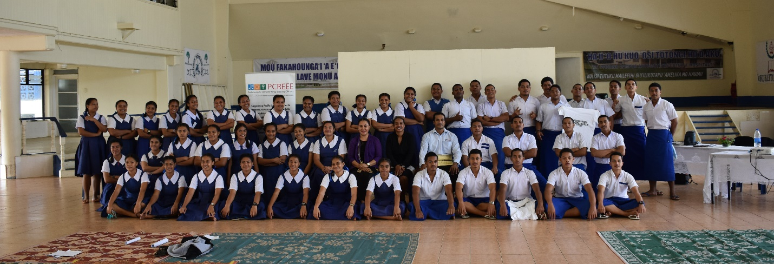
Form 5 and Form 6 students of Mailefihi Siu’ilikutapu College

1.0 Overview
PICTs face challenges with respect to energy for sustainable development due to the (i) population structure (ii) lack of significant economies of scale in the markets (iii) low electricity accessibility rate in some countries, (iv) varying ecosystems with marine being predominant and (v) varying availability of petroleum resources.
The Regional Energy Policy was developed from special concerns faced by PICTs. RE stands as a pillar to support Regional Energy Sector Policy and Planning (besides Transport, Power and Petroleum). As an integrated approach, the basis for achievement of energy security for PICTs is to focus on; (i) rural and remote areas, (ii) the environment of which the livelihoods of PICTs are dependent, (iii) strengthening capacity and (iv) RE and EE.
The PCREEE Regional RE and EE Awareness Campaign is a step forward to raise awareness and secure national interest in RE and EE to counteract the PICTs challenges with respect to energy for sustainable development from the Community to the National Level. Specifically, the Tongan RE and EE Awareness Campaign also promotes the Tonga EU Pac-TVET Programme.
The Joint PCREEE – PacTVET Promotion campaign in Vavaú was conducted in conjunction to the OIREP-PCREEE Awareness in the Outer Islands of Tonga. The PCREEE-PacTVET Promotion Campaign was introduced on the 1st of June at the OIREP-PCREEE-Exploring the Business Opportunities & Strengthening the Business Skills Capacity Of Stakeholders In Vava’u Workshop, which was an initiative supported by MEIDECC Office. MEIDECC Vavau also continued to support the initiative on the 2nd and 3rd of June, after the OIREP-PCREEE Workshop. The support provided was through logistical arrangements to visit four Secondary Schools in Vava’u, to ensure that the Joint PCREEE – PacTVET Promotion campaign was a success.
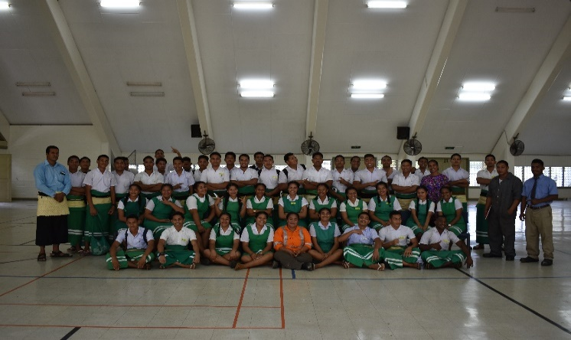
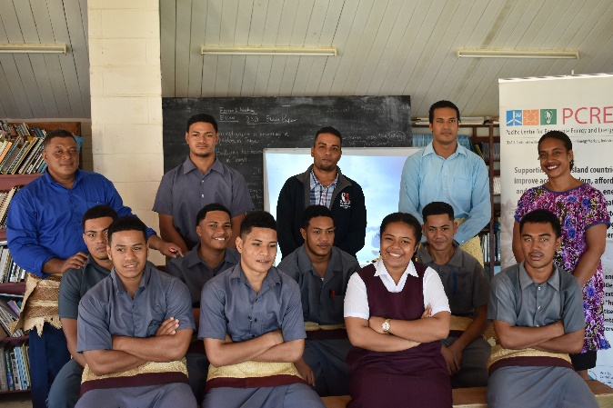
Saineha High School TVET Program
Vava’u High School form 5 TVET class
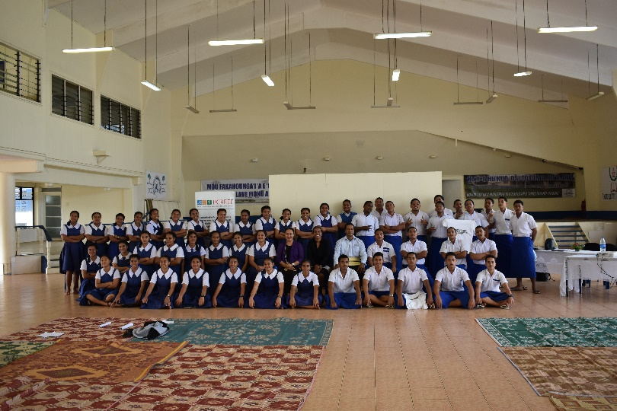
Mailefihi Siu’ilikutapu College form 5 and 6 students classes
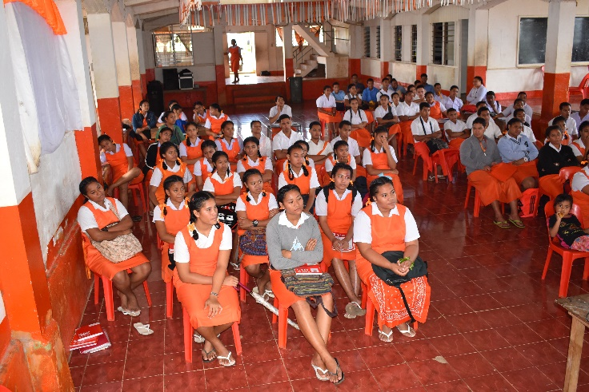
Tailulu College form 5,6 and 7 students
2.0 Objectives
The objective of the Joint PCREEE-PacTVET Promotion and Awareness Campaign was to;
- Raise the awareness in the Tongan Outer Islands on the need to accelerate the progress on RE and EE to meet national energy and GHG ambitions.
- Promote PCREEE and its activities in supporting Tongan Outer Islands energy and GHG ambitions
- Provide Educational and Awareness on RE & EE technology, entrepreneurship, industrial development and innovation
- Promote the EU-PacTVET activities in Tonga

3.0 Outcomes
Objective (a), (b) and (d) of the PCREEE-PacTVET Promotion Campaign were initially captured in conjunction with the OIREP-PCREEE Workshop in Vavaú on the 1st of June. The Workshops saw Stakeholders of the OIREP Project and interested members of the communities attend the organized activity. The attendees also gained an insight on the PCREEE and EU PacTVET activities aligned with the National Government initiatives to achieve national energy and GHG ambitions. (See PR on OIREP-PCREEE Workshop in Annex 1).

Furthermore, Objective (c) was conducted through visits to 4 High Schools which also captured Objectives (a), (b) and (d). This encouraged interactions with students whilst promoting RE and EE, and the TVET educational opportunities in SE (besides promoting the PCREEE and EU PacTVET activities in Tonga).

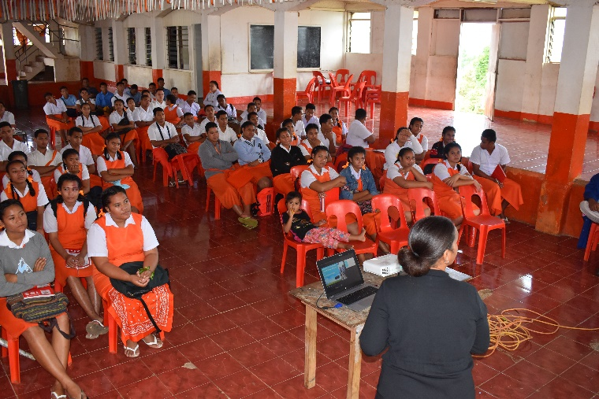

Ms. Darlen Lovi during the SE lecture at Tailulu College

- Raise the awareness in the Tongan Outer Islands on the need to accelerate the progress on RE and EE to meet national energy and GHG ambitions.

The initiative of the PCREEE and EU PacTVET Promotional Campaign assisted the attendees in the following, for the stated objective;

- Identify basis of the existence of PCREEE and EU PacTVET in Tonga
- Understand the establishment of entities to support government Policies in terms of the national energy and GHG ambitions
- Establish importance of stakeholder engagement to assist progress in the RE and EE space to meet the national energy and GHG ambitions

- Promote PCREEE and its activities in supporting Tongan Outer Islands energy and GHG ambitions

The initiative of the PCREEE and EU PacTVET Promotional Campaign assisted the attendees in the following, for the stated objective;

- Promote PCREEEs objectives for PICTs
- Promote PCREEE through identifying PCREEEs presence in the Tongan RE and EE space
- Raise awareness PCREEE initiatives to support energy and GHG ambitions in the Tongan Outer Islands
- Promote PCREEEs support for the EU PacTVET Project in Tonga
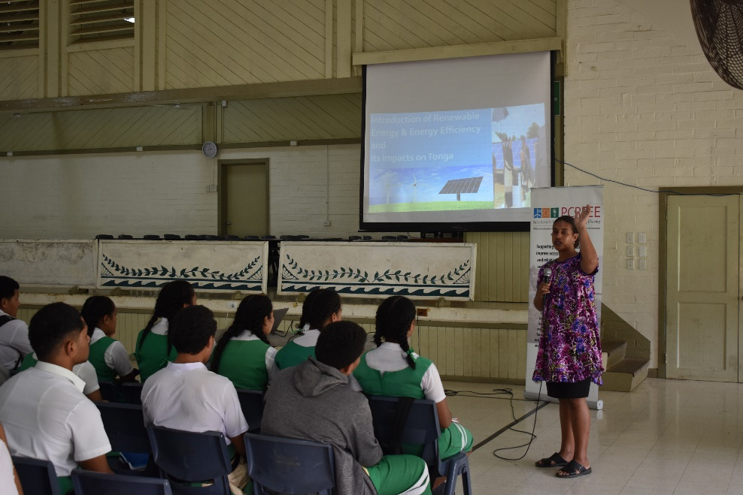

Introduction of PCREEE and its roles in PICT to support SE at Saineha High School

- Provide Educational and Awareness on RE & EE technology, entrepreneurship, industrial development and innovation

To meet objective (c), Four High Schools in Vava’u were visited. This activity was to provide awareness and create interest. The participants were mainly Form 5-7 students.
The SE trainings were conducted in these four High School in Vava’u in these dates and times
Name of School | Date | Time
- Mailefihi Siu’ilikutapu College | 2nd June 2020 | 10:00am
- Tailulu College | 2nd June 2020 | 11:30am
- Vava’u High School | 3rd June 2020 | 10:00am
- Saineha High School | 3rd June 2020 | 2:00pm

The initiative of the PCREEE and EU PacTVET Promotional Campaign assisted the students in the following, for the stated objective;
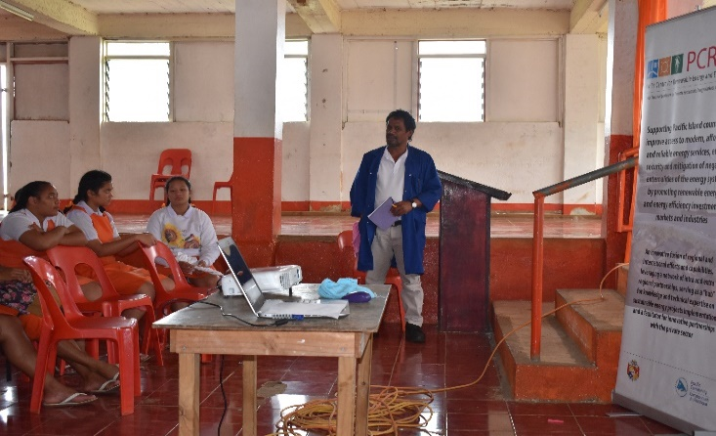
- Educate students on the following;
-Distinguish between brown and green energy
-Identify RE resource availability based educated guesses/observation
-Choose suitable RE technology to harness the available RE resource
-Importance of practicing energy efficient measures
Tailulu College TVET Teacher, Mr. Latu Funaki
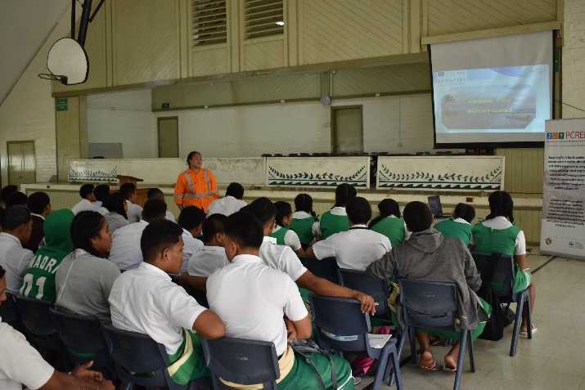
- Promote RE and EE technology as way forward for Sustainable Energy (SE) provisions in Tonga with positive consequential impact as stated;
- Reduction on GHG emission
-Energy Savings
-Savings on cost
-Entrepreneurship opportunities

- Promote EU PacTVET activities in Tonga. The presentation highlighted the important takeaways mentioned;
Tailulu College TVET Teacher, Ms. Susitina Koluse
-Educational and training opportunities through SE certificate level 1-4 which currently undergoing through registration process to become as a National Qualification by TNQAB .
-Industrial development
-Innovation

Each Session had a short quiz to summarize the presentations Quiz participants were given fifteen (15) printed T-shirts in total with the PCREEE logo / a promotional message. Photos were taken to show engagement and participation.

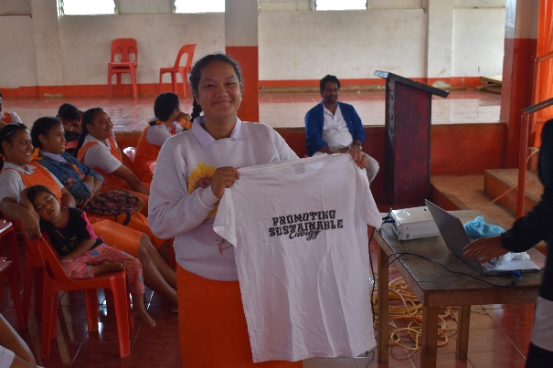
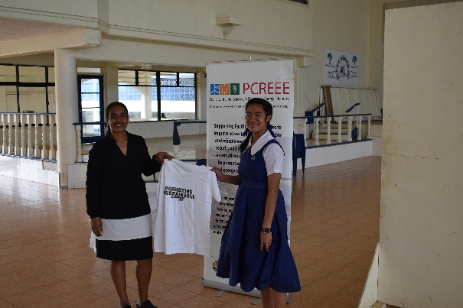
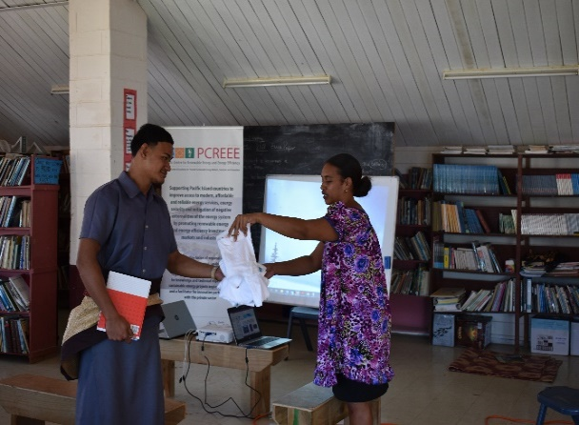
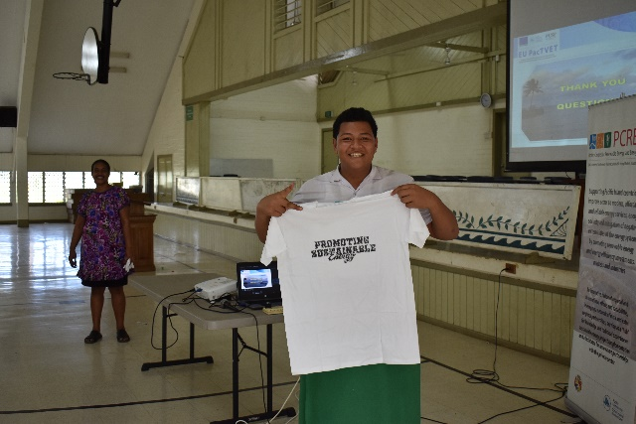
PCREEE Printed T-shirts promotional items awarded to students during the quiz sessions

- Promotion of the EU-PacTVET activities in Tonga

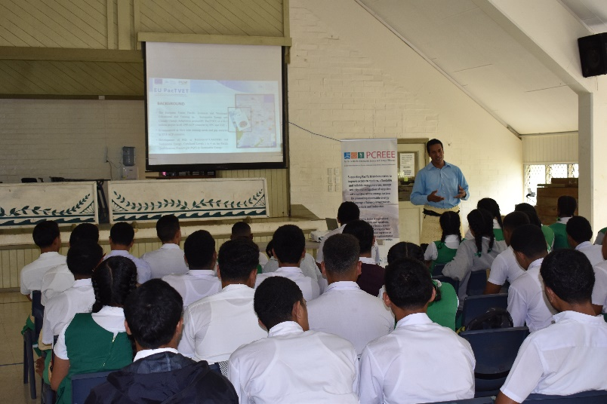
- Introducing the EU-PacTVET programs and its supporting activities to the Pacific Region including Tonga.
- Current Challenges faced by Tonga in promoting SE is due to lack of formal education and training available to be offered by the technical institutions for our youth to get trained. No Formal Qualification on SE has been registered and accreditation by TNQAB so far.
EU-PacTVET ICC, Mr. Paea Tauaika, Introducing the PacTVET program and its supporting activities to Tonga.
- EU-PacTVET project in collaboration with the office of TNQAB are working against time to develop and nationalize the SE cert 1-4 to be accredited as a National Qualification and also provide support to TIST as the primary technical institution to first offer the SE 3 and 4.
There were also positive feedback gathered during the campaign not limited to the following;
- “This is a great SE TVET training opportunity that we did see it’s coming, it will help our TVET classes as opportunity to look at it for more trainings and employment opportunity especially to be part of the Renewable Energy investments to reach 70% to 2030” - Principal of Maliefihi College.
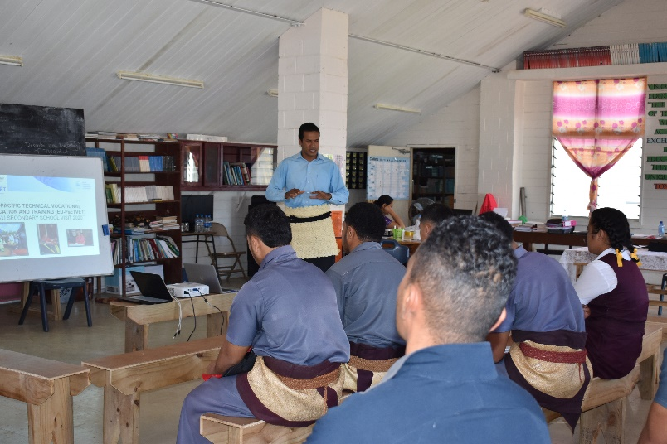
- “I have a child who is currently doing electrical training at TIST but I want him to take SE course immediately once it’s offered by TIST to return back and help fixing our solar house system’’.
- “It gives me confidence in investing on solar system to support our livelihood in this remote islands because I know there will be a formal training on SE available soon and it will help train our children to return back and conduct the installation and maintenance of the system without waiting for contractors. It takes months for the RE technician before their next visit to repair our solar system”.
EU-PacTVET ICC, continue the PacTVET lecture at Vava’u High School

4.0 Takeaways

The joint promotional and awareness campaigns of PCREEE-PacTVET was acknowledged to be a timely initiative that supports the National Government’s role to accelerate on national energy and GHG ambitions to successfully reach its ambitious targets of 50% RE by 2020 and 70% RE by 2030. For progression towards stated Government goals, it is vital to educate the community members on the need for a paradigm shift towards SE. Furthermore, the approach to raise awareness on educational and entrepreneurship opportunities in RE, EE and SE for the Tongan populace, as aligned with the efforts of the National Government, is a sustainable way forward for Tonga.

The promotion and awareness campaign also identified gaps that requires addressing to ensure that the progression of efforts reach fruition.

5.0 Challenges

- Language Barriers - Language barriers prevent vital information from being communicated to stakeholders, interested groups and community members.
- Generally, the educational awareness in the High Schools were observed to be limited by the following;
-varying levels of English proficiencies.
-moderate understanding of RE and EE observed at the High Schools visited
Students were able to grasp concept with use of diagrams/visuals, and through interactions during presentations. However, the quiz participation was a success.

6.0 Suggestions

- Use of Pamphlets and Placards in English and in Tongan for different audiences
- Custom made educational resources (especially Posters) in English and Tongan to be used for RE and EE awareness campaigns in Schools or distributed to school for awareness purpose
- The promotional and awareness campaign should be done every year to increase knowledge and interest of the student and community to SE.

7.0 Annex

Annex 1. PCREEE- OIREP Workshop PR
https://www.pcreee.org/article/promoting-sustainable-energy-business-opportunities-ha-apai-and-vava-u-kingdom-tonga

Annex 2. PCREEE-PacTVET School Visits _ Participants Lists

End

