Didactic Guide
  - Minigrids, Grid Stability in Insular Power Systems and Energy Storage

SIDS DOCK in cooperation with PCREEE, CCREEE and ECREEE.
Developed with key technical support of UNIDO and CIEMAT.
With the financial support of AECID and ADA.

Didactic Guide

Module Title Minigrids, Grid Stability in Insular Power Systems
and Energy Storage

OBJETIVES

General objective
The objective of this module is that the student learn which are the main criteria that they should take into consideration to achieve a high penetration of unmanageable renewable energy sources in insular power systems with a focus on Storage, Demand Management and Scheduling tools

Specific objectives
- Learn the procedure to size a minigrid and understand why the demand response programs are a key factor to reduce the Energy cost of an isolated power system.
- Identify the specific characteristics and limitations of the insular power systems.
- Know the main factors that affect the power system stability in high RES penetration scenarios in islands as well as to identify the main requirement that should be taken into account to reduce or mitigate these affections.
- Know the different storage technologies and their application in insular power systems
- Understand the importance of an optimal operation of an insular power system and identify which are the procedures to develop an optimal scheduling of the generation assets.
- Know experiences on islands to achieve the objective of increasing the Renewable energy generation around the world.

COURSE STRUCTURE
- Minigrids
  - Overview of the main RES generation technologies for islands: PV, Wind, Ocean energy, Biomass
  - Minigrid Concept and classification
  - Economic sizing of minigrids. Topology and technology decision
  - Demand side management in small insular minigrids
  - Operation and Maintenance in isolated minigrids

- Overview of Insular Power Systems
  - System size and infrastructure
  - Economic and environmental aspects of the Insular Power systems
  - Challenges and opportunities of the Insular Power systems

- Insular Power system management with High RES penetration
  - General aspects (Generation/Demand balance, voltage and auxiliary services)
  - Grid stability
  - Renewable generation characteristics and technical limitations
  - Characteristics and response of the RES generation to overcome problems of power stability
  - Modifications on the power system to increase the RES penetration
  - Power systems analysis
  - Example: Stability analysis of the integration of PV in isolated diesel dominated microgrids

- Storage Systems: Principles and applications in Insular Power Systems
  - Storage technologies for islands
  - Components of an energy storage system and operation modes
  - Storage applications
    - Generation: RES smoothing, time shifting
    - Distribution Level: Frequency regulation, voltage regulation, Load following, deferral investment
    - Consumer Level: Price following for end-users
  - Examples of storage integration in islands: Chemical Storage systems in islands: the cases of Tilos (Greece) and La Graciosa (Canary Islands, Spain)

- Technical and Economic operation of Insular Power Systems
  - Forecasting of RES and Load (Long-Term and Short-Term)
  - Demand side management and Demand response
  - Economic schedule
  - Spinning reserve and storage role in the operation of an Insular Power system

CONCEPTUAL MAP
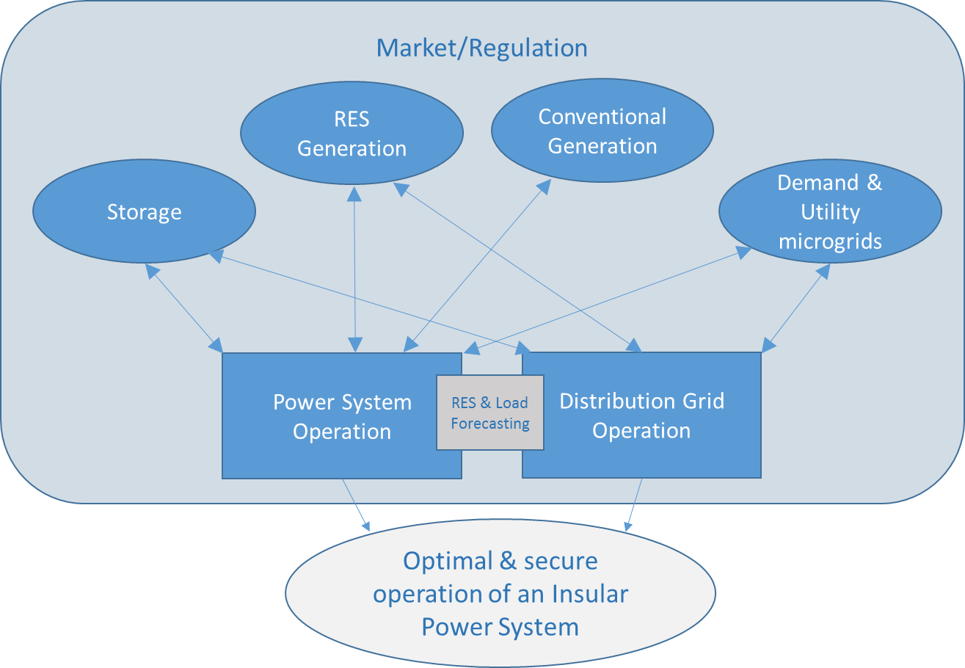

ACTIVITY PLAN
The study of this course requires reading and understanding of the theoretical concepts, which you will find in the documentation of the module. The content of this study covers the areas of the course activities, which will be evaluated at the end of this module. These activities are the following:
- Displaying the multimedia content and conduct of the assessment test type associated with it. This test will consist of 5 multiple choice questions. There are 2 attempts to do so.
To pass this activity the participant must achieve 80% correct answers (4 correct answers).
- Read the documentation. In the first place, the main text of the module has to be read. Later on, the student should check the bibliography to get a further understanding of the different concepts and in order to have an overview of all the data and information that is being addressed in each chapter.
- Case study. Technical-economic analysis of Grid Integration of photovoltaic systems with and without energy storage. The objective is to learn the basic parameters involved in the technical-economic evaluation of the interconnection to grid of a hybrid plant (Photovoltaic + Energy storage) to determine the best possible option according to the existing technical limitations, from a number set of scenarios.

A short self-assessment test will be presented to evaluate the knowledge and understanding after the performance of the practical case. For each question there will be several possible answers and only one correct. There are 5 attempts to perform the test. To overcome this activity the participant must have 100% of the correct answers.

Final self-assessment test, through which it can be checked the level of conceptual understanding of the module, and it can be used as a reference of these aspects that deserved a further analysis by the student

This test will present 20 questions with several possible answers and only one correct. You have 1 hour and 2 attempts to perform it. To pass this activity the participant should reach 80% of correct answers (16 correct answers).

To properly complete the course, the estimated time commitment is 20 hours distributed as is most convenient for each participant. Being a self-training mode is allowed flexibility in the implementation of activities, although we recommend regularly in the course, spending one to two hours daily, to the best use.

All those activities with more than one attempt for implementation, will consider the highest score to reach the final result.

DIPLOMA
Upon graduation UNIDO, CIEMAT and ECREEE will issue a certificate of achievement for participants who exceed the following requirements:
- View 100% of the content and achieve 80% of the assessment test associated with it.
- Perform the case study and correctly answer to 100% of the questions associated with it
- Overcoming 80% of the final self-assessment test.
Once achieved these requirements, the participant may access the appropriate section in the virtual classroom and download the diploma in electronic format.

