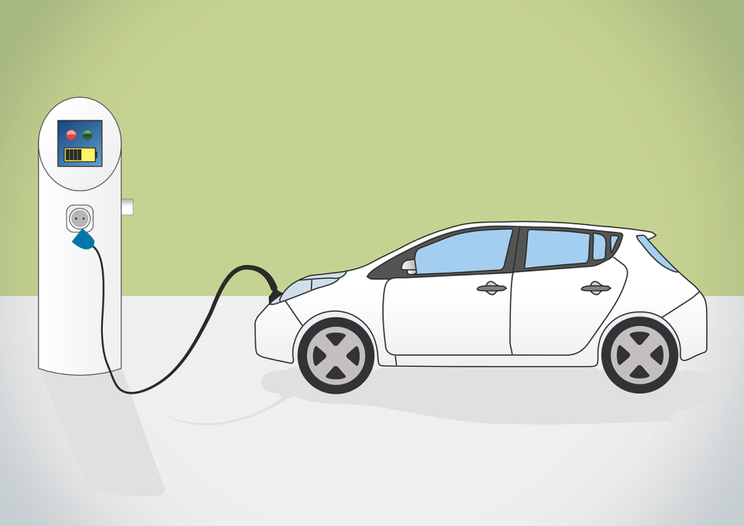

Didactic Guide
  - E-mobility
SIDS DOCK in cooperation with PCREEE, CCREEE and ECREEE.
Developed with key technical support of UNIDO and CIEMAT.
With the financial support of AECID and ADA.

Didactic Guide

E-mobility

OBJECTIVES

General objective
The main objective of this course is giving knowledge in the electric mobility solutions and technologies focused in the region.

Specific objectives
- Knowledge of basics and working principles of the constitutive parts of electric vehicles.
  - Energy storage, Batteries, Electric motors, Control electronics, Chargers, Mechatronics.
- Knowledge of the different vehicle alternatives and characteristics.
  - Bicycles,, motorcycles, light cars, cars, buses..
- Comprehension of charging of electric vehicles
  - Charging process, modes, plugs and connectors
- Understanding of the existing electric network, related to electric vehicles.
  - Knowledge of the existing electric network.
    - Generation, transportation, distribution and consumption.
  - Comprehension of the integration of e-mobility in the existing electric networks.
- Knowledge of the future of Smart Networks.
  - Distributed generation
  - Management and integration of Smart electric vehicles.

COURSE STRUCTURE
- Electric vehicles, constitutive parts
  - Energy Storage
    - Batteries
    - Fuel-Cells
    - Super Capacitors
  - Electric motors
    - Working Principles.
    - Electrical and mechanical characteristics.
    - Motors types
  - Control electronics
    - Power electronics elements.
    - Inverters
    - Chargers
  - Mechatronics
- Electric vehicles, alternatives
  - Classification of electric vehicles.
  - Past, present and future of EV’s.
  - Types of electric vehicles.
- Charging of electric vehicles
  - Charging modes.
  - Charging connectors and plugs.
  - Chargers and infrastructure.
- Electric networks for EV’s.
  - Description of the electric networks.
  - Electricity Timeline generation and consumption
  - Generation.
  - Renewable energy sources and EV’s.
  - Transportation
  - Distribution
  - Electric vehicle integration on the existing networks
- Smart networks and EV’s
  - Description and elements
    - V2G and G2V.
  - Distributed generation, consumption and smart agents
  - Integration of the electric vehicle in the smart networks.

CONCEPTUAL MAP
Enviroment

Renewable energies

Batteries
Electronics

Motor

EV Components

Electricity
Generation
NOT renewables

Electric Vehicles

Transportation

EV types

Electric Grids
Dsistribution
Chargers

Electricity Energy Market

ACTIVITY PLAN
The study of this course requires reading and understanding of the theoretical concepts, which you will find in the documentation of the module. The content of this study covers the areas of the course activities which will be evaluated at the end of this module. These activities are the following:
- Displaying the multimedia content and conduct of the assessment test type associated with it. This test will consist of 5 multiple choice questions. There are 2 attempts to do so.
To pass this activity the participant must achieve 80% correct answers (4 correct answers).
- Read the documentation. In the first place, the main text of the module has to be read. Later on, the student should check the bibliography to get a further understanding of the different concepts and in order to have an overview of all the data and information that is being addressed in each chapter.
- Case studiy 1. Calculation of the grid capacity of an island for the charging of electric vehicles. From a given grid of an island in the study area, it is intended to calculate the maximum number of electric vehicles that could be loaded by time slots.
Case study 2. Design of the mix of electrical production sources to minimize the cost for charging a number of electric vehicles on an island, in the area of influence. An average car will be used for the calculations, from which the data will be given. It should be done for several scenarios of use of the vehicles, related to the use of them.

A short self-assessment test will be presented for each one of the case studies to evaluate the knowledge and understanding after the performance of these practical cases. For each question there will be several possible answers and only one correct. There are 5 attempts to perform each of the tests. To overcome this activity the participant must have 100% of the correct answers.

Final self-assessment test, through which it can be checked the level of conceptual understanding of the module, and it can be used as a reference of these aspects that deserved a further analysis by the student

This test will present 20 questions with several possible answers and only one correct. You have 1 hour and 2 attempts to perform it. To pass this activity the participant should reach 80% of correct answers (16 correct answers).

To properly complete the course, the estimated time commitment is 20 hours distributed as is most convenient for each participant. Being a self-training mode is allowed flexibility in the implementation of activities, although we recommend regularly in the course, spending one to two hours daily, to the best use.

All those activities with more than one attempt for implementation, will consider the highest score to reach the final result.

DIPLOMA
Upon graduation UNIDO, CIEMAT and ECREEE will issue a certificate of achievement for participants who exceed the following requirements:
- View 100% of the content and achieve 80% of the assessment test associated with it.
- Perform the case study and correctly answer to 100% of the questions associated with it
- Overcoming 80% of the final self-assessment test.
Once achieved these requirements, the participant may access the appropriate section in the virtual classroom and download the diploma in electronic format.

