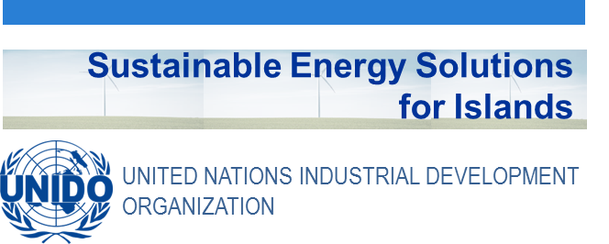
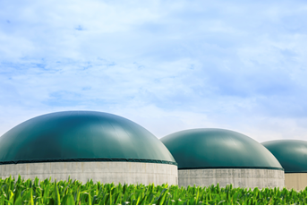

Didactic Guide
Bioenergy. Anaerobic digestion of organic waste to energy solutions
SIDS DOCK in cooperation with PCREEE, CCREEE and ECREEE.
Developed with key technical support of UNIDO and CIEMAT.
With the financial support of AECID and ADA.

Didactic Guide

Bioenergy. Anaerobic digestion of organic waste to energy solutions

objectives

General objective

The general objective is to provide a global perspective of Biogas in an energy and environment context in the framework of Latin America and the Caribbean. The module presents the theoretical foundations concerning the anaerobic digestion process, and the technical aspects needed to obtain a broad understanding of this renewable energy are disclosed, from the source of production to final use, in its different areas such as: resource characteristics, available technologies, composition and production, current applications and new developments. In addition, information on projects related to biogas, that are currently underway in the region of Latin America and the Caribbean, will be provided.

Specific objectives
- To introduce the students to the knowledge and importance of biogas in order to stimulate the implementation of this renewable energy in Latin America and the Caribbean.
- To make the students aware of different types and characteristics of existing biodegradable wastes (agro-industrial waste, livestock waste, organic fraction of municipal waste, sewage sludge), as a resource for biogas production and its current importance as an energy source, so that they can evaluate, based on its characteristics and generation, the biogas potential in their respective islands countries and territories.
- To introduce students to the environmental and energetic benefits that can be obtained with appropriate management of biodegradable wastes.
- To study the fundamentals of the process to produce methane, microbiology, factors that influence the operation and control of the process, and the final products.
- To inform on the different types of existing anaerobic digesters, and the selection of the most appropriate ones depending on the characteristics of biodegradable waste to be treated.
- To show the most suitable anaerobic digesters for application in rural areas in developing countries. Students will complete a case study that will aim to determine the design of a digester for livestock waste treatment in rural areas, and calculate the biogas that can be obtained, and its possible applications.
- To study the biogas generation process that occurs in landfills, extraction infrastructure and requirements of use, and the benefits of its removal. The application of landfill biogas production model “LandGEM EPA version 3.02” to a sanitary landfill, whose details will be provided, will be conducted by the students.
- To raise awareness about the bioreactor landfill concept and to expose the research being carried out in order to take it into account as a possible future implementation in Island countries and territories.
- To study the composition and characteristics of biogas by showing the current applications and the new developments that are taking place. To analyze the possible applicable uses in Latin America and the Caribbean.
- To inform on successful experiences in Latin America and the Caribbean on the production and use of biogas, through case studies of currently operating plants. Also, to report about PROBIOGAS, a unique and strategic project which has taken place in Spain, in order to promote agro-industrial biogas.

COURSE STRUCTURE
Biogas
Module Objectives
1. Introduction
1.1. Sustainable development
2. Biodegradable Waste
2.1. Waste Characterization Parameters
2.2. Manure Waste
2.2.1. Production
2.2.2. Composition
2.2.3. Manure waste characteristics
2.2.4. Livestock in Island countries and territories
2.3. Agro-industrial wastes
2.3.1. Agro-industrial waste characteristics
2.3.2. Agro-industrial waste production in Island countries and territories
2.4. Municipal Solid Waste
2.4.1. Production
2.4.2. Composition
2.5. Sludge wastewater treatment plant
2.5.1. Production
2.5.2. Characteristics
2.5.3. Sludge wastewater treatment plants in Island countries and territories
2.6. Waste mixture: Codigestion
3. Anaerobic Digestion or Biomethanation
3.1. Historical Review: The Finding of Biogas
3.2. Environmental benefits and advantages of Anaerobic Digestion
3.2.1. Environmental benefits of anaerobic digestion
3.2.2. Advantages of anaerobic digestion
3.3. Biodegradability of organic material components
3.4. Anaerobic process stages
3.4.1. Hydrolysis
3.4.2. Acidogenic phase
3.4.3. Acetogenic phase
3.4.4. Methanogenic phase
3.4.5. Formation of hydrogen sulphide
3.5. End Products of Anaerobic Digestion Process
3.5.1. Biogas
3.5.2. Digestate
3.6. Factors influencing the operation and control of anaerobic processes
3.6.1. Startup phase. Initial inoculum
3.6.2. pH
3.6.3. Alkalinity
3.6.4. Volatile Fatty Acids (VFA)
3.6.5. Redox Potential
3.6.6. Temperature
3.6.7. Nutrients
3.6.8. Toxicity and inhibition
3.6.9. Homogenization
3.6.10. Hydraulic Residence Time (HRT)
3.6.11. Solids Retention Time (SRT)
3.6.12. Organic Loading Rate (OLR)
4. Anaerobic technologies. Digesters in rural areas of developing countries
4.1. Brief History: Evolution of technology
4.2. Digesters types depending on the load frequency
4.2.1. Batch
4.2.2. Continuous
4.2.3. Semicontinuous
4.3. Anaerobic Digestion in rural areas in developing countries
4.3.1. Technology Integration
4.3.2. Advantages and disadvantages of the application of basic digesters in rural
4.4. Small-scale digesters and low cost
4.4.1 Fixed-Dome Digester
4.4.2 Floating Drum Digester
4.4.3 Tubular Polyethylene Digester
4.5. Construction and design of a polyethylene tubular digester
4.5.1. Dimensioning and design
4.5.2. Construction materials
4.5.3. Working area
4.5.4. Construction of the structure to the digester
4.5.5. Installing the digester and first load
4.5.6. Greenhouse construction
4.5.7. Construction of gas pipeline
4.5.8. Biogas production
4.6. Factors influencing the operation and control of this type of digesters
4.7. Programs for development

5. Advanced Anaerobic Technologies
5.1. Interaction between substrate, nutrients and microorganisms
5.2. Digesters based on keeping suspended biomass inside the reactor
5.2.1. Continuously Stirred Tank Reactor (CSTR)
5.2.2. Plug Flow
5.2.3. Contact Digester
5.2.4. Upflow Anaerobic Sludge Blanket (UASB)
5.3. Attached growth systems
5.3.1. Biomass attached to fixed surfaces
5.3.2. Biomass attached to moving surfaces
5.4. Two-Phase Digesters
5.5. Comparison between different technologies
5.6. Evolution of industrial digesters (large size)
5.7. Practical experience in Latin America: Ron Brugal plant in Dominican Republic
5.7.1. Introduction
5.7.2. Process
5.7.3. Treatment plant vinasse generated in Ron Brugal
5.7.4. Characteristics of anaerobic digestion of Ron Brugal
5.7.5. Characteristic of biogas obtained in the plant
5.8. Unusual strategic project PROBIOGAS
5.8.1. Objective
5.8.2. Scope
6. Landfill gas. Biogas from MSW landfill
6.1. Situation in Island countries and territories with respect to the treatment of MSW
6.2. Stages of formation of biogas in a sanitary landfill
6.3. Conveniences of landfill gas extraction
6.4. Extraction infrastructure and use of landfill gas
6.4.1. Collection wells and conduction lines
6.4.2. Torch
6.4.3. Regulating and metering station
6.4.4. Cleaning systems to remove corrosive compounds and water
6.4.5. Biogas utilization system
6.4.6. Investment costs associated
6.5. Energy potential of a sanitary landfill
6.5.1. Biogas production in a sanitary landfill
6.5.2. Potential of biogas
6.6. CDM Projects in landfills. Experiences in Island countries and territories
6.6.1. Case Study. New landfill gas plant in Bordo Poniente landfill (Mexico)
6.7. Landfill Bioreactor
6.7.1. Characteristics of bioreactor landfills
6.7.2. Potential advantages of the bioreactor landfills
6.7.3. Considerations to take into account in the bioreactor landfills
6.7.4. Epa's research about landfill bioreactor. Practical case: Yolo County Landfill
7. Biogas
7.1. Characteristics of the main constituents
7.1.1. Methane
7.1.2. Carbon dioxide
7.1.3. Minority compounds
7.2. Equivalences of BIOGAS with other energy sources
7.3. Uses of biogas as a renewable energy source
7.3.1. Obtaining heat by direct combustion
7.3.2. Electricity generation
7.3.3. Cogeneration systems
7.3.4. Integration into the natural gas grid
7.3.5. Vehicle Fuel
7.4. Energy production from biogas in Island countries and territories
7.5. Biogas treatment depending on usage
7.5.1. Moisture reduction
7.5.2. H₂S reducción
7.5.3. CO₂ reduction
7.5.4. Treatment with filters

CONCEPTUAL MAP
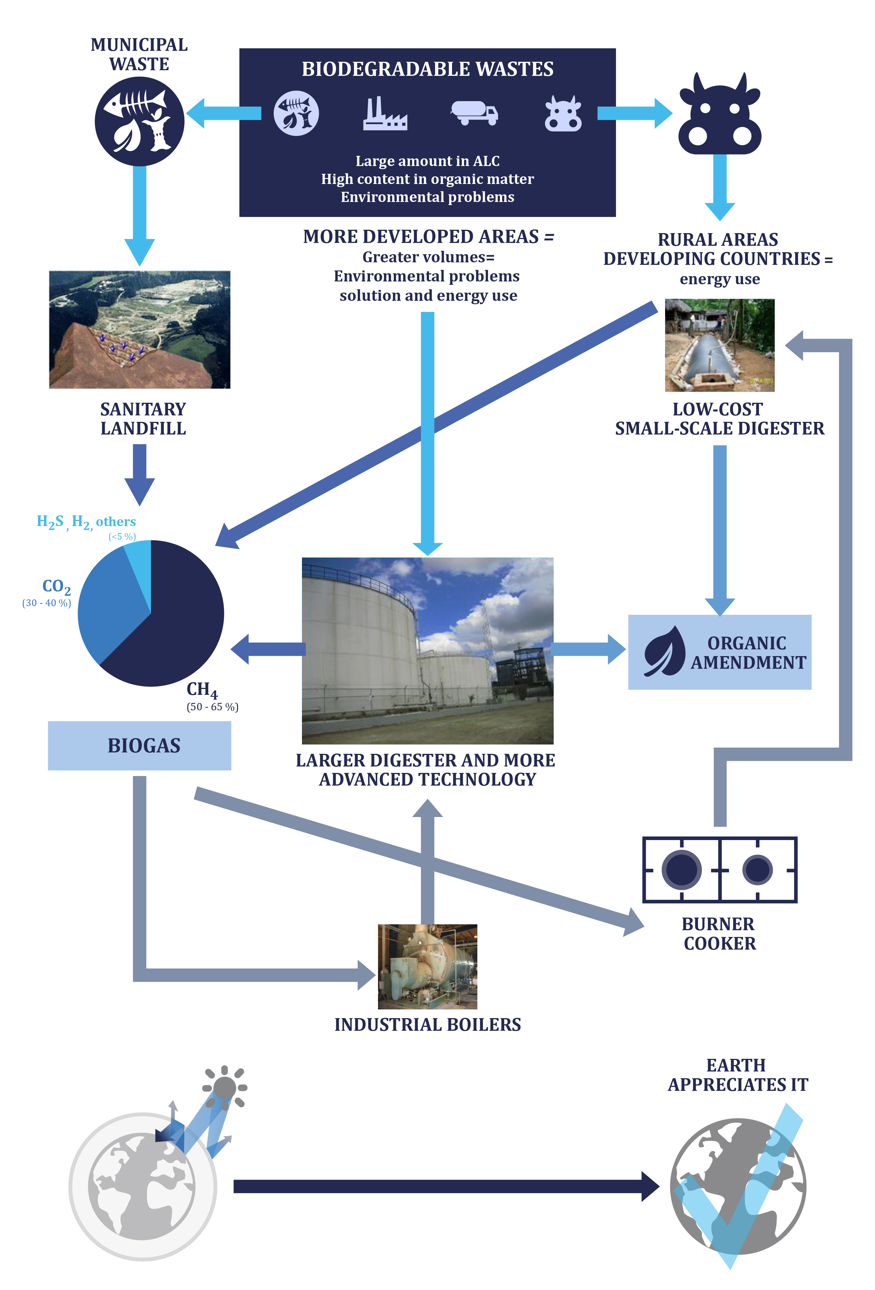

METHODOLOGY AND PLANNING
The study of this course requires reading and understanding of the theoretical concepts, which you will find in the documentation of the module. The content of this study covers the areas of the course activities which will be evaluated at the end of this module. These activities are the following:
- Displaying the multimedia content and conduct of the assessment test type associated with it. This test will consist of 5 multiple choice questions. There are 2 attempts to do so.
To pass this activity the participant must achieve 80% correct answers (4 correct answers).
- Read the documentation. In the first place, the main text of the module has to be read. Later on, the student should check the bibliography to get a further understanding of the different concepts and in order to have an overview of all the data and information that is being addressed in each chapter.
- Case study: it is proposed to improve the energy conditions of a rural family who lives in an insular territory from generated wastes by the animals of their small farm. To do this, from the data provided, the student should perform: the design of a low cost digester and its structure, the design of the first two loads to the digester, an estimation of the production of biogas that can be obtained and, finally, possibilities to use the energy obtained. With this exercise, the students will become familiar with the concepts they have learned.
A short self-assessment test will be presented with 5 attempts to perform the test. To pass these activities the participant should have 100% of the correct answers.
- Final self-assessment test, through which it can be checked the level of conceptual understanding of the module, and it can be used as a reference of these aspects that deserved a further analysis by the student. This test will present 20 questions with several possible answers and only one correct. You have 1 hour and 2 attempts to perform it. To pass this activity the participant should reach 80% of correct answers (16 correct answers).

To properly complete the course, the estimated time commitment is 20 hours distributed as is most convenient to the participant. Being a self-training mode is allowed flexibility in the implementation of activities, although we recommend regularly in the course, spending one to two hours daily, to the best use.

All those activities with more than one attempt for implementation, will consider the highest score to reach the final result.

DIPLOMA
Upon graduation UNIDO, CIEMAT and ECREEE will issue a certificate of achievement for participants who exceed the following requirements:
- View 100% of the content and achieve 80% of the assessment test associated with it.
- Perform the case study and correctly answer to 100% of the questions associated with it
- Overcoming 80% of the final self-assessment test.
Once achieved these requirements, the participant may access the appropriate section in the virtual classroom and download the diploma in electronic format.

