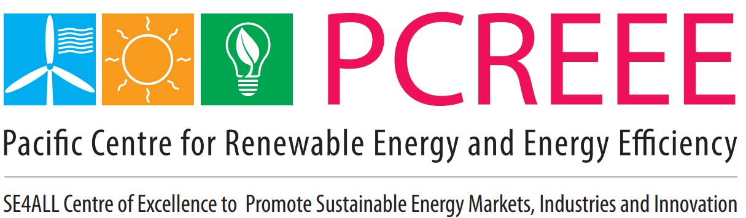  Ministry of Climate Change, Port Vila, Vanuatu | UNDP/GEF BRANTV Project  BACK TO OFFICE REPORT (BTOR) – PV Solar Local Operator Training in Kole 1 Community, East Santo  Submitted by: Joel Galeb  Submission Date: 3rd May 2021
Component: 1: Capacity and Awareness Enhancement on Sustainable Energy and Low Carbon Development.  Component: 3: Institutional Framework Enhancement for Sustainable Energy and Low Carbon Development.  Activity Title:  - PV Solar Local Operator Training. | Output 1.1 Activity ref #: 1.1.1C & 1.1.1d– 2020 AWP  Output 5B.3 Activity ref #: 5B.3.3  Project Document Description of Activity.  1.1.1c: Training program for local operators of village community PV systems (3 to 10kW, with or without mini-grids) in Vanuatu. Training covers wiring of electrical connections; operation and monitoring of PV panels, batteries, and mini-grids; fee collection; and simple maintenance. Around 25 persons will be trained, ensuring adequate number of personnel to support each of the project’s 10 training with emphasis on systems operated and used by village communities as opposed to institutions.  1.1.1e: training program in the installation, troubleshooting, and repair of small SHS and nano grids  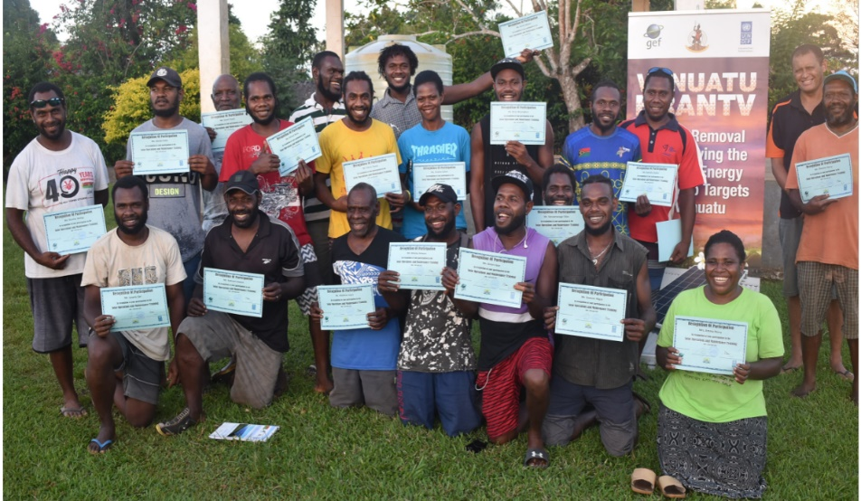
Name (s) of officers taking part in the Activity 1.1.1c,d & e : Joel Galeb (PMU) and Mr. Stephen Mataitini ( PVTC Instructor )
Date of activity 1.1.1: 19th – 23rd April 2021. | Location of Training:  - Kole 1 Village, East Santo Island.
Approved Mission Itinerary:  Ms. Doreen Leona, Project Manager and  Mr. Antony Garae, Director DoE | Counterparts Discussed-with/Met :(In each location)  - Pacific Centre for Renewable Energy and Energy Efficiency (PCREEE) and South Pacific Commission (SPC) office in Tonga  - Village Chiefs, Village Council  - Church leaders,  - Women group,  - Youths and  - Community members.  - Department of Fisheries  - 20 training participants
Objectives of the Mission:
To achieve BRANTV Project Output 1.1, Activity 1.1.1c & 1.1.1e.:
Planned Activities/Interventions during the mission:
PV Solar Local Operator Training, East Santo Island Kole Village:
- Theory component
- Practical Sessions (Three Station Setup).

Description of Mission Conduct/ Main Findings (vis-à-vis the objectives /activities above):

Introduction

Local Operator Training (LOT) is conducted to upskill communities of the BRANTV Project Demo sites the capacity to maintain Community Scale PV Solar systems installed in the communities. This training is targeted for demo sites in the Northern region from the island of Mota Lava in Torba Province, Malekula, Ambrym, Maewo, Malo and East Santo. Communities in East Santo are Kole 1, Kole 2, Kole 3, Lathi and supposedly for Lelek and Sara, however didn’t turn out as planned as Lelek and Sara had other plans and didn’t turn up for the training.

The first participants arrived in Luganville on the 16th of April and the last participants arrived on 18th of April. Everyone departed Luganvile and traveled to Kole 1 (Training site) on 18th of April. On arrival, the community led by Chief John Hov organized are welcome ceremony and speeches were presented to acknowledge PMU/DoE, PVTC and PCREEE and SPC for choosing their village to host the training. The participants were given time to introduce themselves, whereby the PMU officer Mr. Joel Galeb responds to express word of thanks to the chief and community for accepting the request to host the training. Further he continued to give a brief background of the project and purpose of conducting this training and its direct benefits to the participants and the Community at large. Further he elaborated on how this training will relate to the Government achieving its national policies on the National Energy Road Map Targets by 2030. The official opening of the training was then declared by Kole Presbyterian Church Clark Mr. Johnsen
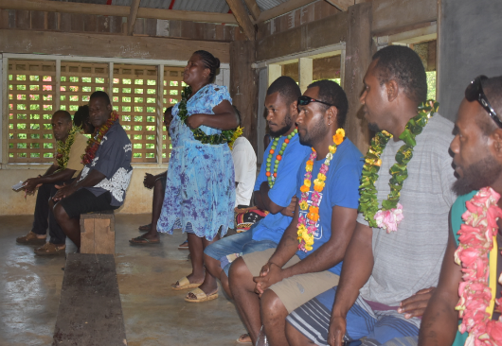
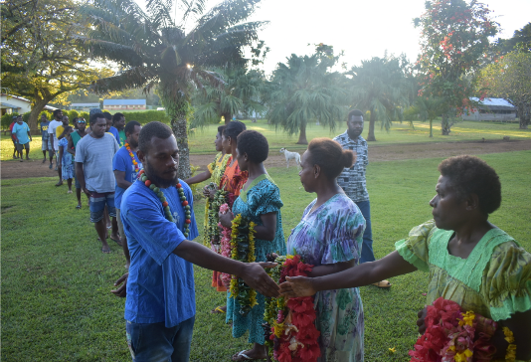
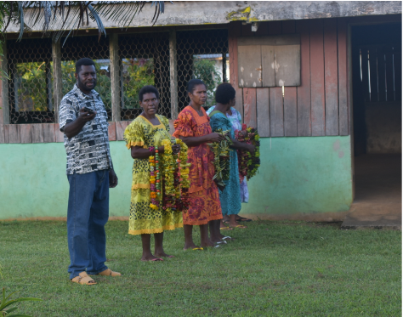

Pict 1: Community welcome team Pict 2: Receiving of Salusalu Pict 3: Participants introducing themselves
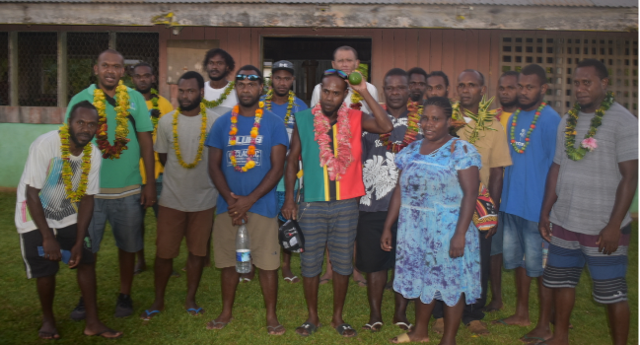
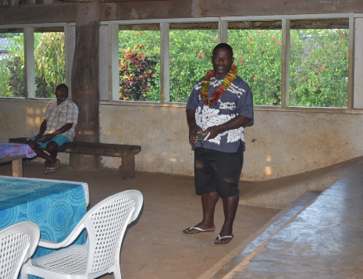

Pict 4: Chief John Hov of Kole opening speech. Pict 5: Team group photo Launching of training.

Training Sessions

Registration commenced on the 19th of April. A total of twenty (20) participants registered of whom two are females participants.

On the first day of class, trainees were given a chance by the PVTC instructor to introduce themselves and express their interests and what they expect to achieve from this training. The participants were divided into four (4) groups of five (5) days training. As structured by the instructor the first three (3) days of training, Monday, Tuesday and Wednesday were allocated to sessions on theory. Participants were lectured on the functions and other vital theoretical information of the PV Solar System. Activities and exercises were given out to the four groups and presented by group leaders to the instructor and the entire class. During those days, the theory assessments were handed out to the participants to complete while learning the different theoretical information of the System Components.
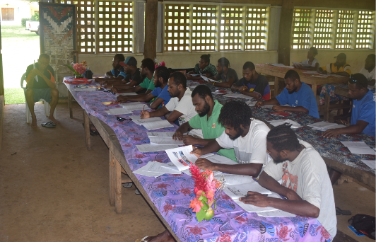
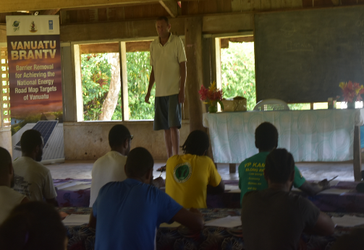
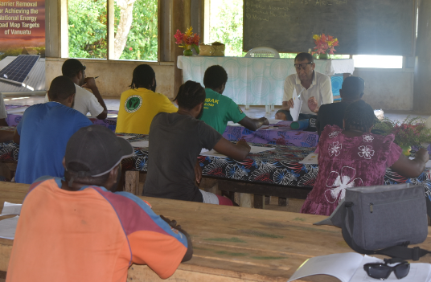

Pict 6: Theory lessens with PVTC instructor. Pict 7: Theory lessens with PVTC instructor. Pict 8: Theory lessens with PVTC instructor.
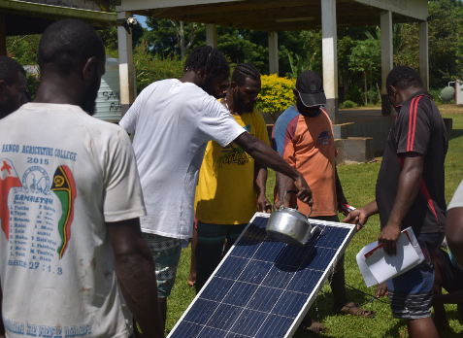
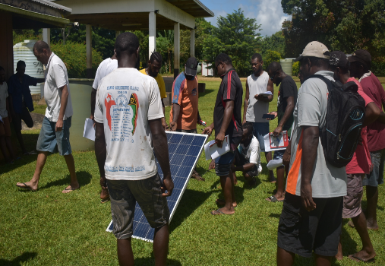
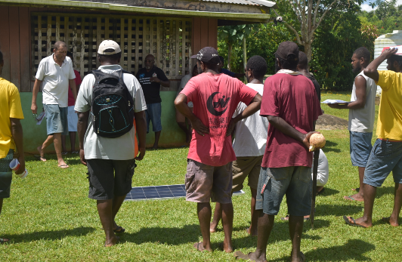

Pict 8: PV Solar Module Voc&Isc theoretical test. Pict 9: PV Solar Module Voc&Isc temperature test

The final two days of training, Thursday and Friday was assigned for hands on practical exercises. Each of the participants had a chance to feel and work with the tools and equipment to connect a PV Solar System of capacity 250W. Practical exercises were thought on how to connect PV Solar System and troubleshooting techniques to detect fault in a DC system and the AC wiring of community buildings and productive uses.

During the last two (2) days of training, Practical Assessments were conducted by the Instructor to each of the trainees. The objective is to test their understanding of the topics thought in the class room learning. All four (4) groups were given a chance to connect their systems, and were assessed and tested of their connections. The results were accurate and proved by switching on LED Lights connected to their systems. For reference, PV Solar System Local Operator Training Manuals were handed to each of the participants for guidance and to help them gain more interest in PV Solar and other RE Technologies. The training ended on Friday 23rd April with presentation of Certificates of Attainment to all 20 participants. The Certificate of Qualification will be issued by the Vanuatu Qualification Authority (VQA). The final exercise involved participants visited households in the village and trouble shoot faults reported in their home Solar System to determine the cause of the problem and fix it.
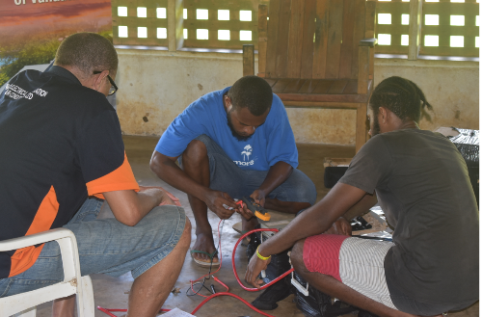
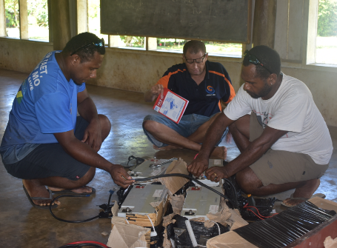
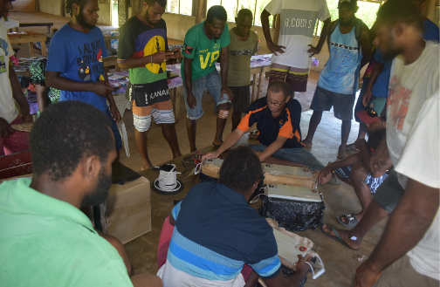

Pict 10: PVTC Instructor explain practical exercise. Pict 11: Practical exercise and assessment.
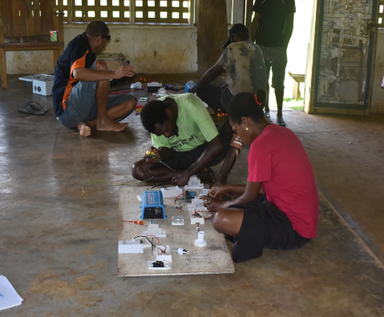
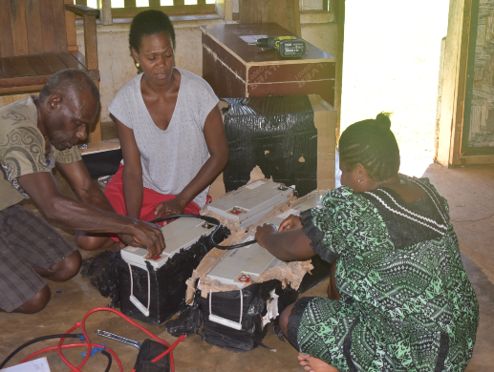
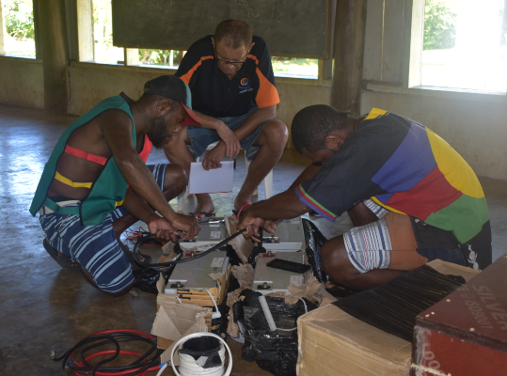

Pict 12: Practical exercise and assessment. Pict 13: Practical Session.
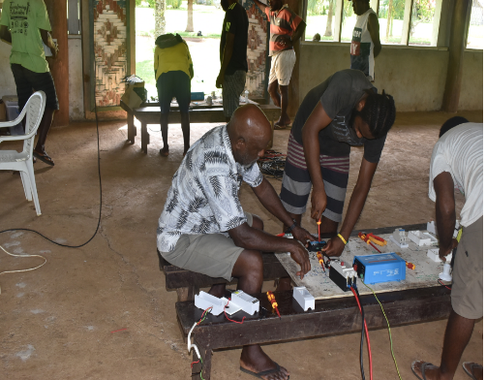
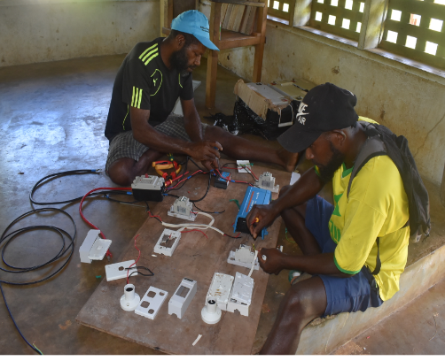
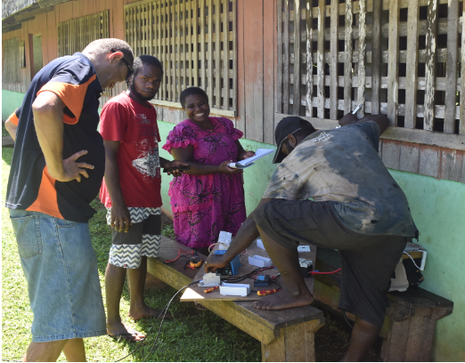

Pict 14: Practical Session Pict 15: Practical Session Pict 15: Practical Session.

Training Remarks

At the end of the training sessions, participants were given a chance to express his/her opinion on the training and how they will utilize the knowledge and skills they gained in their respective communities. They express their word of thanks to the Vanuatu Government and most importantly to funding partners, GEF, UNDP, PCREEE/SPC and DOE to organize such an important training that is brought right down to their door steps. Most of them mentioned that they have been doing PV Solar Installations and Electrical Wiring from experiences. They never came across such a training that gives a clear explanation of the whole solar and electrical system. They believe that the knowledge they gained will highly be beneficial to their communities. One participant mentioned, with a higher number of younger generations travelling to Australia and New Zealand for Fruit Picking Scheme, PV Solar Systems is a priority in their bucket list to purchase for home lightings. However, the technical knowledge for maintenance in the community is low, thus this training gives them the confidence to maintain any solar systems in the community. They will become valuable assets helping the communities to maintain their solar systems and charge a bit of money to earn for their income.

Acknowledgement

Overall, Local Operator Training at Kole village was a success. The Community of Kole 1 Village was well organized and had prepared to host the participants and facilitators for five (5) days of training. Everyone enjoyed a good hospitality from the host community. Meals were provided in time and accommodation was well taken care off. The Training Instructor Mr. Stephen Mataitini from Pacific Vocation Training Centre (PVTC) has wealth of experience in training of standalone PV solar systems. With that he had delivered an exceptional training lesson which was well acknowledged by both the participants and the representative of BRANTV PMU Mr. Joel Galeb. The success is made possible through the funding partners. As such, the host Community of Kole 1, the facilitator and the training participants wish to convey their words of appreciations to GEF/UNDP, PCREEE/SPC and the Government of Vanuatu for funding the training program. All these were made possible through their funding commitments.

Recommendations
There are some areas that were identified from this first training and are recommended for consideration:
- Language used in the training manual is English and the participants recommends that this is translated into Bislama version a national dialect that is understood by all participants who is not fluent in English language.
- All training materials should be well checked, identified and well packed for shipment to and from the training location.
- Communications has been a challenge. It is recommended that Community is well informed of their expectations and duties and responsibilities well in advance to give them ample period of time for preparation. The PMU who is the focal point in facilitating trainings is responsible for information flow between different parties involved.
.

Specific Project Performance/Implementation Issues (including key challenges):
- The greatest challenge rest with logistics. It is not easy to move people from different islands to come to the training location. Participants traveled by air, sea and land to arrive in Luganville and then traveled to Kole village.
- Poor Network Coverage in some project sites to confirm names of participants makes communications a greatest challenge.
Recommendations/Follow-up Points and by whom:
- PMU
- PVTC

Attachments/Annexes to this Report:
Pictures of training in the main body of the report.

Reported by:  Joel Galeb | Signature:
Endorsement by Supervisor /Head of the Unit
I have read this report (and its Appendices) and support its outcomes and conclusions.

Signature: Doreen Leona Date:

