OUTCOME REPORT ON THE JOINT OIREP-PCREEE WORKSHOP ON
EXPLORING THE BUSINESS OPPORTUNITIES & STRENGTHENING THE BUSINESS SKILLS CAPACITY OF STAKEHOLDERS IN HA’APAI & VAVA’U
20th May to 1st June 2020
Kingdom of Tonga

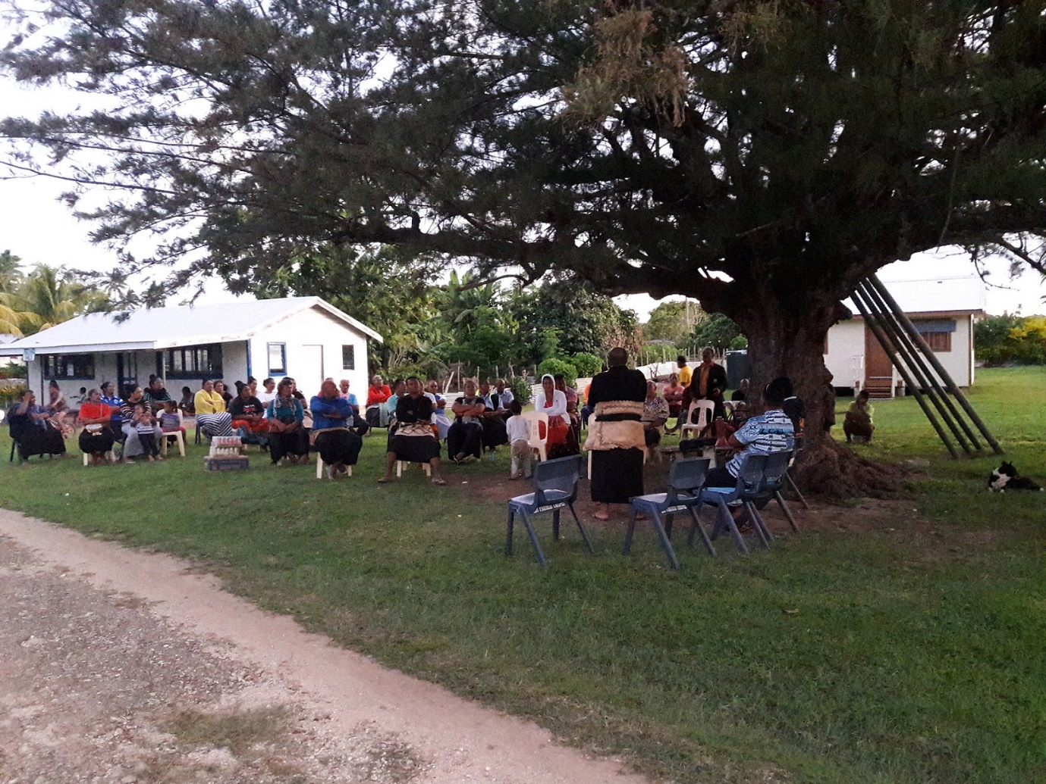

- ACKNOWLEDGMENT

Organising a successful workshop was from the support of the Asian Development Bank (ADB) and Australia Funded-Outer Island Renewable Energy Project (OIREP) Safeguard Specialist, Kaione Loumoli, Sione Pongi – Tonga Power Limited, Paea Tau’aika – EU-PacTVET ICC for Tonga. In arranging of the logistics and contacting the main targeted participants beforehand. The success of this workshop is the result of the PCREEE team hard work.

However, the key for the success of the workshops is the involvement and interest of the participants. Where the workshops were first started at the Ha’apai Group (Nomuka Is, Ha’afeva Is, ‘Uiha Is, Ha’ano Is) and then Vava’u. The atmosphere of cooperation between the different participants of each island community provided and identify the needs in renewable energy and energy efficiency. Thus the acknowledgement of the team, the support from the Ministry of MEIDECC and the participants of the workshops and many thanks for the hard work and the information provided.

- BACKGROUND

The Nuku’alofa-based Pacific Centre for Renewable Energy and Energy Efficiency is a regional set up to up-scale and replicate success stories in renewable energy and energy efficiency, conduct targeted private sector activities in capacity development, knowledge management and innovation, awareness raising, as well as investment and business promotion. The Centre has a strong focus on the private sector and industry while supporting targeted renewable energy and energy efficiency programs to enhance the productivity of key industries with high job leverage (e.g. agriculture, tourism, fishery, manufacturing, creative industry) and the creation of a local sustainable energy servicing and manufacturing industry.

- MISSION OBJECTIVES
The workshop aims at:
- Improving the business skills and awareness about sustainable energy business start ups
- Raising the awareness on possible small-scale business opportunities and productive utilization of renewable energy in the local community sector
- Strengthening the capacity of Stakeholders in preparing proposals on utilizing sustainable energy to support small scale businesses
- Identify workable strategies to raise effective, sustainability management of the installed mini grids

- MISSION OUTCOME
- Increased number of business initiated in Vava’u and Ha’apai
- Increased productive usage of electricity due to new business opportunities
- Sustainability of the OIREP systems is guaranteed
- Increased economic growth in Vava’u and Ha’apai

- INTRODUCTION
The Government of Tonga through its Tonga Energy Roadmap (TERM) is aiming to (i) reduce the country’s dependency on externally sourced fuels with exposure to the associated price volatility while (ii) improving energy efficiency, (iii) increasing the accessibility to electricity for the Tongan Population and (iv) improving the affordability of electricity for all users via a lower electricity tariff. In recognition of these four objectives, Tonga has set, amongst other targets, an ambitious target to generate 50% of the country’s electricity from renewable energy resources by 2020 (now changed to 2021 due to the Coronavirus pandemic). The Outer Island Renewable Energy Project (OIREP) is seen as an important milestone for the government to achieve these goals and objectives. The goals and objectives shall be met by provision of sustainable and environmentally friendly renewable energy from technologies such as solar photovoltaic power and battery energy storage.

The Pacific Community (SPC) Pacific Centre for Renewable Energy and Energy Efficiency (PCREEE) is a regional vehicle for accelerating the deployment of renewable energy and energy efficiency in the Pacific Islands by supporting the private sector to lead and to invest. Output 4.2 of the PCREEE is about strengthening local sustainable energy industry is strengthened through assisting the startup of local energy entrepreneurship activities.

The awareness and training workshop on strengthening the business capacity of the private sector will be led by the OIREP team with support from the PCREEE team and other key stakeholders.

- SCHEDULE OF WORKSHOPS
Workshops
Nomuka Island, Ha’apai Group | Date: Wednesday 20th May, 2020  Time: 7:00 pm – 9:00 pm  Venue: Nomuka Community Hall  Participants: 22 participants (11 Male, 11 Female)
Ha’afeva Island, Ha’apai Group | Date: Thursday 21th May, 2020  Time: 7:00 pm – 9:00 pm  Venue: Free Wesleyan Church Hall  Participants: 15 (9 Male, 6 Female)
‘Uiha Village, ‘Uiha Island, Ha’apai Group | Date: Saturday 23rd May, 2020  Time: 11:00 am – 1:00 pm  Venue: Free Wesleyan Church  Participants: 32 (18 Male, 14 Female)
Felemea Village, ‘Uiha Island, Ha’apai Group | Date: Saturday 23rd May, 2020  Time: 4:00 pm – 6:00 pm  Venue: Felemea Community Hall  Participants:18 (8 Male, 10Female)
Ha’ano Island, Ha’apai Group | Date: Monday 25th May, 2020  Time: 6:00 pm – 8:00 pm  Venue: Pukotala  Participants: 48 (24 Male, 24 Female)
Neiafu, Vava’u | Date: 1st June, 2020  Time: 10:00 am – 12:30 pm  Venue: Fakamelino Hall, Neiafu, Vava’u  Participants: 20 (12 Male, 8 Female)

- CONSULTATION MEETING ANALYSIS

  - OIREP Overview and Status & Safeguard and Gender
This session was a brief introduction of Outer Island Renewable Energy Project conducted by Kaione Loumoli – OIREP Safeguard Specialist and continued to the project Safeguard and Gender Action Plan. The participants were asked if there any issues with them or the environment regarding with the implementation of the Project. These are the issues and challenges were raised from the participants at the workshops regarding with the OIREP.

Workshop at Nomuka & Ha’afeva
- Issues were raised with the implementation of OIREP being slow and when is it going to be finished.
- Kaione mentioned two women from each islands involved in the implementation of the project but from the participants there are no women participated in the project’s implementation.
- The health doctor of Ha’afeva were concern of having a separate solar system for the clinic to store the medicines since electricity is only available from 7pm – 12pm.

‘Uiha & Felemea
- The participants raised that their electricity bill is much more expensive than Tongatapu and why the government could not advise us to let Tonga Power run the island’s electricity. Sione Pongi – TPL stated that TPL is now ready to assist but all depend on the decision from the government. There will be no profit for TPL but TPL is paying back the payment of the people from the Outer Islands staying, working and paying electricity bills in Tongatapu. All services is to appreciate the donation of the families from these islands in Tongatapu.
- Suvenia Alofi, member of ‘Uiha Electricity Committee stated that one of the Electricity Committee policy is there will be no household or individual to generate electricity other from the island’s source of electricity from any form like solar etc.

Ha’ano
- One of the participants, Kienga Tuimoala raised the issue of their electricity bill is more expensive than Pangai and Tongatapu. Electricity bill is TOP $60 fixed for a month but the electricity is only providing service for 5 hours (7pm – 12am) a day no matter how many appliances you have at home.
- Paula Mafile’o stated that the community wants their electricity to be operated by government, since 2002 and Ha’ano had many problems running the electricity because of the lack of management skills and technical knowledge to operate as a business.

These challenges raised from the participants shows the barriers that is holding the communities back from investing in renewable energy. As mentioned by the member of the ‘Uiha’s Electricity Committee, it is prohibited for any person to produce electricity other from the island’s main source of electricity. Electricity tariff in these islands is high compared to the main islands which raise the interest of the communities in investing in renewable energy technologies.

  - Business Opportunities in Renewable Energy and Energy Efficiency
The session introduced the possibilities of a small-scale solar-related business opportunity in renewable energy and energy efficiency, and plans of the PCREEE. The key objective of the PCREEE and its work were presented at the workshops to raise the awareness among the private sector and the business community on the existence of the PCREEE. Sione Misi-PCREEE promoted the PCREEE Sustainable Energy Entrepreneurship Facility (PSEEF) and the PCREEE’s Sustainable Energy Research Fund and Competition on Renewable Energy and Energy Efficiency Innovation.

Participants were interested in the business opportunity on renewable energy and energy efficiency and also the PCREEE’s Sustainable Energy Entrepreneurship Fund. With the status of electricity service in the islands, the communities are keen to invest in such technology to generate income without relying on the main source of electricity supply during the day. Examples of business opportunity were mentioned at the workshop such as the PCREEE demonstration board at the 2019 Royal Agriculture Show. A sewing machine with a coconut scraper for women powered from solar and other applications.

Nomuka
Participants at the workshop concerns as stated
- How the community or a group of people provide the 80% of the PSEEF? PCREEE is only providing 20% of the facility.
- Esau Tupou Finau, one of the participants stated that there are only two major incomes sources in the islands which are from the women’s handicraft making and men’s fishing. There is a high demand for reliable 24 hours supply of electricity for freezers to store their catch and also to produce ice blocks. This idea of clean and affordable renewable energy electricity will be very helpful especially in starting some small business for some individuals, women’s group or the communities.
- What is the total cost for an individual small solar system? Sione Pongi-TPL assisted with the question that such system is approximately TOP$ 3000 but it depends on the electrical appliances and total capacities.

Ha’afeva
- Participants were concerned on how to apply to the PSEEF.
- The high demand for reliable 24 hours supply of electricity for freezers to store men’s catch and also to produce ice blocks raised the interest in the community in starting a business providing freezers and ice blocks powering from solar.

‘Uiha & Felemea
- One female participant was interested in the idea of solar powering a sewing machine. The interested participant is currently doing sewing at home but only when there is electricity available from 7pm – 12am. From her statement at the workshop, the PSEEF might give her an opportunity to start a business and to sew during the day without relying on the island’s main source of electricity.
- There were 4 women interested in the business opportunity and raised the discussion about the PSEEF criteria and application form.
- Is the PSEEF specific for a group of people OR could an individual apply?

Ha’ano
- One female participant was interested in starting up a business of ice maker powering by solar to sell to the fishermen from other villages and neighbouring islands.
- The high cost of electricity in the island and the electricity service initiate the interest of the community to invest in renewable energy technology.

Vava’u
- The town officer of Ovaka Island (Pasimata Vaisima) raised her concern with the ice block maker that they are using which is consuming a lot of energy and also cost them a high electricity bill. Powering this ice block maker with solar might cut off their electricity bill and save them money.
- Participants were concerned on how to apply to the PSEEF. Application form with extracted criteria were provided to the meeting participants.
- Lucy Faanunu – OIC MEIDECC Vava’u stated that these business opportunities in renewable energy and energy efficiency will be very useful in Vava’u especially the remote Islands with people find difficulties in access to electricity.

Challenge for the business start ups
Participants from all workshops provided their needs and interest in starting up a local business using renewable energy technologies. With only two major income sources which are from the women’s handicraft making and men’s fishing. This idea of clean and affordable renewable energy electricity will be very helpful in starting some small business for the communities.
The challenge for the communities is the support and assistance to start up their business. One of the challenges, communities find it difficult to provide the 80% of the PSEEF for PCREEE to facilitate the 20%. The assistance in designing of such renewable system to meet the PSEEF criteria and the PSEEF application form.

  - Training Opportunities on Energy Technologies
The European Union-Pacific Technical and Vocational Education and Training (EU-PacTVET) in Sustainable Energy and Climate Change Adaptation project is the third component of a larger programme currently being implemented by The Pacific Community and the University of the South Pacific (USP). The EU-PacTVET project is now working closely with Tonga National Qualification and Accreditation Board to accredit qualification certificate Level 1 – 4 in Sustainable Energy to be delivered in secondary schools and tertiary schools in Tonga. The session presented the training opportunities for students who wants to pursue their career in sustainable energy.

Key takeaway on PacTVET SE program and its supporting activities for Tonga.
- Successfully introduced the EU-PacTVET program and its supporting activities to Tonga including the development of the SE National qualifications under the TNQAB framework and guidelines, and the supporting of TIST to become as an accreditation technical institution to deliver the SE TVET cert 3 or 4.
- Introducing the National Energy priorities and ambitious targets such as 50% RE to 2020, 70% RE to 2030 and reduce the GHG emission and increase EE. The Government of Tonga together with Development Partners and Donors has invested more than USD$100m on Renewable Energy program including Solar farms, Solar Mini Grids as supported by OIREP to the outer islands, Wind farms and other future solar investments are now aiming to support the power generation to allow the public to get access to a safer, reliable and affordable electricity supply.
- The challenges that faced by the industry sectors, private sector including SMEs, Training providers and the people in the outer islands is:
- No formal trainings available with recognized qualifications here in Tonga to complement the National Energy targets and to allow the private energy stakeholders to submit a competitive bid to the Solar project tender.
- No formal training available to train the locals (outer islands) on how to install, repair and add on new RE ideas to the solar home systems. None in these outer islands knows how to fix solar street lights that has been standing there for years without functioning. No local private sectors involve in the current OIREP solar mini-grid installation in the 4 islands of Ha’apai.
- RE forecast is expecting to double the current investments in USD to reach the new RE target to 2030, more business opportunities will be available from the Tourism sector down to the Agriculture, Fishing sector to the Education sector. Increase in job opportunities and education opportunities.
- Communities and Energy technicians have confidence in investing on SE knowing that there will be SE TVET training available soon and expecting more reliable RE technician on the ground to do the services in a way that helps the public in an affordable fee.
- Communities requested if it’s possible to conduct the SE training in their islands to allow the people in the communities to participate, due to the circumstances of being remoted from the main Islands, the challenges of transportations and the welfare of their elders.
- Siueti Tupou of Nomuka stated that he would like to his son Tali ki he Lotu Tupou to be part of the first cohort of SE cert 3 at TIST. Tali Tupou is currently studying as an electrician at the Liahona TVET program.
- Saia Langi, Town officer of Muitoa would like his children to be part of the SE TVET training and their names were provided:
- Taanilafo Langi – Currently studying electrical engineering at TIST
- Sefesi Langi – studying TVET Atele
- Mafi Fifita – Electrical engineering at TIST
- Tupou Eliesa of Fakakai is interested in the SE TVET training once it’s available.

- CONCLUSION

Throughout the workshops, participants provided their needs and interest in starting up a local business using renewable energy technologies. With only two major income sources which are from the women’s handicraft making and men’s fishing and the idea of clean and affordable renewable energy electricity will be very helpful in starting some small business for the communities.
There are barriers in some communities that holding the communities back from investing in renewable energy such as prohibiting for any person to produce electricity other from the island’s main source of electricity. Electricity tariff in these islands is high compared to the main islands of Tonga and these issues raise the interest of the communities in investing in renewable energy technologies.

- ANNEXES
Annex 1: Concept Note
Annex 2: Workshop Participants
Annex 3: Press Release

