Didactic Guide
  - Ocean Energy
SIDS DOCK in cooperation with PCREEE, CCREEE and ECREEE.
Developed with key technical support of UNIDO and CIEMAT.
With the financial support of AECID and ADA.

Didactic Guide

Ocean Energy

OBJETIVES

General objective
The main objectives of this module are to provide the theoretical basis on the ocean energy technologies, in particular the wave energy conversion, to be applied in island areas. The main technologies used nowadays will be described, the theoretical concepts to understand the energy conversion from wave to grid and the analysis of the energy potential in a certain sea site. Finally, the most important parts of an industrial project will be analysed.

Specific objectives
- Study the basic concepts related to wave energy
- Study the operation principle of the most important devices and with more technological perspective within the ocean energies
- Study the operation and control of the wave energy devices to obtain the maximum energy
- Learning to quantify the energy generated in a certain location with a certain wave energy device and an appropriate control strategy
- Identification of the most important phases of a Project for the installation of a wave energy converter

COURSE STRUCTURE
- Introduction to wave energy (2h)
  - Present and Future of the Ocean Energy
  - Wave energy
1.3. Tidal energy

Summary of the chapter: The types of ocean energy sources will be described such as wave energy, tidal, currents, thermal gradient and salinity variation, especially the two first. The most important technologies being developed in the industrial environment will be presented as well as the main characteristics of each one. The present and future perspectives of the ocean energy in general will be discussed.

- Energy obtained from the waves (4h)
2.1 Dynamics of the wave energy: energy characterization
2.2. Hydrodynamic coefficients and mathematical model to be studied.
Summary of the chapter: In this section the nature of the waves will be study, the wave spectra, how to calculate the energy content of the waves, as well as the interaction between the waves and a floating body. The simplified mathematical formulation will be explained in order to be applied later in the practical case 1.

- Point absorbers (3h)
2.1. Concept and operation principle
2.2. Operation and control. Basic and advanced strategies

Summary of the chapter: The point absorber type is one of the wave energy devices with more interest from the industrial point of view. Its operation principles will be analysed as well as its constitutive parts, both at mechanical, hydrodynamic, electric and control levels. Additionally, the different operation and control alternatives of wave energy converters will be described at this point, especially complex for this type of resource. Damping and resonant control strategies will be introduced.

- Integration of ocean energies in the electric grid (2h)
4.1. Grid connection regulations
4.2. Devices for grid connection: Power electronics converters
4.3. Ocean energy farms
4.4. Energy Storage

Summary of the chapter: The systems for the conditioning of the generated power will be studied for the technologies analysed previously, both for isolated devices and as wave farms, and their following supply into the electric grid. The problems that the grid can present due to this power injection will be analysed, together with the regulation related to this issue and the solutions to solve those phenomena. Among them, the modification over the control strategies, the design of each device in particular and of the wave farm and the energy storage will be studied at this section.

- Stages of a Project of ocean energy: planning, fabrication, installation, commissioning and maintenance (1.5h)

Summary of the chapter: The different stages of the development of a Project related to the installation of a wave energy system will be described: planning, fabrication, installation, commissioning and maintenance, considering a real case as example. Costs and risks in each phase will be considered as well as environmental issues.

CONCEPTUAL MAP
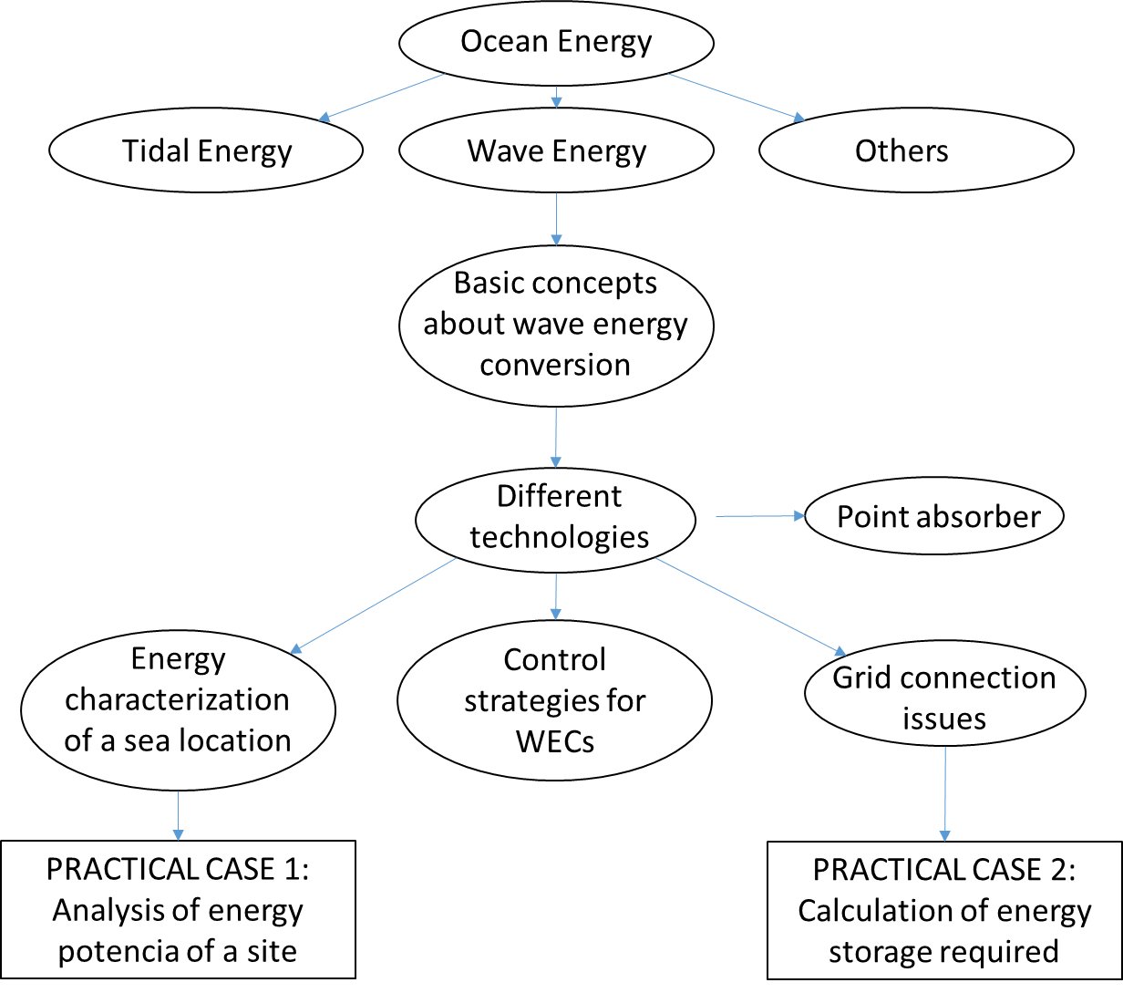

ACTIVITY PLAN
The study of this course requires reading and understanding of the theoretical concepts, which you will find in the documentation of the module. The content of this study covers the areas of the course activities which will be evaluated at the end of this module. These activities are the following:
- Displaying the multimedia content and conduct of the assessment test type associated with it. This test will consist of 5 multiple choice questions. There are 2 attempts to do so.
To pass this activity the participant must achieve 80% correct answers (4 correct answers).
- Read the documentation. In the first place, the main text of the module has to be read. Later on, the student should check the bibliography to get a further understanding of the different concepts and in order to have an overview of all the data and information that is being addressed in each chapter.

Case study. Calculation of the electric energy obtained in a certain location with a wave energy device, using the power matrix. A practical case using EXCEL tool will be developed in order to apply the methodology studied in chapter 2, using real wave data from a site located in island areas.

A short assessment test will be presented to evaluate the knowledge and understanding after the performance of the practical case. For each question there will be several possible answers and only one correct. There are 5 attempts to perform the test. To overcome this activity the participant must have 100% of the correct answers.

Final self-assessment test, through which it can be checked the level of conceptual understanding of the module, and it can be used as a reference of these aspects that deserved a further analysis by the student

This test will present 20 questions with several possible answers and only one correct. You have 1 hour and 2 attempts to perform it. To pass this activity the participant should reach 80% of correct answers (16 correct answers).

To properly complete the course, the estimated time commitment is 20 hours distributed as is most convenient for each participant. Being a self-training mode is allowed flexibility in the implementation of activities, although we recommend regularly in the course, spending one to two hours daily, to the best use.

All those activities with more than one attempt for implementation, will consider the highest score to reach the final result.

DIPLOMA
Upon graduation UNIDO, CIEMAT and ECREEE will issue a certificate of achievement for participants who exceed the following requirements:
- View 100% of the content and achieve 80% of the assessment test associated with it.
- Perform the case study and correctly answer to 100% of the questions associated with it
- Overcoming 80% of the final self-assessment test.
Once achieved these requirements, the participant may access the appropriate section in the virtual classroom and download the diploma in electronic format.

