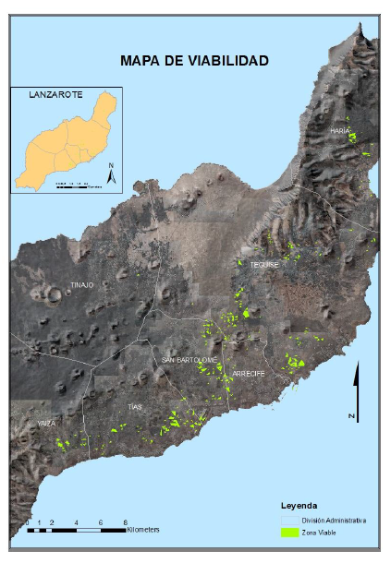
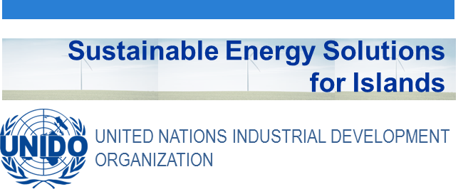

Didactic Guide
  - Geographic Information Technologies and Renewable Energy
SIDS DOCK in cooperation with PCREEE, CCREEE and ECREEE.
Developed with key technical support of UNIDO and CIEMAT.
With the financial support of AECID and ADA.

Didactic Guide

Geographic Information Technologies and Renewable Energy

OBJETIVES

General objective

Provide the student with a basic knowledge that will allow him to begin to address the problem of the integration of renewable energies in islands using the tools of the geographic information technologies (GIT).

Specific objectives
- To know the basic principles of Geographic Information Technologies, what is meant by TIG? What are its main functions and tools? What are the main analytical characteristics?
- To know the main sources of geographic information, its standards and requirements for the development of renewable energy projects, as well as the fundamental criteria of cartography.
- To know applications of these technologies in the field of renewable energies, with special attention to the insular areas, that can contribute to the understanding of their capacities.
- To develop a practical exercise that reinforces the knowledge learned during the course

COURSE STRUCTURE
- Geographic Information Technologies: basic principles.
  - What are GIT?
  - Main functions and applications.
  - Spatial Analysis and Data Structure.
  - Chapter Summary
- Geographic information and cartography
  - Geographic information
    - Standards
    - Sources of geographic information for the analysis of renewable energies
  - Mapping
    - Cartographic Basics and Thematic Mapping
    - Map representation in renewable energy projects
    - Presentation of results on the internet (geoportals).
  - Chapter Summary
- GIT and Renewable Energies
  - Case study and review of the literature.
  - Geographic Information Systems and rural electrification. Application of IntiGIS in islands.
  - Distributed generation and self-consumption. The gSolarRoof model.
  - Chapter Summary

CONCEPTUAL MAP
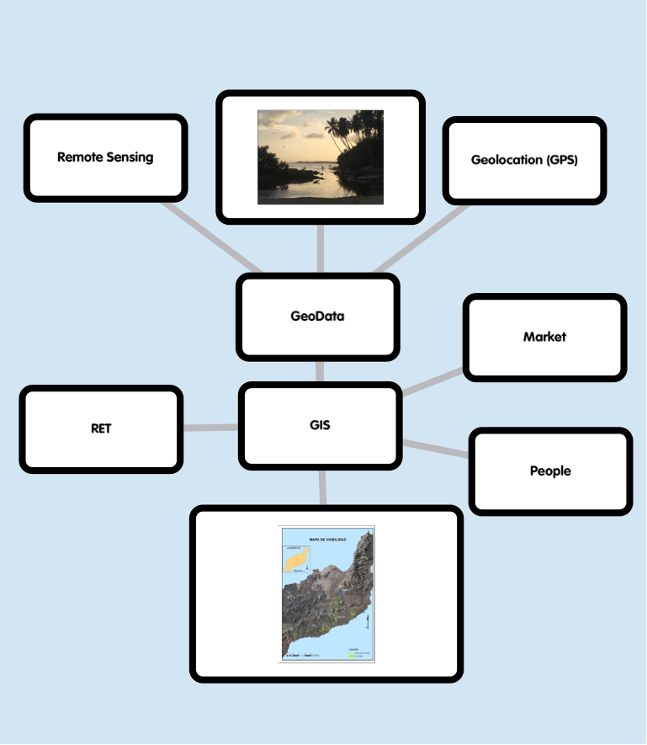

ACTIVITY PLAN
The study of this course requires reading and understanding of the theoretical concepts, which you will find in the documentation of the module. The content of this study covers the areas of the course activities which will be evaluated at the end of this module. These activities are the following:
- Displaying the multimedia content and conduct of the assessment test type associated with it. This test will consist of 5 multiple choice questions. There are 2 attempts to do so.
To pass this activity the participant must achieve 80% correct answers (4 correct answers).
- Read the documentation. In the first place, the main text of the module has to be read. Later on, the student should check the bibliography to get a further understanding of the different concepts and in order to have an overview of all the data and information that is being addressed in each chapter.
- Case study. Analyze and comment on the use of a webmap to analyze the potential of rural electrification with renewable energies in small islands.
A short self-assessment test will be presented to evaluate the knowledge and understanding of the practical cases approach. For each question there will be several possible answers and only one correct. There are 5 attempts to perform the test. To overcome this activity the participant must have 100% of the correct answers.

Final self-assessment test, through which it can be checked the level of conceptual understanding of the module, and it can be used as a reference of these aspects that deserved a further analysis by the student

This test will present 20 questions with several possible answers and only one correct. You have 1 hour and 2 attempts to perform it. To pass this activity the participant should reach 80% of correct answers (16 correct answers).

To properly complete the course, the estimated time commitment is 20 hours distributed as is most convenient for each participant. Being a self-training mode is allowed flexibility in the implementation of activities, although we recommend regularly in the course, spending one to two hours daily, to the best use.

All those activities with more than one attempt for implementation, will consider the highest score to reach the final result.

DIPLOMA
Upon graduation UNIDO, CIEMAT and ECREEE will issue a certificate of achievement for participants who exceed the following requirements:
- View 100% of the content and achieve 80% of the assessment test associated with it.
- Perform the case study and correctly answer to 100% of the questions associated with it
- Overcoming 80% of the final self-assessment test.
Once achieved these requirements, the participant may access the appropriate section in the virtual classroom and download the diploma in electronic format.

