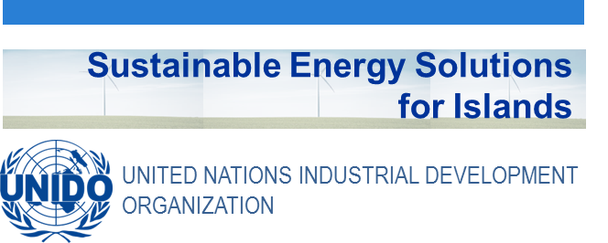
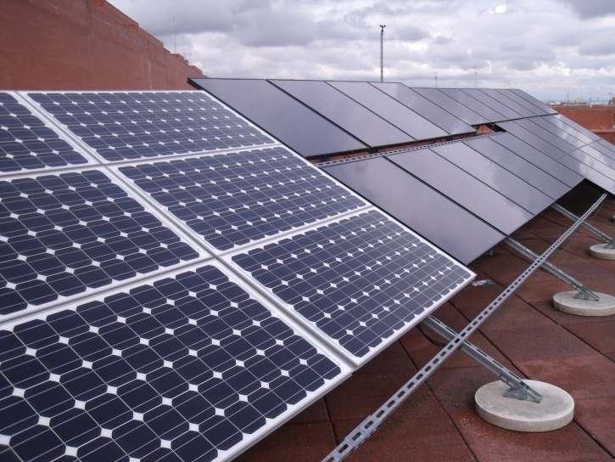

Didactic Guide
Grid-connected and decentralized Photovoltaic systems
SIDS DOCK in cooperation with PCREEE, CCREEE and ECREEE.
Developed with key technical support of UNIDO and CIEMAT.
With the financial support of AECID and ADA.

Didactic Guide

Photovoltaic Solar Energy

objectives

General objective
The overall aim of this module is to supply students with the knowledge necessary to understand the basics of photovoltaic conversion, the current state of technology, how it has evolved from its beginnings to the point of actual development and the different types and characteristics of photovoltaic systems. They should acquire the skills necessary to provide the potential for the development of this energy source in their home countries or in other countries in which they will perform their work, thus contributing to the expansion of the energy generated by photovoltaic means. This will in turn result in greater diversification of energy sources, an increased use of clean energy and, consequently, the reduction of emissions of greenhouse gases

Specific objectives
- Allow the student to understand the basic principles of photovoltaic conversion, how it is possible to transform the sun's energy into electricity and the key elements necessary to perform such a transformation
- To know the main components of stand-alone systems and small networks (mini-grids) photovoltaic systems, its applications and basic dimensioning.
- To explain basic principles and concepts of solar radiation and its influence on energy conversion.
- To know the main components of photovoltaic systems connected to the grid and to estimate and simulate the electrical output of these systems.

COURSE STRUCTURE
To achieve the proposed objectives, the module is structured into 5 main chapters divided into several blocks. They make an overview of all aspects related to the conversion of the sun's energy into electricity, from the physical bases to the most common applications.

- Basics of photovoltaic conversion. Cells, modules and PV generators
Photovoltaic Solar Energy in the context of renewable energies. The world situation
Opportunities
Fundamentals of photovoltaic conversion. PV cell and module technology
The photovoltaic effect. The photovoltaic solar cell
Solar cell structure
Working principle
Quantum efficiency and spectral response
Characteristic parameters of the solar cell
Different types of photovoltaic cells
The photovoltaic generator and its associations. Flat plate module and concentration systems
Introduction
The photovoltaic modules
Different types of photovoltaic modules
The I-V characteristic of the photovoltaic module
Factors affecting the I-V characteristic of the PV generator
The characteristic equation
Reference conditions for the I-V characteristic
Extrapolation to other operational conditions
Efficiency of a photovoltaic module
Brief note about concentration systems
Types of concentrating systems
Summary of the chapter

- Fundamentals of Solar Radiation and Generated Energy
Nature of Solar Radiation
Irradiance and solar radiation
Spectral composition of solar radiation
Direct and diffuse components of solar radiation
Characterization of Solar radiation
Clock time and solar time
How to determine the solar position
Declination, altitude and solar azimuth angles
Influence of atmosphere and climate
Mounting structures and generated power
Installing a PV generator. Supporting structures
Tracking systems
The energy delivered by the PV generator
Extrapolation of power values to operational conditions. Method – 1 (symplified)
The loss factors
Summary of the chapter

- Photovoltaic system components and standards
Power Storage and Conditioning
Energy storage system
Charge regulator
CC/AC Converters
Maximum power point tracking system
Balance of system
Loads in photovoltaic systems
Lighting
Pumps
Vaccine refrigeration
Other loads and applications
International standards
Standardization bodies and accredited laboratories
Photovoltaic standards
Summary of the chapter

- Stand-alone photovoltaic systems and mini-grids
Stand-alone photovoltaic systems
Solar Home Systems (SHS) and Lighting Kits
Minigrids
Basics of PV sizing
Basic Sizing
Hibrid systems sizing
Some Ideas on Advanced Dimensioning
Summary of the Chapter

- Grid-connected photovoltaic systems
Photovoltaic modules associations. Descriptions and problems
By-pass diodes
Blocking diodes
Operating parameters
Basic parameters
Determination of losses and yields
Sizing of a photovoltaic system
The photovoltaic generator
DC/AC inverters
Cabling and connections
Technical and legal aspects
Summary of the Chapter

CONCEPTUAL MAP

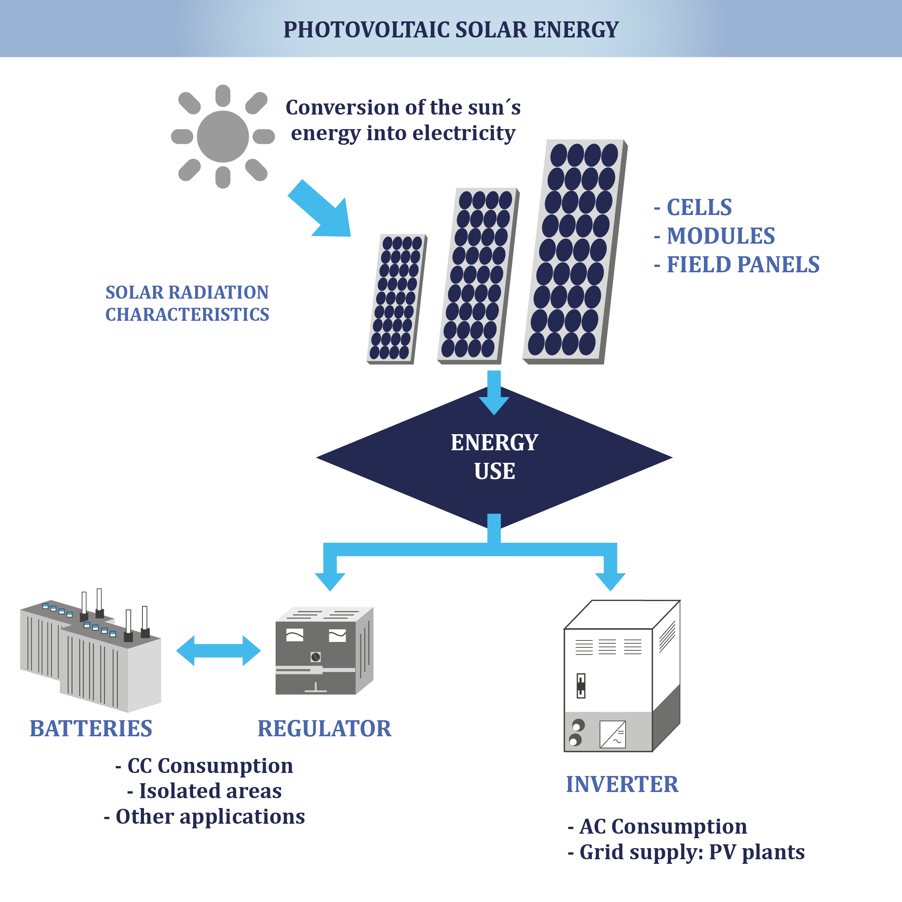

ACTIVITY PLAN
The study of this course requires reading and understanding of the theoretical concepts, which you will find in the documentation of the module. The content of this study covers the areas of the course activities which will be evaluated at the end of this module. These activities are the following:
- Displaying the multimedia content and conduct of the assessment test type associated with it. This test will consist of 5 multiple choice questions. There are 2 attempts to do so.
To pass this activity the participant must achieve 80% correct answers (4 correct answers).
- Read the documentation. In the first place, the main text of the module has to be read. Later on, the student should check the bibliography to get a further understanding of the different concepts and in order to have an overview of all the data and information that is being addressed in each chapter.
- Case Studies. Two case studies are presented. One case study is based on the desalination of water by photovoltaic solar energy in the Islands, and the second one includes an evaluation of the environmental and socio-economic aspects of photovoltaic solar energy in Islands. Related, 2 short multiple choice test will be presented. They have 5 attempts to perform it. To pass these activities the participant should have 100% of the correct answers.
- Final self-assessment test, through which it can be checked the level of conceptual understanding of the module, and it can be used as a reference of these aspects that deserved a further analysis by the student
This test will present 20 questions with several possible answers and only one correct. You have 1 hour and 2 attempts to perform it. To pass this activity the participant should reach 80% of correct answers (16 correct answers).

To properly complete the course they are estimated 20 hours of work distributed at the participant convenience. Being a self-training process, it allows flexibility in the implementation of activities, although we recommend regularity spending one to two hours daily to take advantage of the course.
In all activities, which allow more than one attempt to achieve them, the highest score will be considered the final result.

DIPLOMA
Upon graduation UNIDO, CIEMAT and ECREEE will issue a certificate of achievement for participants who exceed the following requirements:
- View 100% of the content and achieve 80% of the assessment test associated with it.
- Perform the case studies and correctly answer to 100% of the questions associated with it
- Overcoming 80% of the final self-assessment test.
Once achieved these requirements, the participant may access the appropriate section in the virtual classroom and download the diploma in electronic format.

