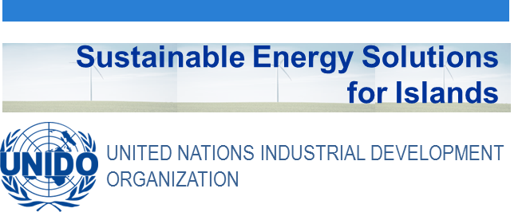
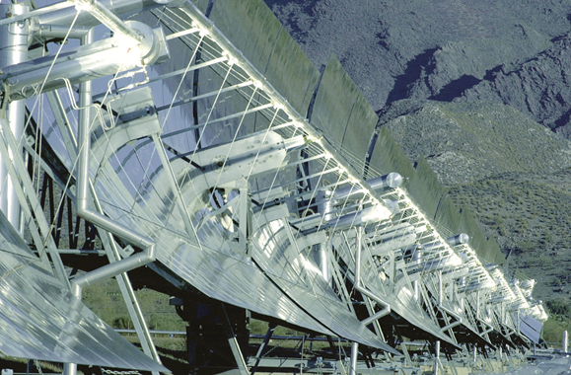

Didactic Guide

Solar thermal Systems and Applications for water heating and industrial process heat

SIDS DOCK in cooperation with PCREEE, CCREEE and ECREEE.
Developed with key technical support of UNIDO and CIEMAT.
With the financial support of AECID and ADA.

Didactic Guide

Solar thermal Systems and Applications for water heating and industrial process heat

OBJECTIVES

General Objective
- The purpose of the Solar Thermal Energy Module is to provide a general overview of the potential applications that solar thermal technologies have. Starting from physics fundaments on which these technologies base up to offering an outline for developing new approaches, the students will acquire the capability to define and design, at an elementary level, some solar thermal systems for a specific location.

Specific Objectives
- Understanding the availability of solar resources for solar thermal technologies in a specific location, in order to define, briefly, the potential these technologies have
- Defining the type of solar thermal systems that can be implemented for a specific application and location, identifying the main components these systems have
- Understanding the way solar thermal systems work and their potential integration with other conventional thermal systems
- Defining and elementary designing solar thermal systems

MODULE STRUCTURE

- Introduction
Solar radiation
The solar spectrum. Components of solar radiation

- Solar Radiation Databases

- Energy Balance in a Solar Thermal Collector
Thermal functioning of a solar thermal collector
Energy transfer mechanisms
Radiation
Conduction
Convection

- Solar Thermal Systems: from the Flat Collector to Concentrating Dishes
Low-temperature collectors (below 125ºC)
Medium and high-temperature collectors

- Solar Domestic Hot Water and Heating
Possible configurations
Direct Systems
Indirect systems
Thermosyphon or natural circulation systems
Compact systems
Orientation and inclination of the collectors
Solar heating

- Solar Cooling and Air Conditioning
Closed-cycle thermal cooling equipment
Open loop solar cooling
Development in Latin American and Caribbean countries

- Solar Industrial Process Heat
Keys to Integrating Solar Plants
Process temperature
Energy flux transfer medium
Consumption profile

- Linear Focus Technology: Parabolic Troughs and Fresnel
Parabolictrough collector components
Fresnel-type linear concentrators
Applications
Linear focus collector plants
Predesign of the solar field

- Focal Point Technology: Central Receiver Power Plants and Parabolic Dish
Central receiver or power tower systems
The solar field
The receiver
The thermal energy system
Parabolic dish systems

- Thermal Storage
Sensible heat storage
Sensible heat storage materials
Sensible heat storage configurations
Latent heat storage
Latent storage materials
Latent heat storage configurations
Thermochemical storage
Applications

- Worldwide Status
Low-temperature solar systems
Medium and High-Temperature Solar Systems
Barriers to real deployment of solar thermal energy

CONCEPTUAL MAP

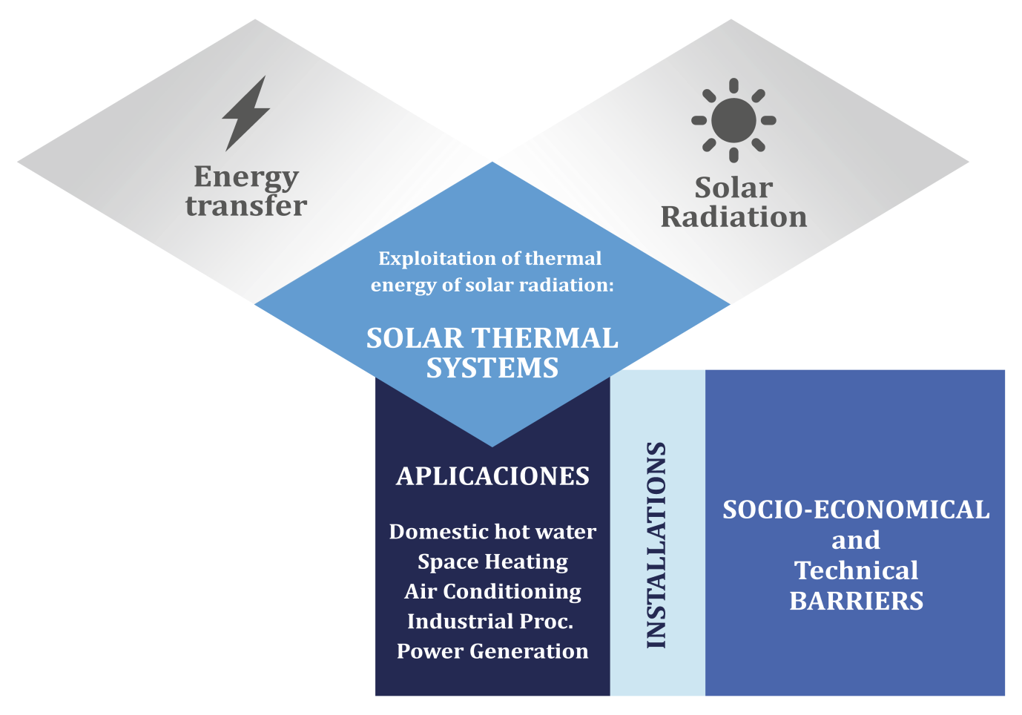

PLAN OF ACTIVITIES
The study of this course requires reading and understanding of the theoretical concepts, which you will find in the documentation of the module. The content of this study covers the areas of the course activities which will be evaluated at the end of this module. These activities are the following:
- Displaying the multimedia content and conduct of the assessment test type associated with it. This test will consist of 5 multiple choice questions. There are 2 attempts to do so.
To pass this activity the participant must achieve 80% correct answers (4 correct answers).
- Read the documentation. In the first place, the main text of the module has to be read. Later on, the student should check the bibliography to get a further understanding of the different concepts and in order to have an overview of all the data and information that is being addressed in each chapter.

Case study: “Elemental predesign of a parabolic trough solar field for a power plant of 11 MWe”. The case study should be performed whenever the student is sure of having understood and consolidated the concepts and information given in the Extensive documentation. It is suggested to re-read in advance the 1, 3, 8 and 10 chapters. It is not critical if the student is able to solve this practical case the first time, but it is necessary that, after its study, the student is able to solve it by his/her own.

A short test will assess the comprehension of the fundamental concepts of this practical case. It has 5 attempts to perform it. To pass this activity the participant should have 100% of the correct answers.

Final self-assessment test, through which it can be checked the level of conceptual understanding of the module, and it can be used as a reference of these aspects that deserved a further analysis by the student

This test will present 20 questions with several possible answers and only one correct. You have 1 hour and 2 attempts to perform it. To pass this activity the participant should reach 80% of correct answers (16 correct answers).

To properly complete the course, the estimated time commitment is 20 hours distributed as is most convenient for each participant. Being a self-training mode is allowed flexibility in the implementation of activities, although we recommend regularly in the course, spending one to two hours daily, to the best use.
All those activities with more than one attempt for implementation, will consider the highest score to reach the final result.

DIPLOMA
Upon graduation UNIDO, CIEMAT and ECREEE will issue a certificate of achievement for participants who exceed the following requirements:
- View 100% of the content and achieve 80% of the assessment test associated with it.
- Perform the case study and correctly answer to 100% of the questions associated with it
- Overcoming 80% of the final self-assessment test.
Once achieved these requirements, the participant may access the appropriate section in the virtual classroom and download the diploma in electronic format.

