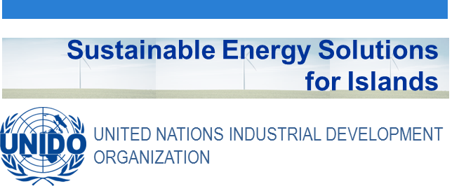

Didactic Guide

General Introduction into Island energy and Climate change mitigation and resilience

SIDS DOCK in cooperation with PCREEE, CCREEE and ECREEE.
Developed with key technical support of UNIDO and CIEMAT.
With the financial support of AECID and ADA.

Didactic Guide

General Introduction into Island energy and

Climate change mitigation and resilience

OBJECTIVES

General objective
This module will describe the causes and effects of climate change and the general global framework of policies aimed to halt it. The core objective is providing general understanding of the problem of climate change and the strategies that are being developed in the law and environmental economics. The topics will be first approached from a global perspective to later focus on the specific issues affecting islands, given particular attention to Small Island Developing States.

Specific objectives
This module should provide the student with:
- A complete and comprehensive picture of the environmental changes related to climate change.
- A clear understanding of the complex processes and the progresses in the policy-making in this matter.
- A first approach to the wide range of energy technologies that will play a significant role in the transition to a clean global energy system.
- Basic tools to apply the former knowledge in the design and implementation of policies and plans in small island energy systems.

COURSE STRUCTURE

- The Climate change and its impacts on islands.

  - What is the climate change?
  - Physical and scientific aspects of the climate system and the climate change.
  - Impacts on the socio-economic and natural systems.
  - Consequences in the oceans, coasts and islands.
Summary of the chapter: This section will provide an overview on the scientific aspects of the climate change, gathering the main physical evidences and its causes, the climate models and projections as well as changes in the natural ecosystems, with a special focus in the oceans, the sea level, and the consequences in the coast and islands. It will also introduce the different economic and social impacts depending on the different world regions.
- International policies to tackle the climate change.

  - The response from the International Community.
  - Kyoto Protocol.
  - Paris Agreement.
  - European policies.
Summary of the chapter: This chapter will show the design and implementation of policies at global, regional and national levels, aimed to curb the global warming in a challenging environment which requires balancing economic development and sustainable growth. It will review the origins and key milestones of the Intergovernmental Panel on Climate Change (IPCC) and the United Nations Framework Convention on Climate Change (UNFCCC). There will also be a summary about the European policies, designed for positioning Europe at the forefront in the fight against the climate change.
- The energy sector and the climate change.

3.1. The world energy sector.
3.2. Scenarios and outlooks.
3.3. The role of renewable energy.
Summary of the chapter: This chapter will contain the key facts and figures to understand the interplay among energy markets, development of technologies and policies around the world; how the coal, oil and natural gas markets are evolving and the deployment of renewable energy. It will also provide with some energy scenarios along different regions that will be required to fulfil with the Paris Agreement.
4. Isolated energy systems; islands.
4.1. Vulnerabilities of small islands.
4.2. Challenges and solutions for isolated systems.
4.3. Current situation, initiatives and plans in different regions.
4.4. Case studies.
Summary of the chapter: The last chapter will focus in the small islands; technical and economic challenges both for mitigation and resilience of their energy systems. We will explore at length how they are being facing to these changes in different cases studies and the more significant ongoing initiatives.

ACTIVITY PLAN
The study of this course requires carrying out the following activities:
- Displaying the multimedia content and conduct of the assessment test type associated with it. This test will consist of 5 multiple choice questions. There are 2 attempts to do so. To pass this activity the participant must achieve 80% correct answers (4 correct answers).
- Read the documentation. In the first place, the main text of the module has to be read. Later on, the student should check the bibliography to get a further understanding of the different concepts and in order to have an overview of all the data and information that is being addressed in each chapter.
- Case study. The student shall analyse a fictitious example of an isolated energy system in an island territory. Geographical, social, economic data and features of its current energy system will be provided, as well as alternatives for a clean energy transition roadmap. The student will have to be able to understand the implications of the different proposed alternatives and answer the questions thereon.
A short self-assessment test will be presented to evaluate the knowledge and understanding of the case study approach. For each question there will be several possible answers and only one correct. There are 5 attempts to perform the test. To overcome this activity the participant must have 100% of the correct answers.
- Final self-assessment test, through which it can be checked the level of conceptual understanding of the module, and it can be used as a reference of these aspects that deserved a further analysis by the student
- This test will present 20 questions with several possible answers and only one correct. You have 1 hour and 2 attempts to perform it. To pass this activity the participant should reach 80% of correct answers (16 correct answers).
- To properly complete the course, the estimated time commitment is 20 hours distributed as is most convenient for each participant. Being a self-training mode is allowed flexibility in the implementation of activities, although we recommend regularly in the course, spending one to two hours daily, to the best use.
All those activities with more than one attempt for implementation, will consider the highest score to reach the final result.

DIPLOMA
Upon graduation UNIDO, CIEMAT and ECREEE will issue a certificate of achievement for participants who exceed the following requirements:
- View 100% of the content and achieve 80% of the assessment test associated with it.
- Perform the case study and correctly answer to 100% of the questions associated with it
- Overcoming 80% of the final self-assessment test.
Once achieved these requirements, the participant may access the appropriate section in the virtual classroom and download the diploma in electronic format.

